|  |  |
| --- | --- |
| # correct |  |
| Total #?’s |  |
| **GRADE** |  |

Name:________________________________________

**Water, Solutions,**

**Acid/Bases**

**and**

**Nuclear Chemistry**

Unit 4

Student Manual

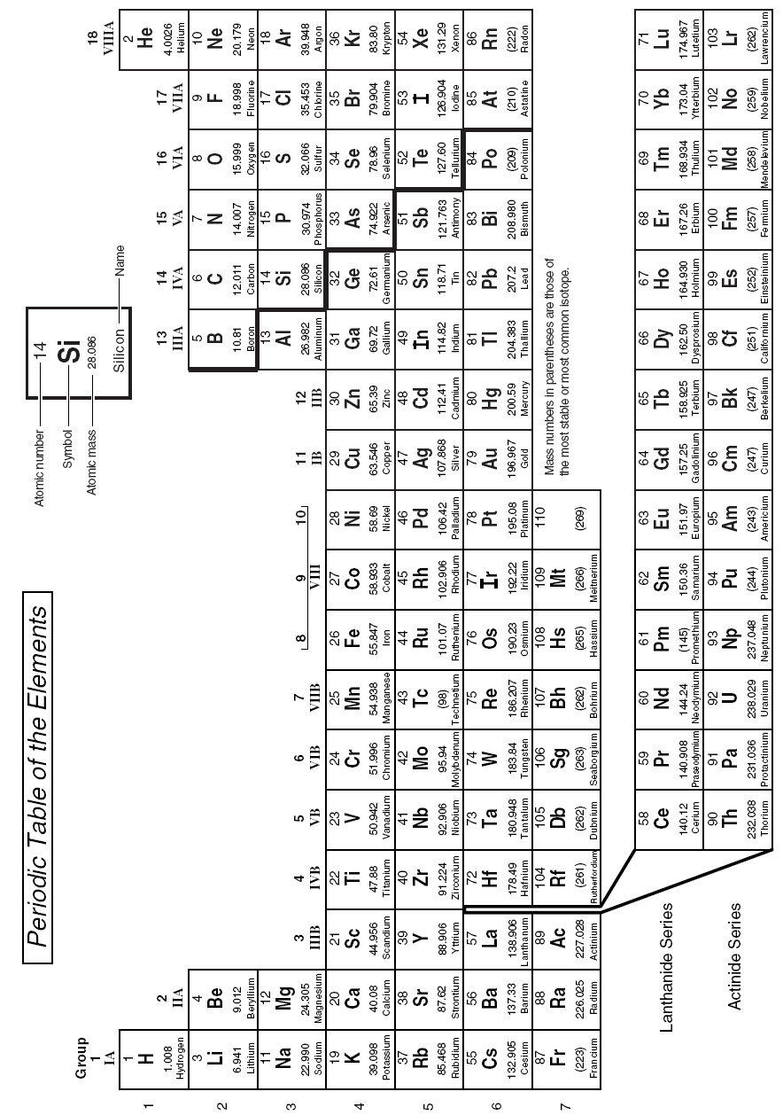

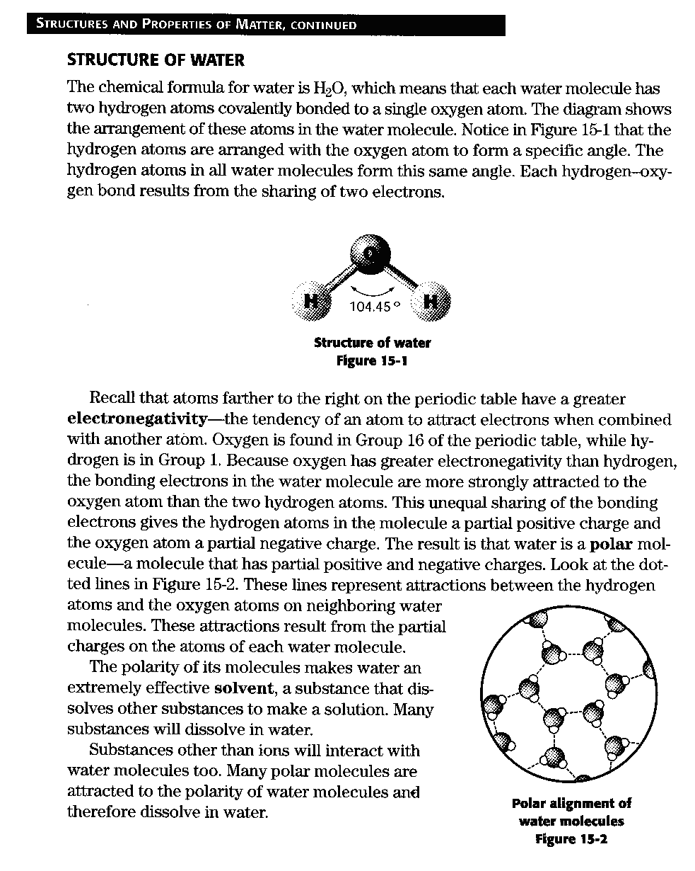

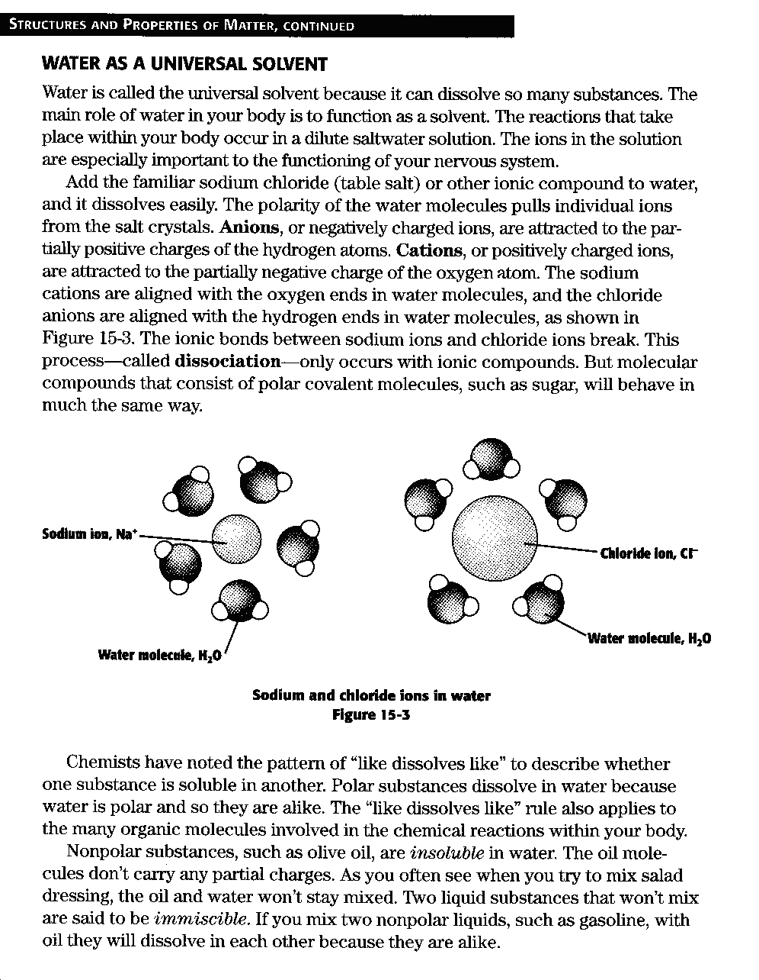

**Solution Chemistry Questions**

1. What are some of the special properties of water?
2. What happens to density as water becomes ice?
3. What is specific heat?
4. Why is water an important solvent?

**The Structure of Water**

**Water as a Universal Solvent**

1. What is the formula of water?
2. Draw a water molecule. Include the angle of the bonds.
3. Why is water a polar molecule?
4. Why is water an effective solvent?
5. How does table salt dissolve in water?
6. Why will a solid dissolve in one substance but not another?

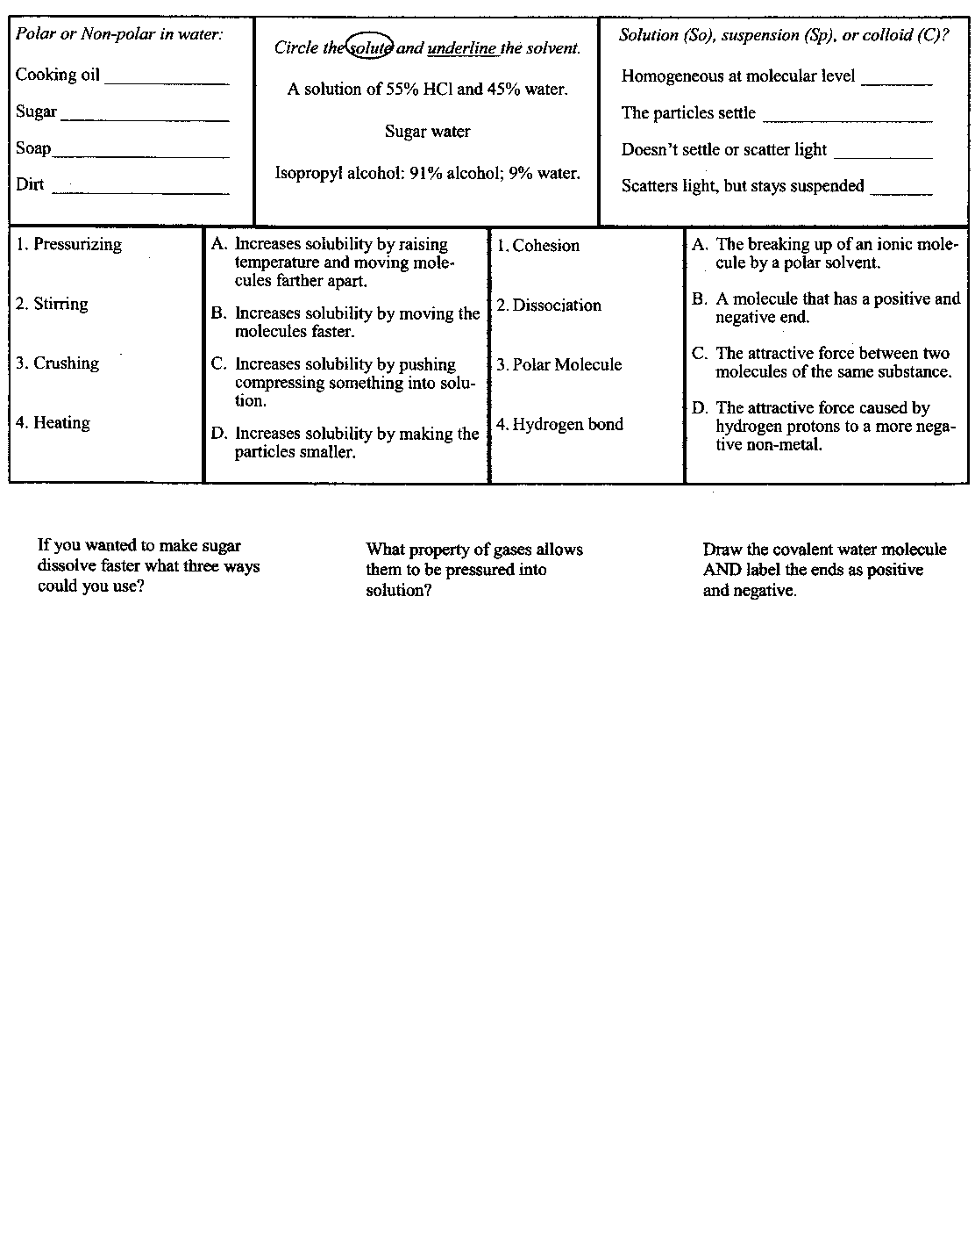**Polarity of Molecules**

*Determine whether the following molecules are polar or non-polar*

1. N2
2. H2O
3. CO2
4. NH3
5. CH4
6. SO3
7. HF
8. CH3OH
9. H2S
10. I2
11. CHCl3
12. O2

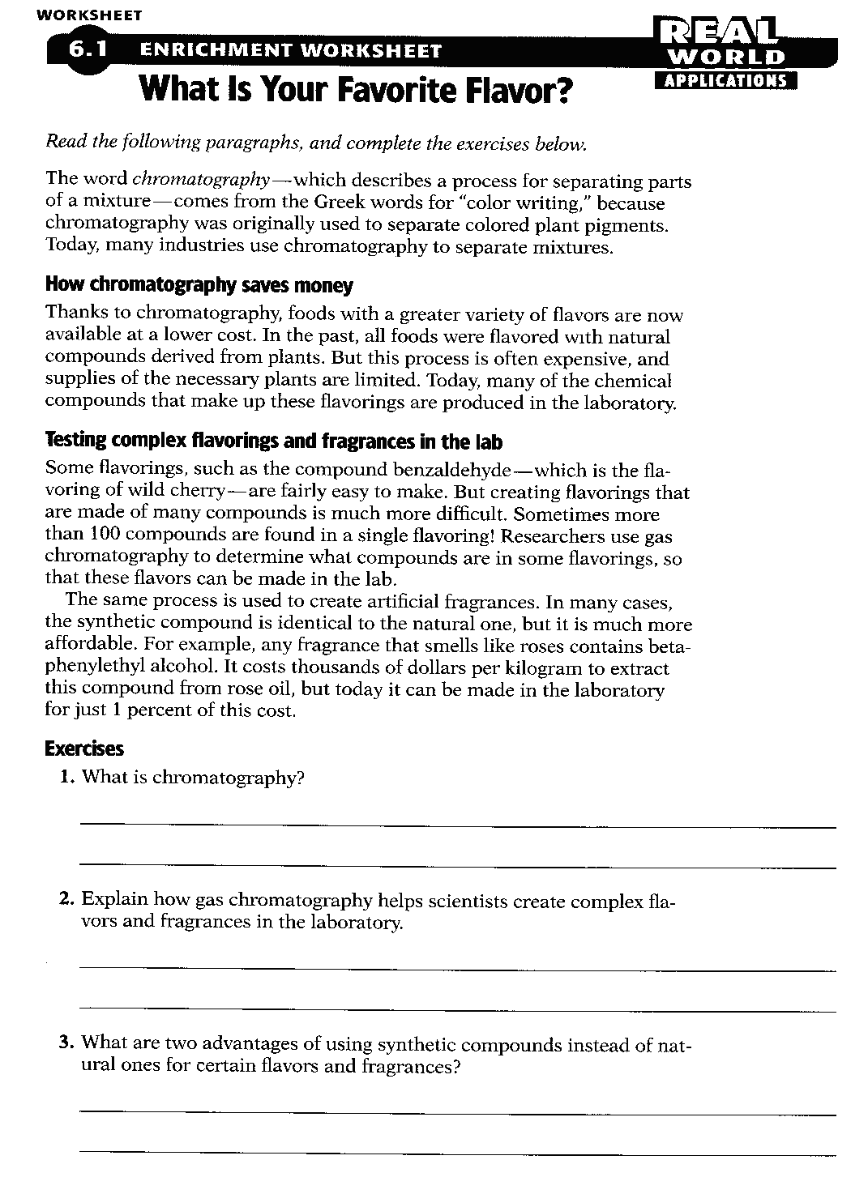

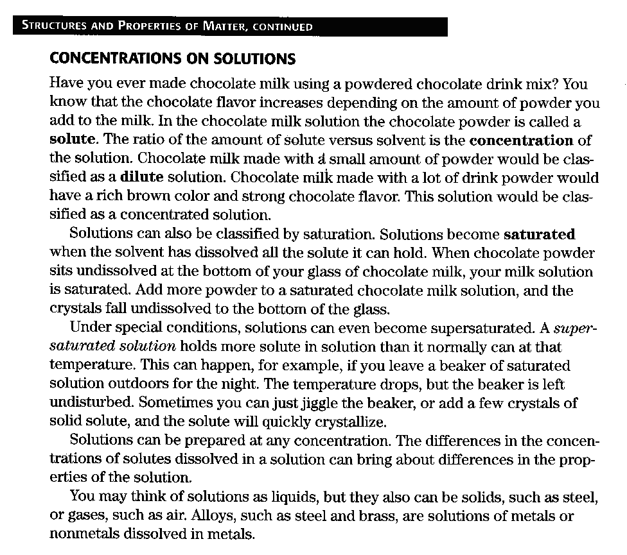

1. What is the concentration of a solution?
2. What is a saturated solution?
3. What is a supersaturated solution?
4. Explain how a substance is diluted?

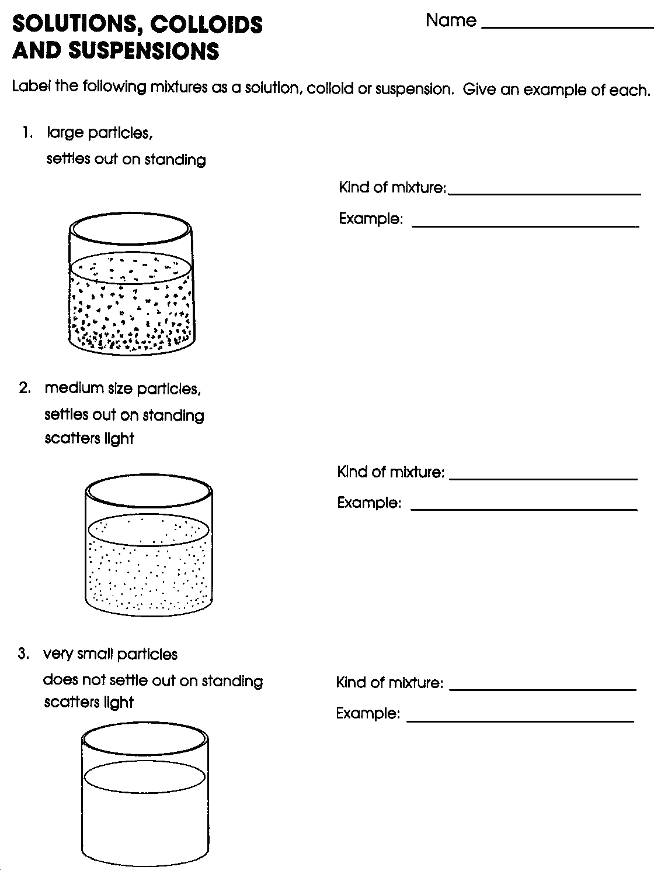

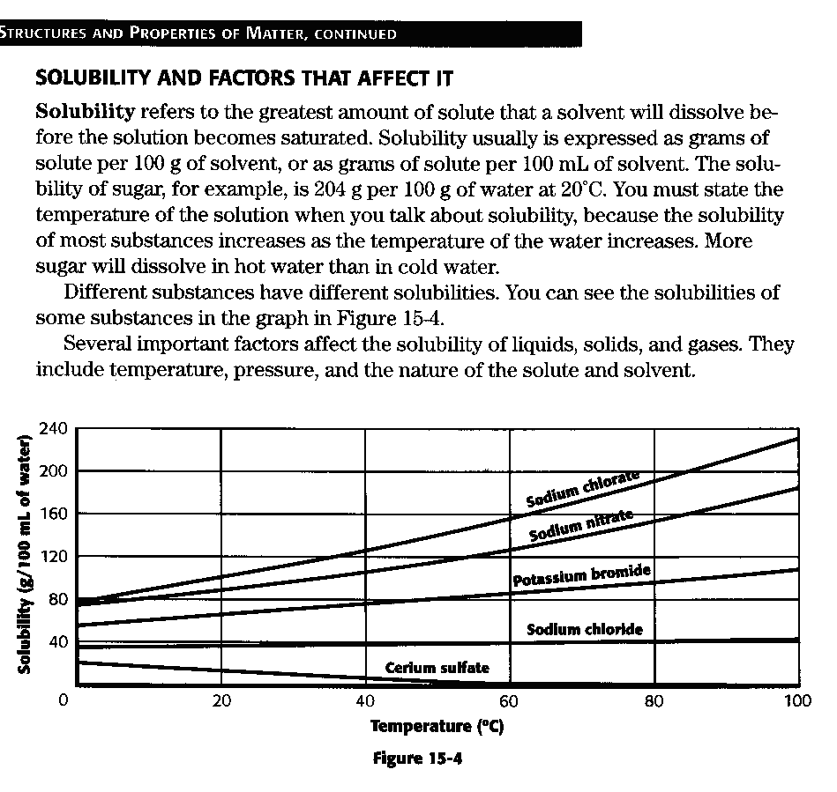

1. What is solubility?
2. Why must you state the temperature when you talk about solubility?
3. What is the solubility of sodium chloride at 60 C? Potassium bromide at 40 C? Sodium nitrate at 0 C?
4. What happens to solubility as temperature increases?

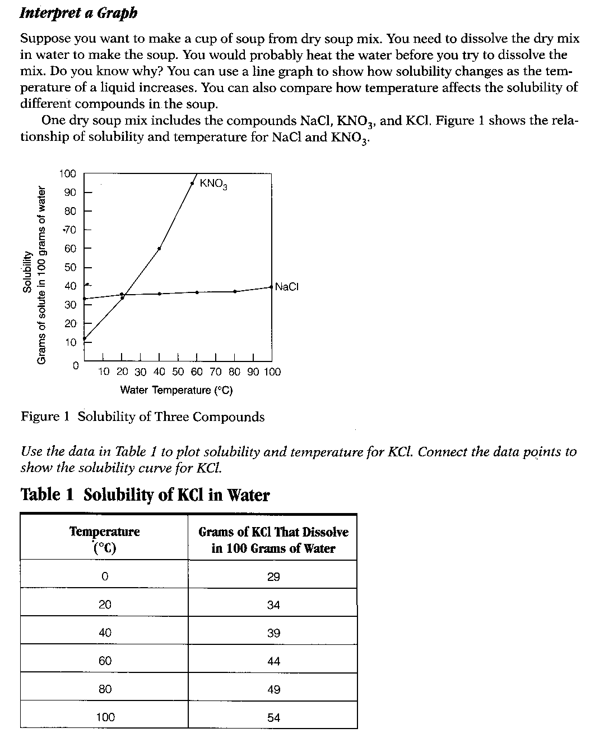**Temperature Questions**

1. How does temperature affect solubility?
2. On the solubility graphs, what does the x-axis represent? The y-axis?
3. What happens to the solubility of a gas as the temperature of the solvent raises?
4. What does it mean when the gas solubility graph shows a negative slope?

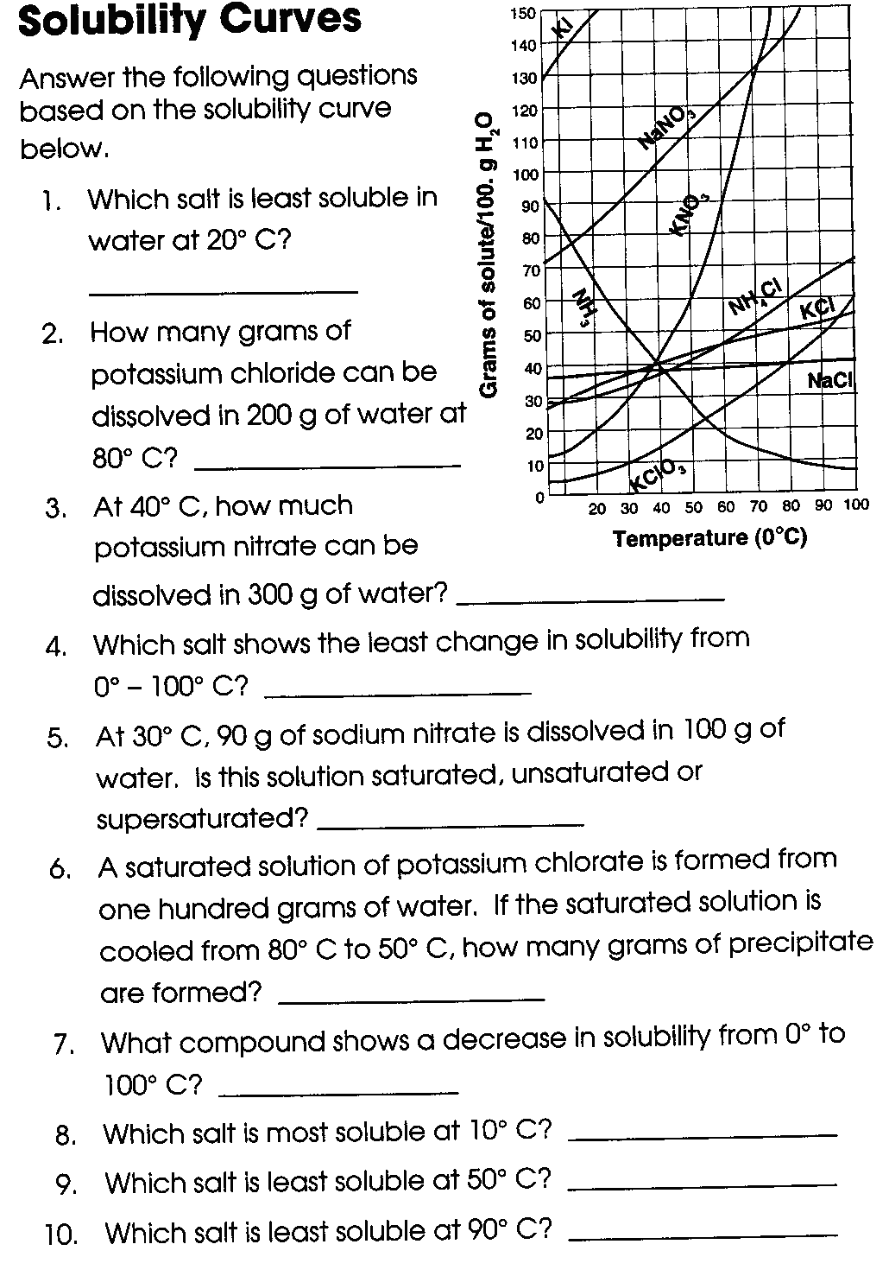

Name: ______________________ Solubility Graphs

**Solubility** measures the amount of a material (**solute**) that will dissolve in a **solvent** at a given temperature. Often the solvent will be water. As you would expect, different materials dissolve at different rates. Use the solubility graph provided to answer the following questions.

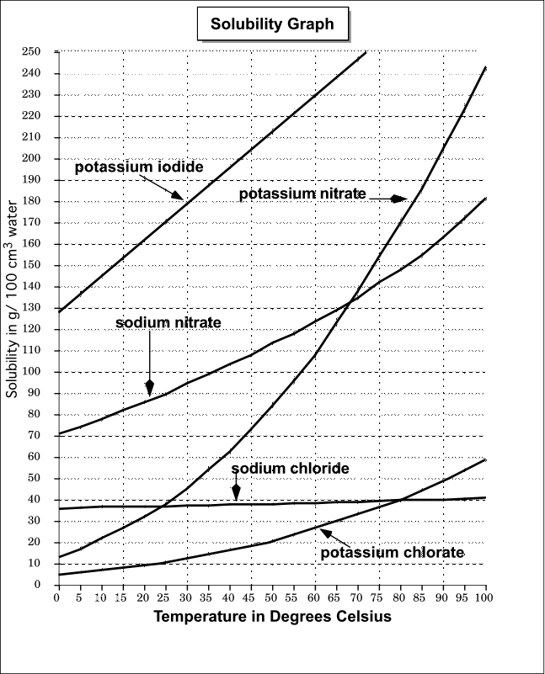

1) Is solubility a physical or chemical property?

2) According to the graph. as the temperature increases, what happens to the amount of solute being dissolved in water?

3) The slope of a graph indicates how rapidly the solute dissolves as the temperature increases - the steeper the slope the more rapidly it dissolves. According to the graph, what substance dissolves the fastest between 0°C and 50°C based on the slope of the curve?

4) What substance changes the least in solubility across the entire temperature range?

5) How many grams of potassium iodide will dissolve at 30°C? ________

6) At what temperature will 20 grams of potassium chlorate dissolve in water? ________

7) How many grams of sodium nitrate will dissolve at 90°C? ________

8) At approximately what temperature will 85 grams of potassium nitrate dissolve in water? ________

9) What substance dissolves best at the freezing point of water (0°C ) ? _________________________

10) Based on your knowledge of how heat energy affects particle spacing and movement, why would more material (solute) dissolve in water (solvent) at higher temperatures?

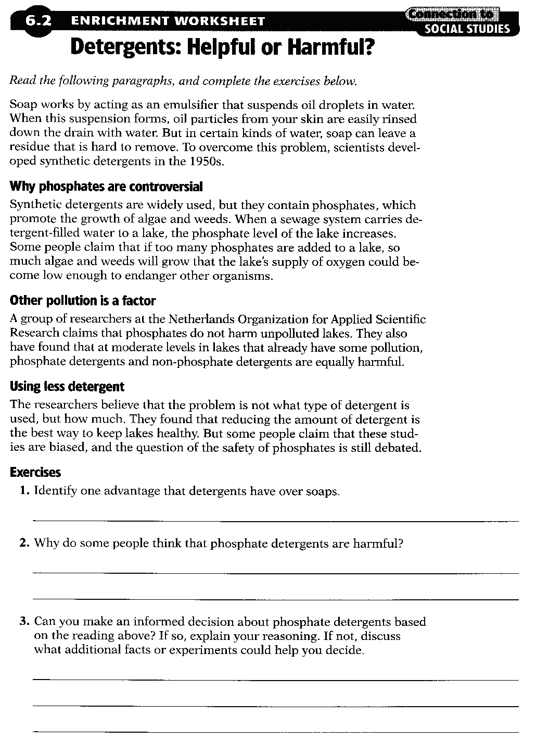

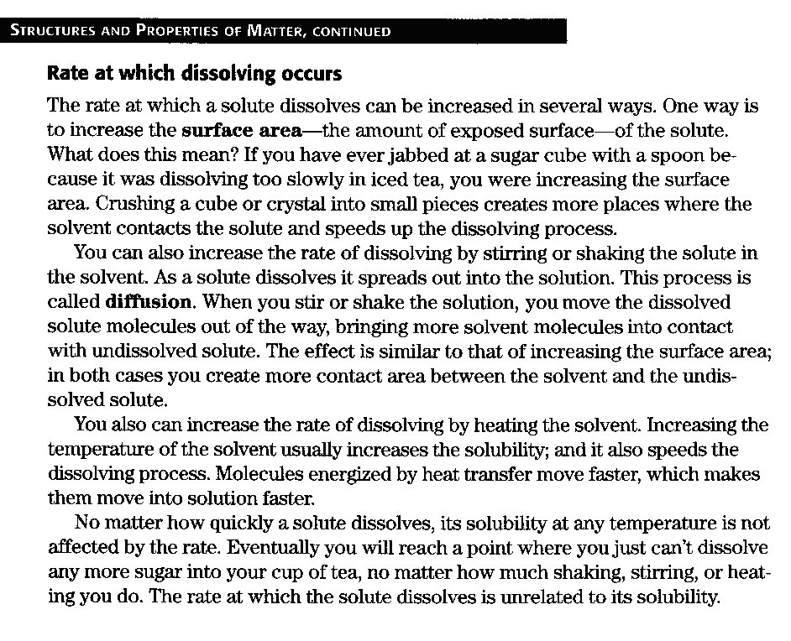

1. How can the rate of dissolving be increased?
2. What is diffusion?
3. How does increasing temperature affect solubility of a substance?
4. Explain why the dissolving rate and solubility is unrelated.

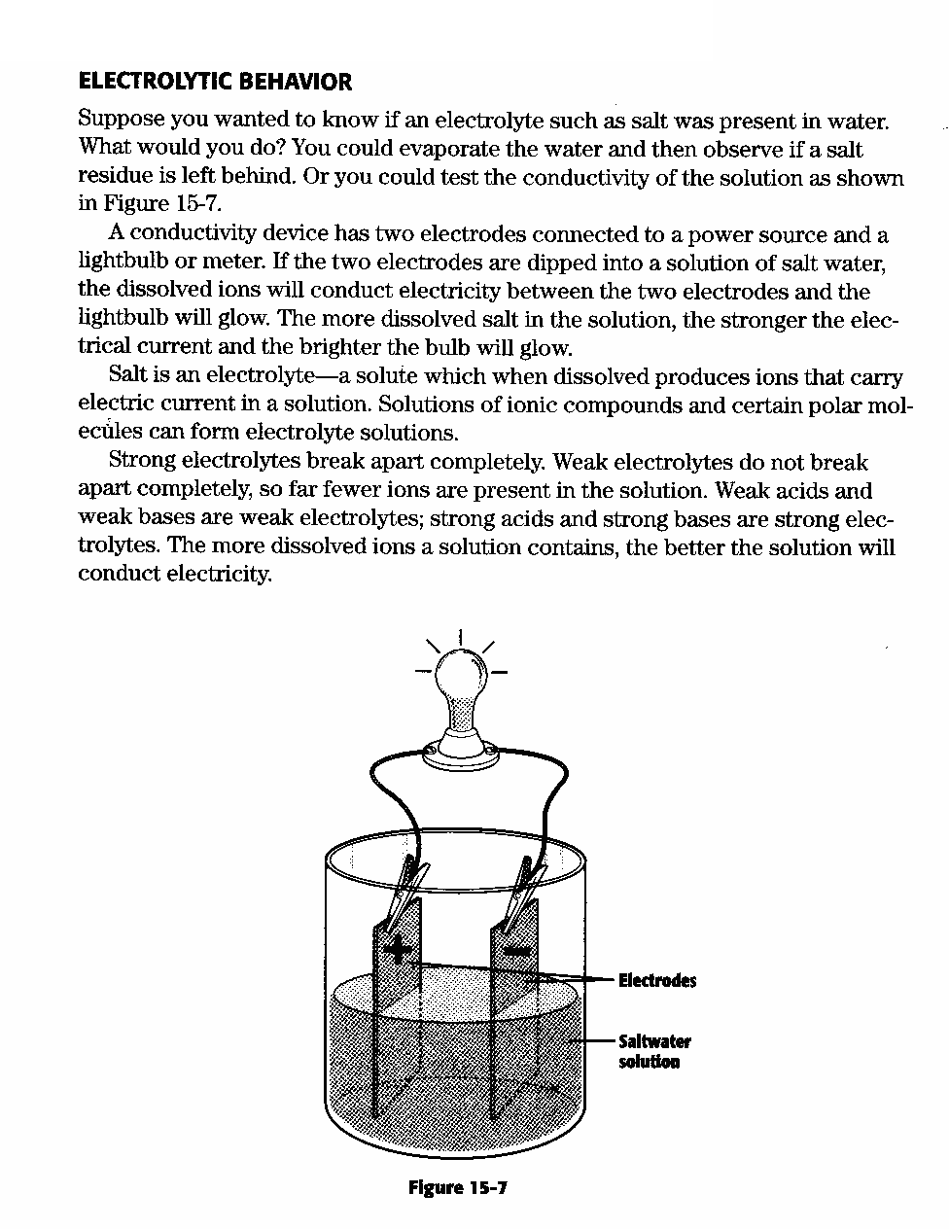

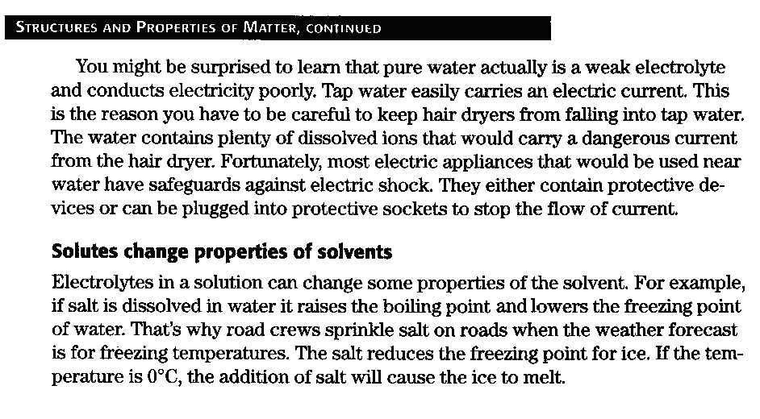

1. What is a conductivity device?
2. What is electrolyte?
3. How do electrolytes affect acids and bases?
4. Why can tap water easily carry an electric current and pure water cannot?
5. How do solutes change properties of solvents?

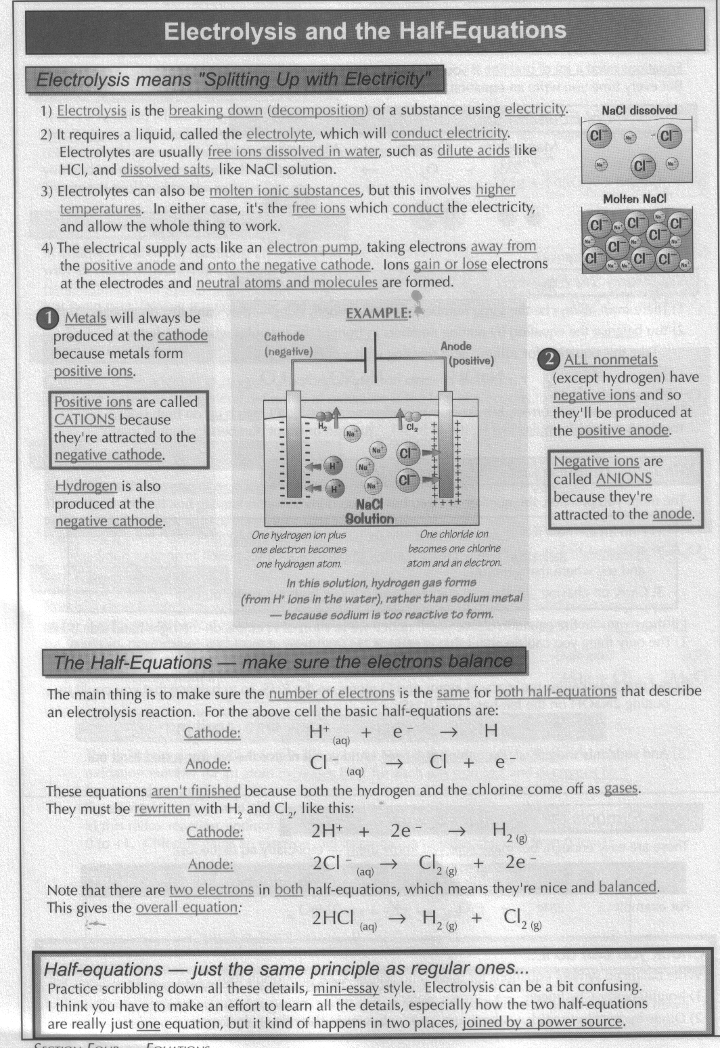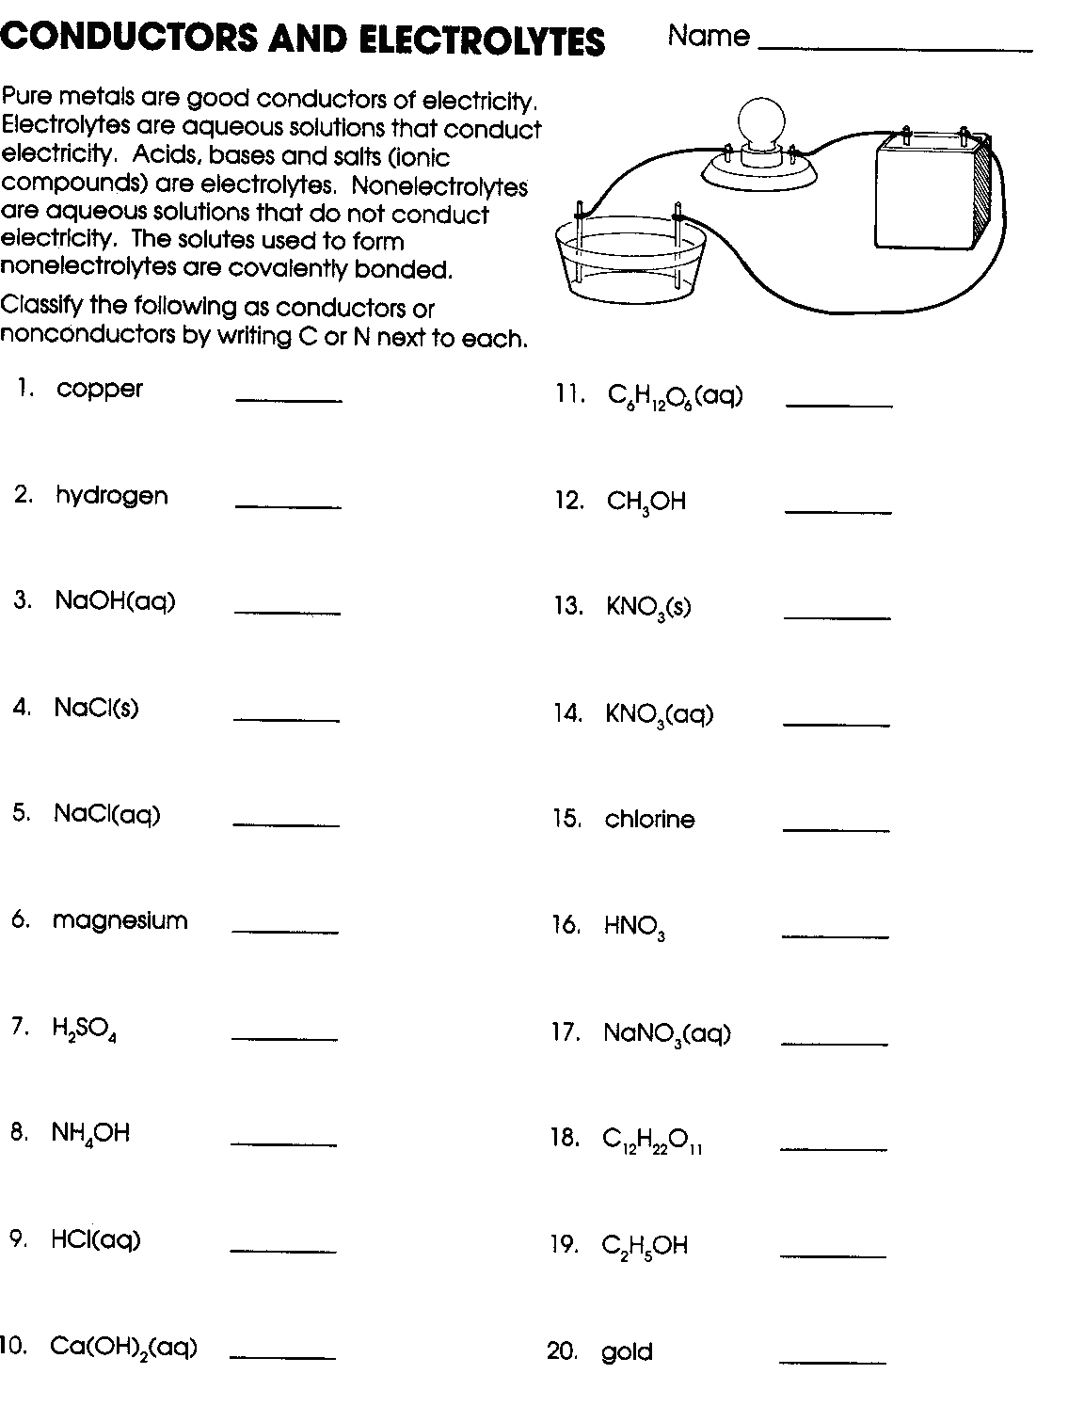

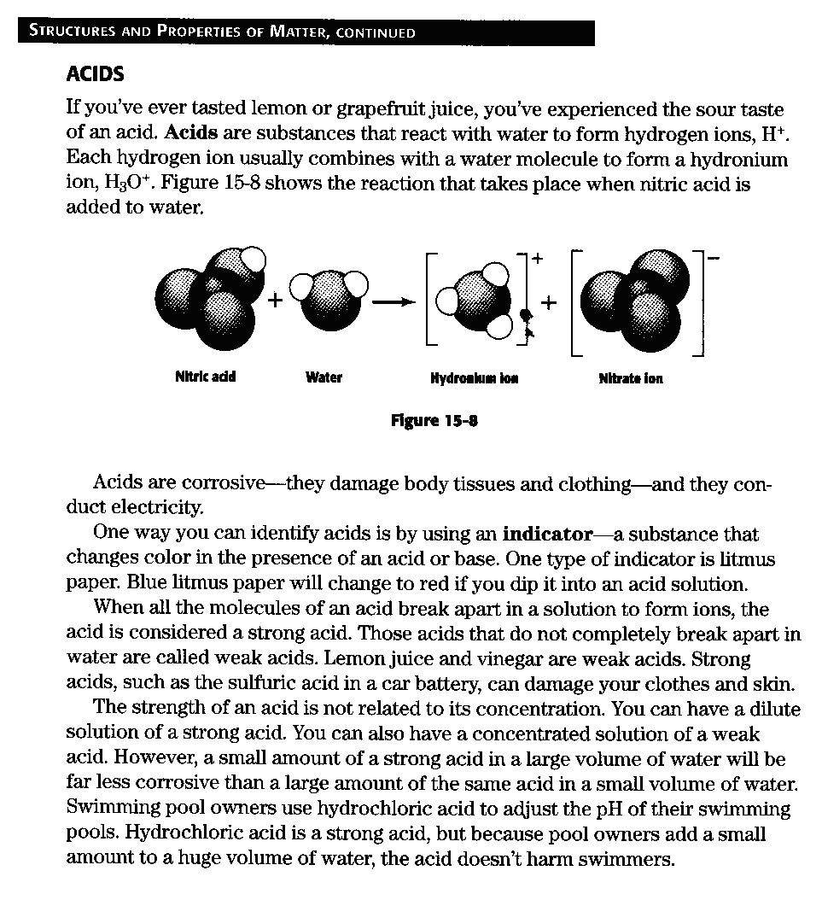

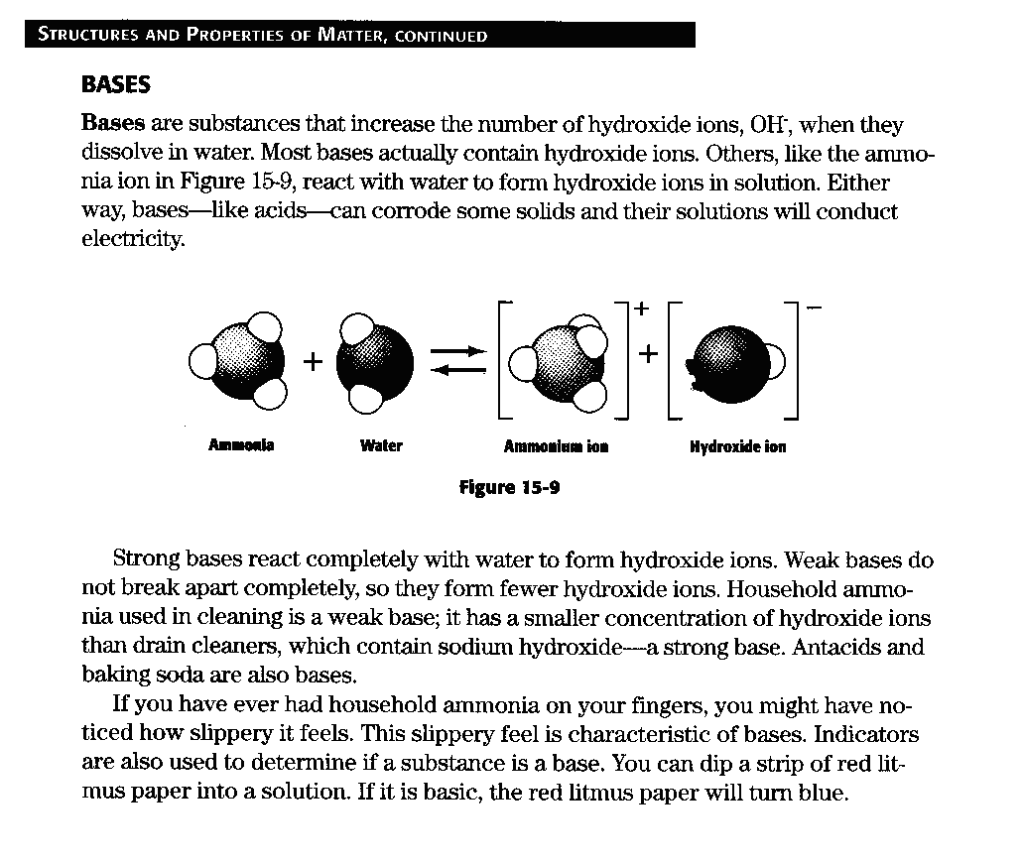

**Acid and Base Questions**

1. What are acids?
2. Give two characteristics of acids.
3. What is an indicator?
4. Compare a strong acid to a weak acid.
5. What is a base?
6. What type of ions do bases form?
7. Give two characteristics of bases.
8. Compare a strong base to a weak base.

**ACID, BASE, OR SALT**

*Classify each of the following compounds as an acid, base or salt. Then, indicate whether each acid and base is strong or weak.*

1. HNO3 _______________________ ______________________
2. NaOH _______________________ ______________________
3. NaNO3 ___________________________________ _________________________________
4. HCl _______________________ ______________________
5. KCl _______________________ ______________________
6. Ba(OH)2 __________________________________ _________________________________
7. KOH _______________________ ______________________
8. H2S _______________________ ______________________
9. Al(NO3)3 __________________________________ _________________________________
10. H2SO4 ___________________________________ _________________________________
11. CaCl2 ___________________________________ _________________________________
12. H3PO4 ___________________________________ _________________________________
13. Na2SO4 ___________________________________ _________________________________
14. Mg(OH)2 ___________________________________ _________________________________
15. H2CO3 ___________________________________ _________________________________
16. NH4OH _______________________ ______________________
17. NH4Cl _______________________ ______________________
18. HBR _______________________ ______________________
19. FeBr3 __________________________________ _________________________________
20. HF _______________________ ______________________

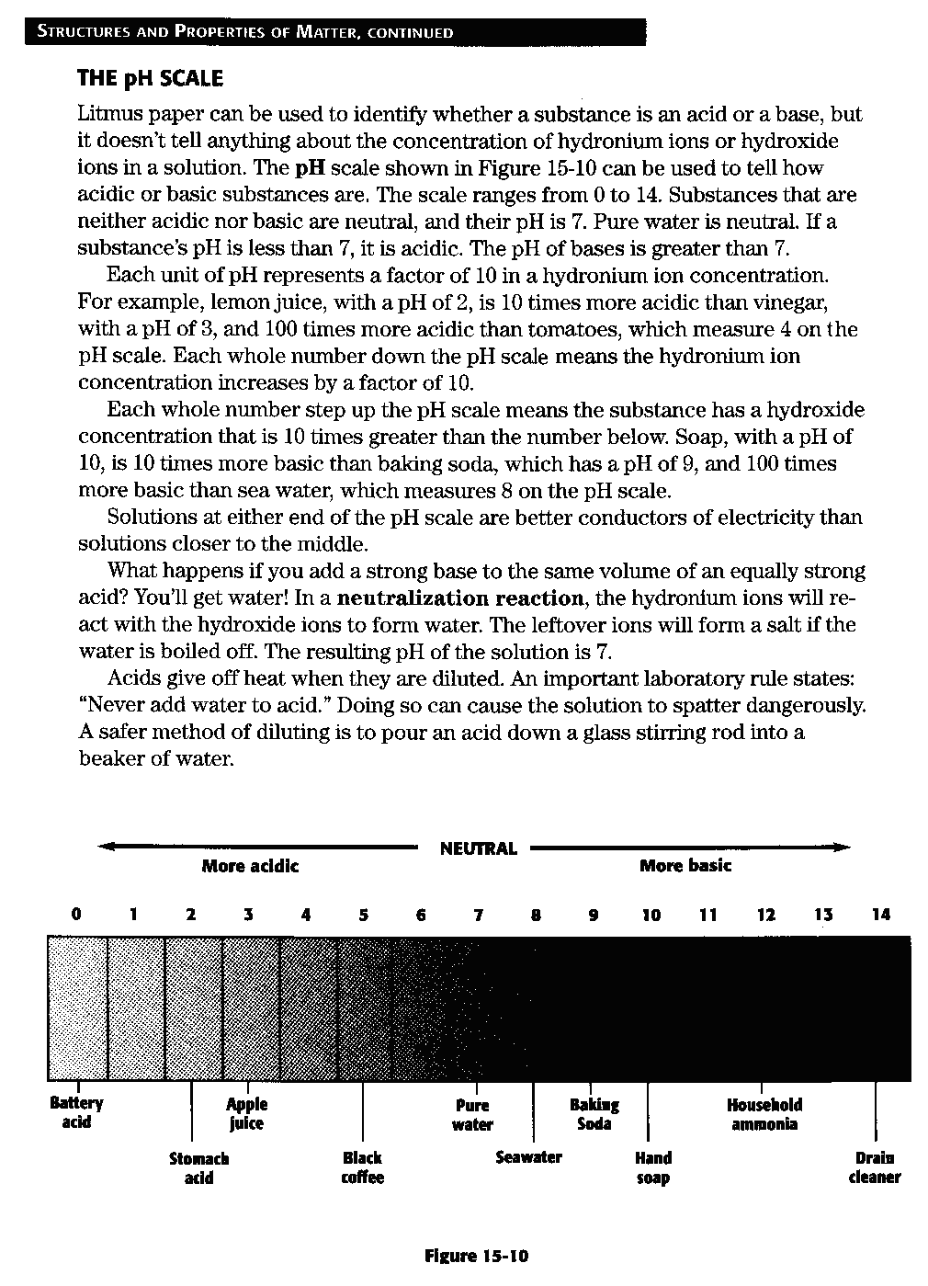

**The pH Scale**

1. What is litmus paper used for?
2. What is a pH scale used for?
3. What scale is used for the pH scale?
4. What is the range of acids? Bases? Neutral?
5. What is a neutralization reaction?
6. Compare the substances at either end of the scale to those in the center of the scale.
7. What is the very IMPORTANT laboratory rule about acids? Why do labs have this rule?

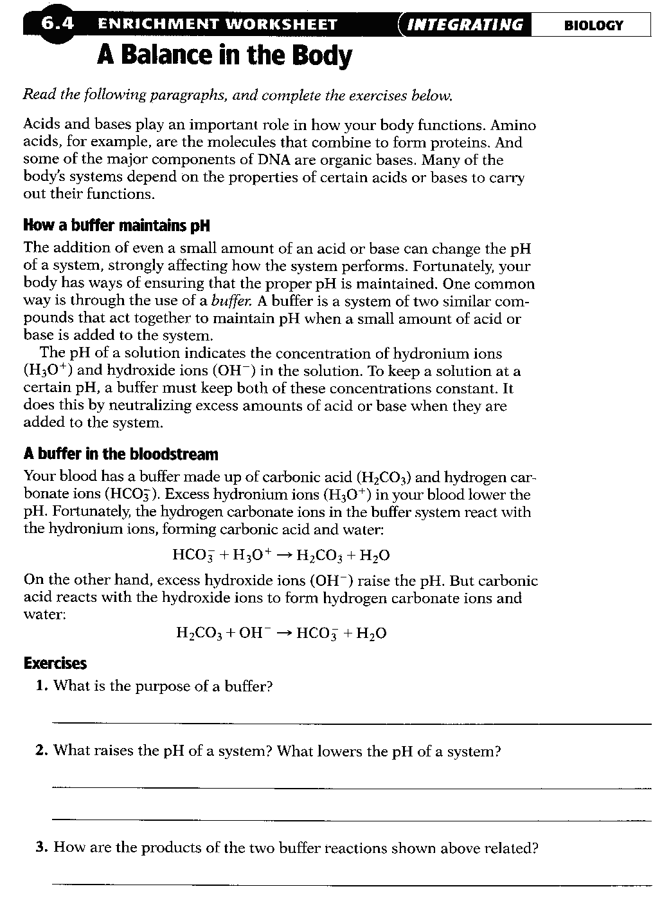

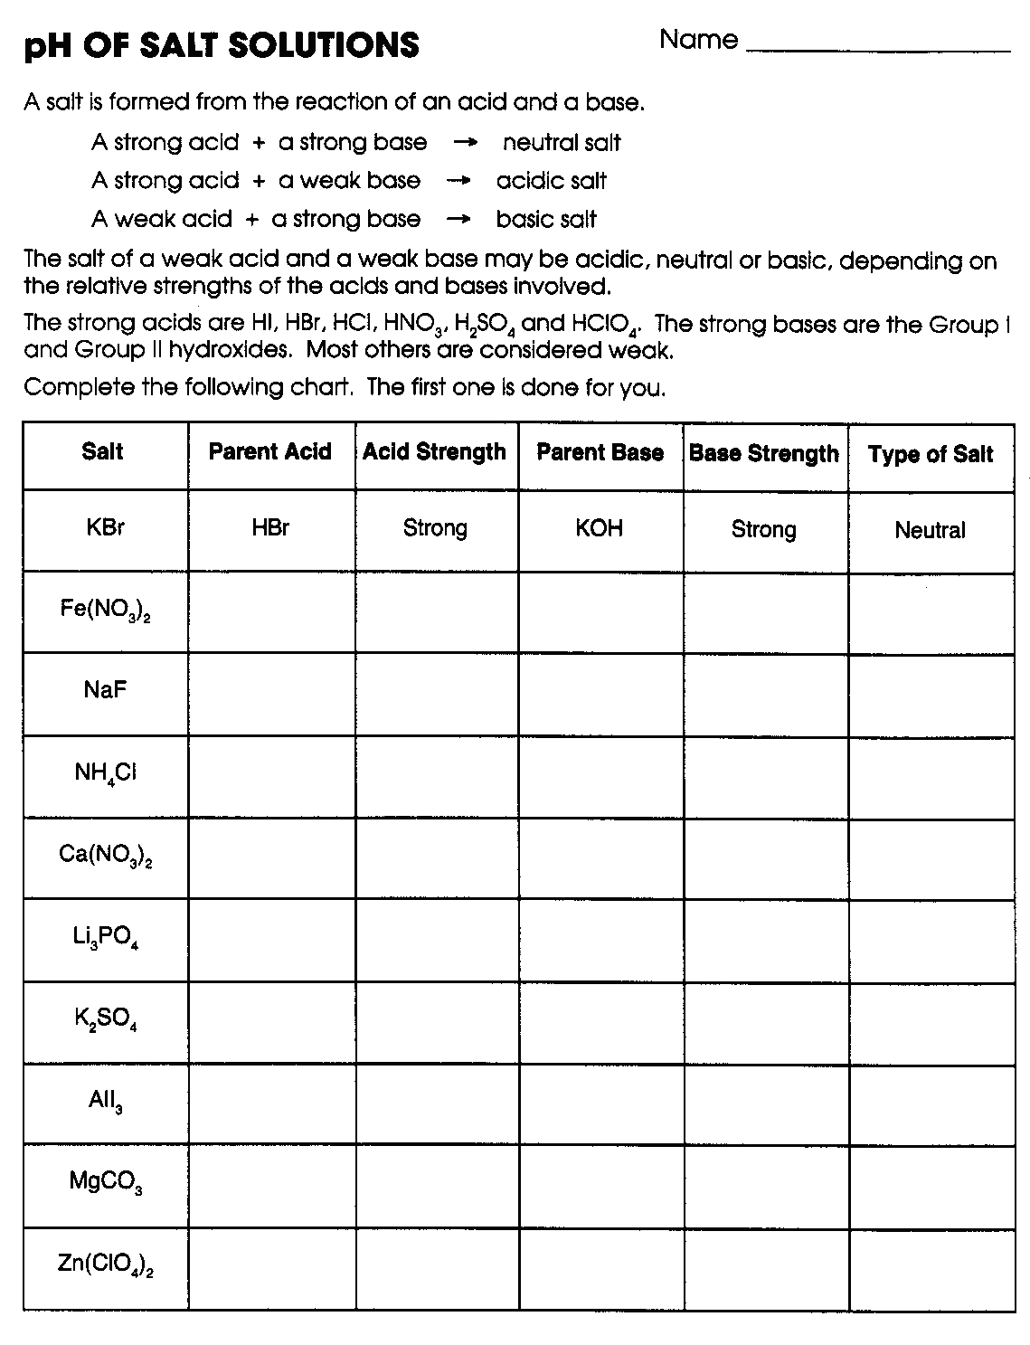

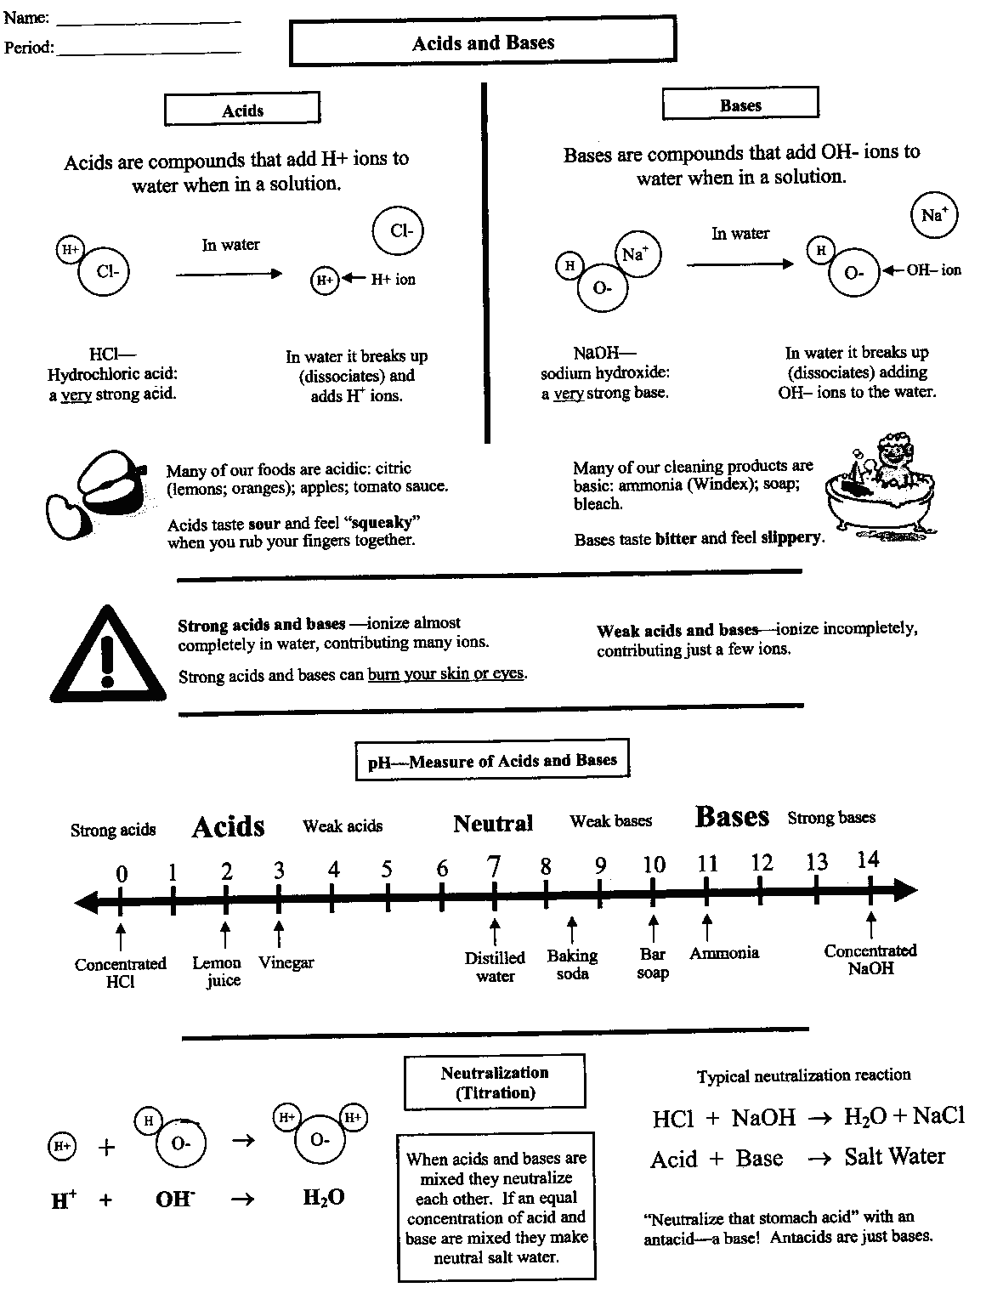

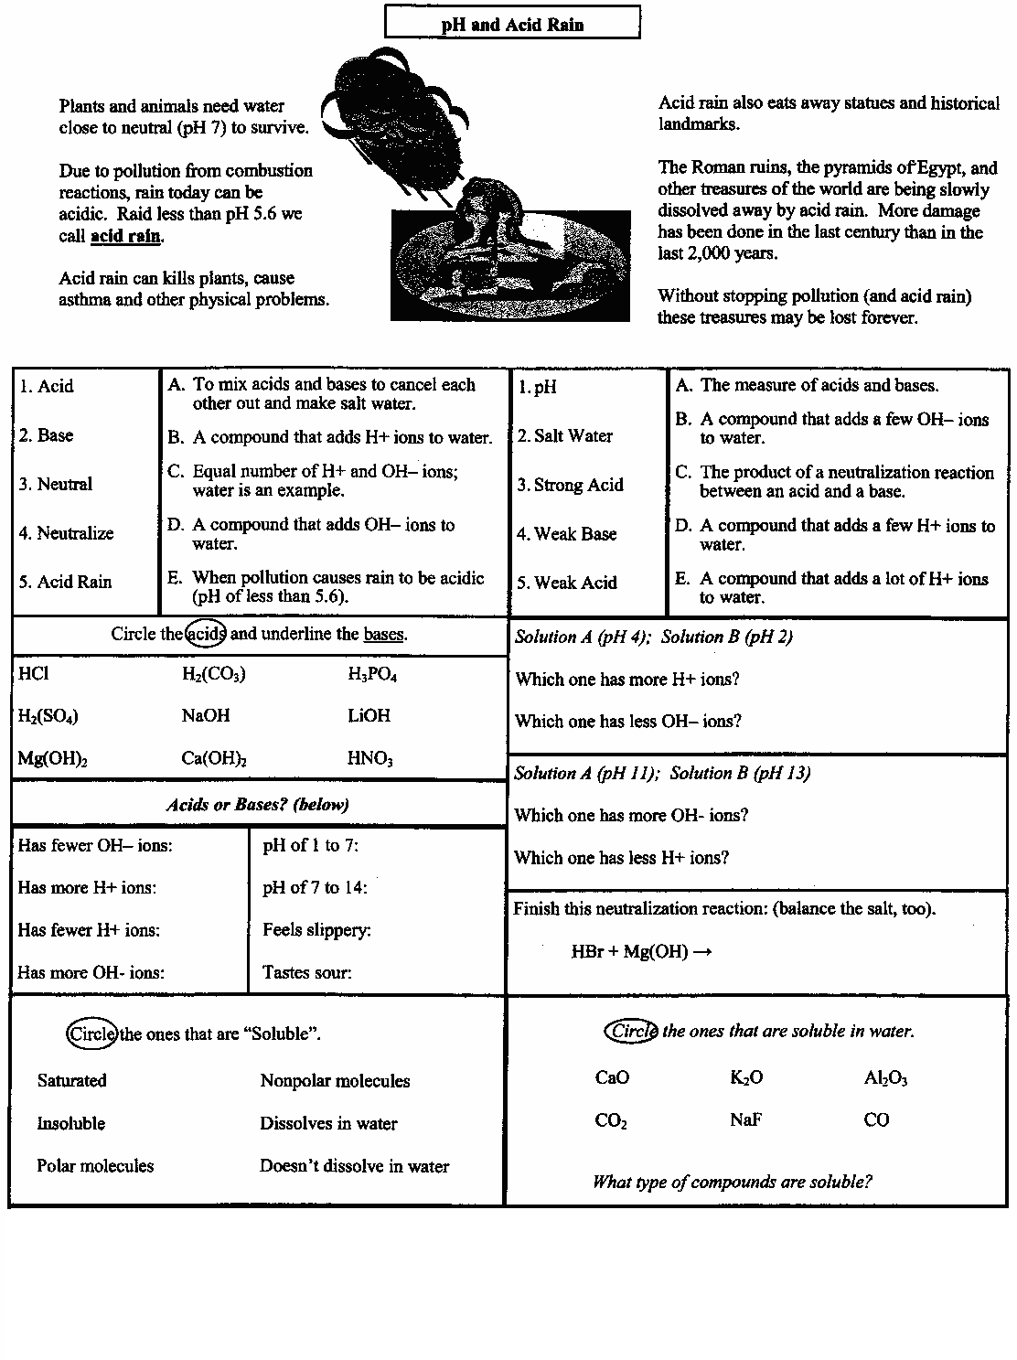

**Acids and Bases**

*Identify each item listed below as to whether it refers to an acid, a base, or both an acid and a base. Use the letters in the key.*

**KEY: A = acid B = base AB = acid and base**

_____ 1. sour taste _____ 12. is used in pickling

_____ 2. bitter taste _____ 13. forms through ionization

_____ 3. produces hydrogen ions in _____ 14. forms through dissociation

solution

_____ 4. is an electrolyte _____ 15. Compounds that produce this

in solution are made up of polar

molecules.

_____ 5. is slippery _____ 16. produces hydronium ions

_____ 6. is often corrosive _____ 17. most compounds that produce this

in solution are made up of polar

molecules

______ 7 exists as a crystalline solid in _____ 18. exists in aqueous solution

an undissolved state

______ 8. produces hydroxide ions in _____ 19. HCl is an example

solution

______ 9. can be detected with an indicator ______ 20. ammonia is a common example

______10. soaps are an example ______ 21. conducts electricity

______11 may be used to make fertilizer

*Complete the following. Write you answers on the lines provided.*

1. Use the information above to identify four properties that acids and bases have in common
2. Identify three characteristics of acids that are NOT true of bases.

24. Identify three characteristics of bases that acids do not have.

