Name: ___________________________________________
# correct
Total #?’s
GRADE

Energy
Transformations

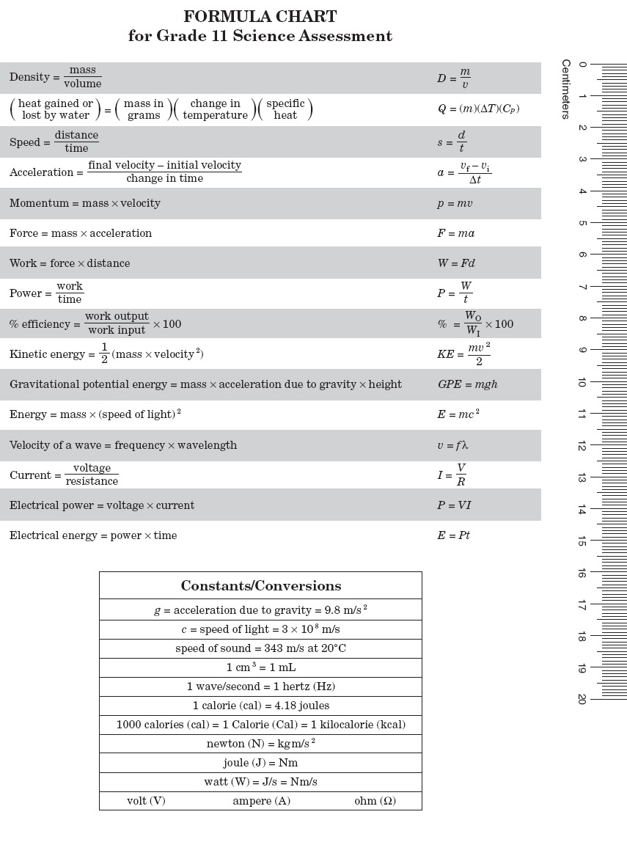
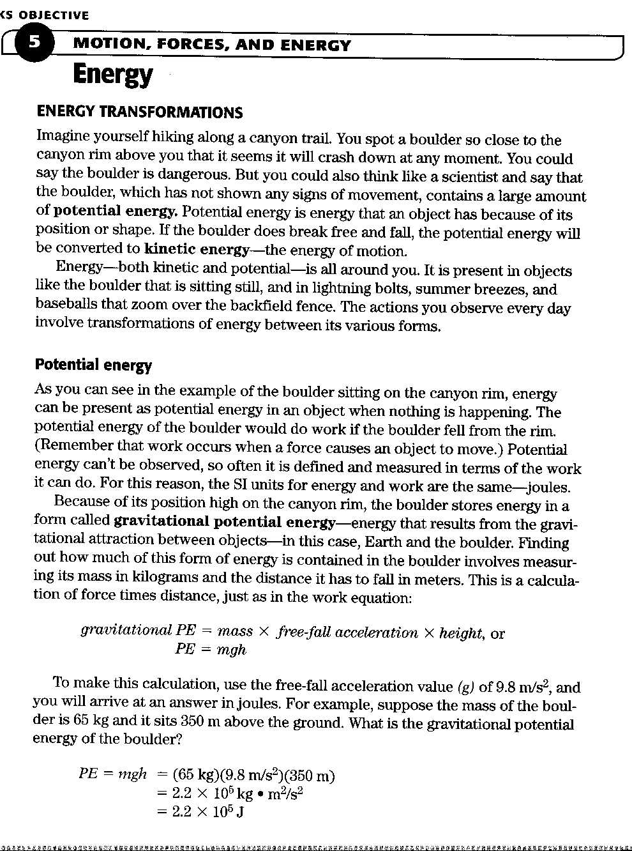
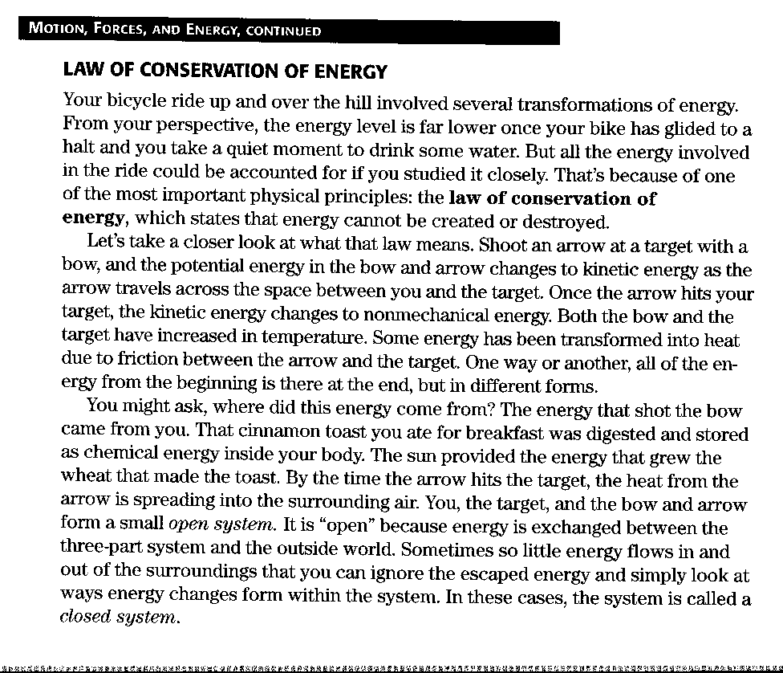
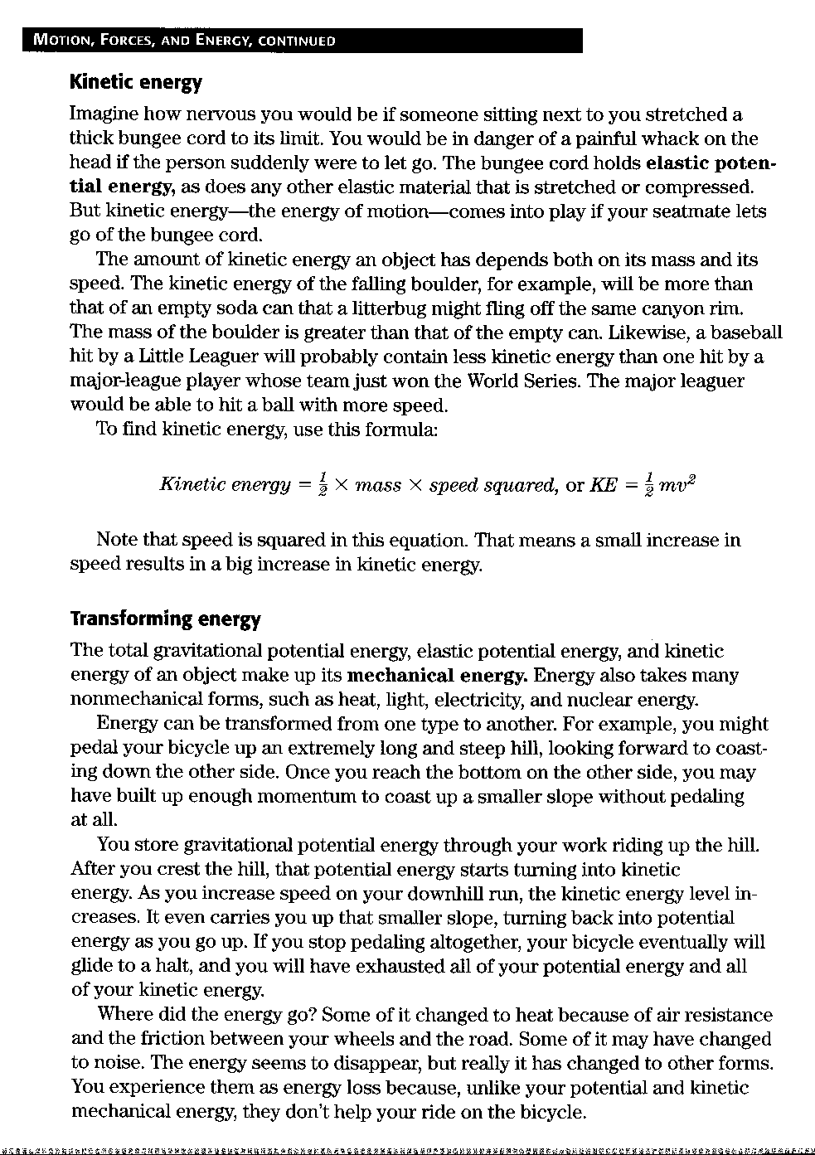

Energy Questions
Use the preceding reading pages to answer the following questions in complete sentences.

- What is potential energy?

- What is kinetic energy?

- What is the formula for gravitational potential energy?

- How does elastic potential energy come into play?

- What is the formula for kinetic energy?

- What is mechanical energy?

- Explain how energy changes form.

- State the law of conservation of energy.

- What is the difference between an open system and a closed system?
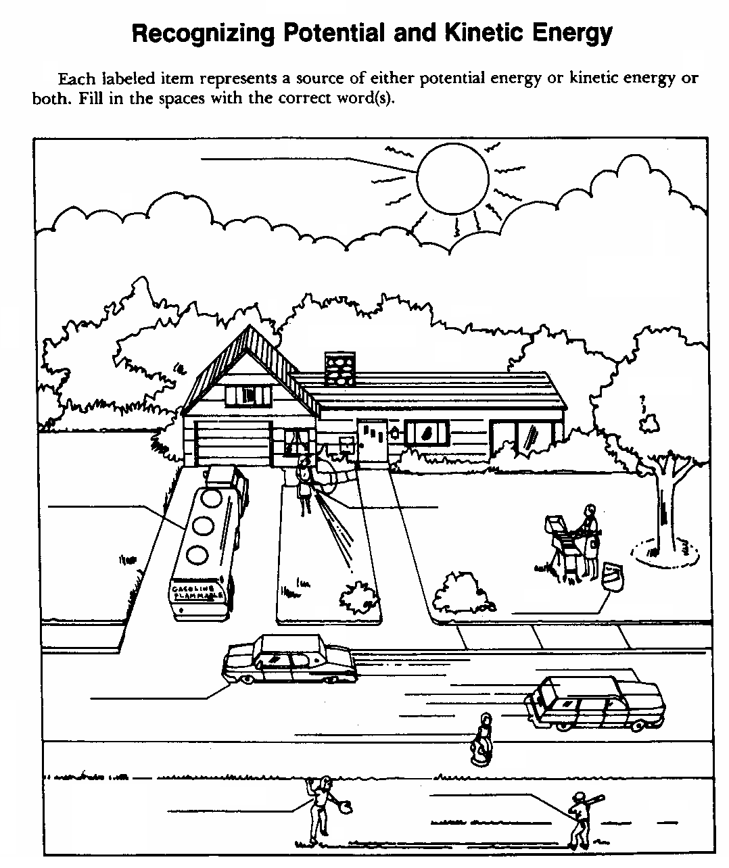

Potential and Kinetic Energy Math – I

Potential energy is stored energy due to position. Kinetic energy is energy that depends on mass and velocity (movement). Potential energy (PE) is mass x g x height or
PE = weight x height. PE is measured in units of Joules.

Formulas: | Abbreviations: | Units:
Potential energy = weight x height | PE = wh | Joule (J)
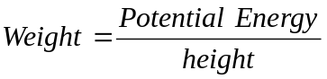 | 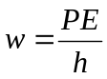 | Newtons (N)
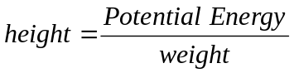 | 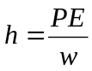 | Meter (m)

Kinetic Energy is energy that is dependent on mass and velocity. In a closed system, the sum of the potential energy and the kinetic energy is constant. As potential energy decreases, the kinetic energy increases.

Formulas: | Abbreviations: | Units:
Kinetic Energy = ½ mass x velocity² | KE = ½ m x v² | Joule (J)
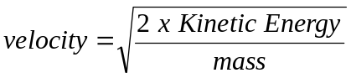 | 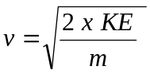 | Meters per second (m/s)
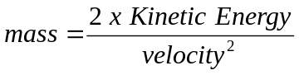 | 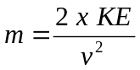 | Kilogram (kg)

NOTE: Whenever you are using the kinetic energy formula to find velocity you must take the square root of V² to find V (the last step of the formula).

- Calculate the kinetic energy in joules of a 1500 kg car moving at the speed of 29 m/s.
Formula and Work Set-Up

KE =

m =

v² =

v =

ans. ______________________

- Calculate the gravitational potential energy in a car with a mass of 1200 kg at the top of a 42 m high hill.
Formula and Work Set-Up

PE =

m =

g =

h =

ans. ______________________

- Calculate the GPE of a 65 kg climber on top of Mount Everest (8800 m high).
Formula and Work Set-Up

PE =

m =

g =

h =

ans. ______________________

- A 30 kg child has 190 J of kinetic energy after sledding down a hill. What is the child’s speed in meters per second at the bottom of the hill?
Formula and Work Set-Up

KE =

m =

v² =

v =

ans. ______________________
GPE and KE Math – II

Potential energy (PE) is stored energy due to position. Kinetic energy (KE) is energy that depends on mass and velocity (movement). Potential energy (PE) is PE = mass x g x height or PE = weight x height. PE is measured in units of Joules (J).

Formulas: | Abbreviations: | Units:
Potential energy = weight x height | PE = wh | Joule (J)
 |  | Newtons (N)
 |  | Meter (m)

Kinetic Energy is energy that is dependent on mass and velocity. In a closed system, the sum of the potential energy and the kinetic energy is constant. As potential energy decreases, the kinetic energy increases.

Formulas: | Abbreviations: | Units:
Kinetic Energy = ½ mass x velocity² | KE = ½ m x v² | Joule (J)
 |  | Meters per second (m/s)
 |  | Kilogram (kg)

NOTE: Whenever you are using the kinetic energy formula to find velocity you must take the square root of v² to find v (the last step of the formula).

- A rock has a mass of 50 kg and is 10 m off the ground. What is the GPE of the rock?
Formula and Work Set-Up

PE =

m =

g =

h =

ans. ______________________
2. The world record for pole vaulting is 6.15 m. If the pole vaulter’s GPE is 4942 J, what is his mass?
Formula and Work Set-Up

PE =

m =

g =

h =

ans. ______________________
3. A cheetah runs with a speed of 31 m/s. Suppose a cheetah with a mass of 47 kg runs at this speed. What is the cheetah’s kinetic energy?

Formula and Work Set-Up

KE =

m =

v² =

v =

ans. ______________________

4. A diver has 3400 J of GPE after stepping up onto a diving platform that is 6.0 m above the water. What is the divers mass in kilograms?

Formula and Work Set-Up

PE =

m =

g =

h =

ans. ______________________

5. A 35 kg child has 190 J of kinetic energy after sledding down a hill. What is the child’s velocity in meters per second at the bottom of the hill? (take the square root of v²).
Formula and Work Set-Up

KE =

m =

v² =

v =

ans. ______________________

6. A cat sits on the top of a fence that is 2.0 m high. The cat has a gravitational potential energy of 88.9 J. What is the mass of the cat?
Formula and Work Set-Up

PE =

m =

g =

h =

ans. ______________________

7. A tennis ball with a mass of 51 g has a velocity of 9.7 m/s upward. What is the kinetic energy of the ball? (Note: you must convert g to kg before solving).

Formula and Work Set-Up

KE =

m=

v² =

v =

ans. ______________________

Potential and Kinetic Energy-III

Potential energy is stored energy due to position. Kinetic energy is energy that depends on mass and velocity (movement). Here is a review of the formulas:

Formulas: | Abbreviations: |  |  | Units:
Potential energy = weight x height | PE = wh |  |  | Joule (J)
Kinetic Energy = ½ mass x velocity² |  | KE = ½ m x v² | Joule (J)

Here is a review of the units used for the physics terms:

Physics Term | Units used to Measure the Term | Abbreviation of Units
Energy (any type) | Joules | J
Weight | Newtons | N
Height | meters | m
Mass | kilograms | kg
Velocity | meters per second | m/s

For a closed system, the sum of the potential energy and the kinetic energy is a constant. If the potential energy decreases, the kinetic energy increases. Also, if kinetic energy decreases, the potential energy increases.

Solve the following problems:

- What is the potential energy of a rock that weighs 100 newtons that is sitting on top of a hill 300 meters high?

Ans: __________________________
- What is the kinetic energy of a bicycle with a mass of 14 kg traveling at a velocity of 3 m/s?

Ans: __________________________
- A flower pot weighing 3 newtons is sitting on a windowsill 30 meters from the ground. Is the energy of the flower pot potential or kinetic? How many joules is this?

Ans: __________________________

- When the flower pot in Problem 3 is only 10 meters from the ground, what is the potential energy?

Ans: __________________________

- How much of the total energy in Problem 3 and 4 has been transformed to kinetic energy as the pot hits the ground?

Ans: __________________________

- A 1200 kg automobile is traveling at a velocity of 100 m/s. Is it energy potential or kinetic? How much energy does it possess?

Ans: __________________________
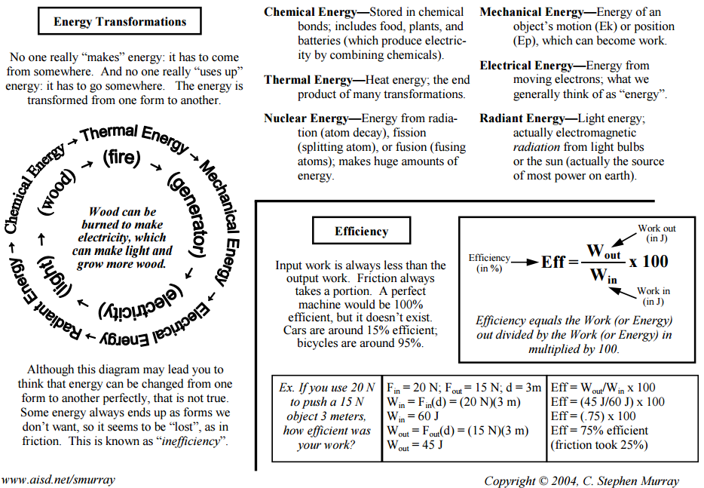
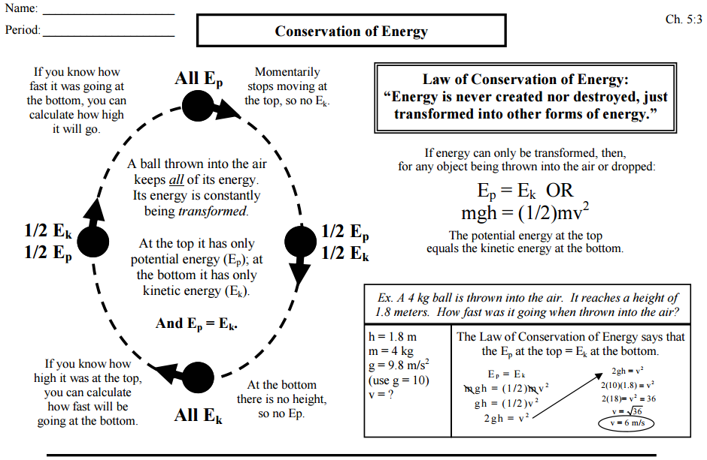
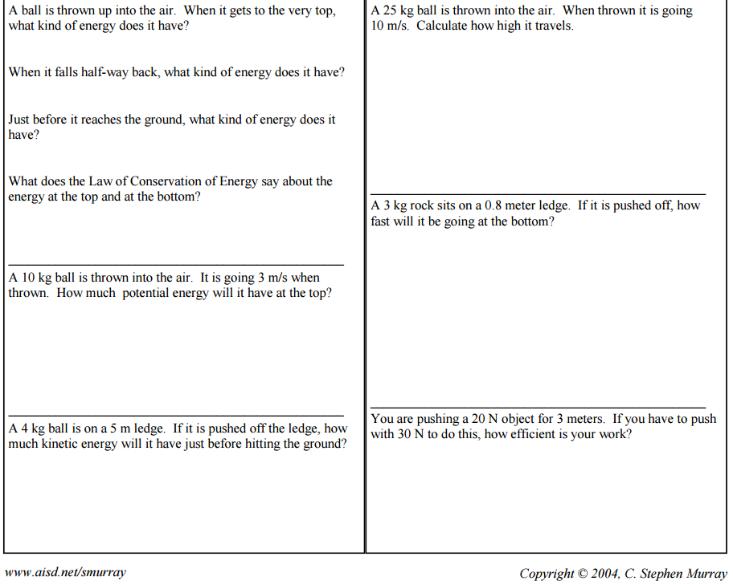
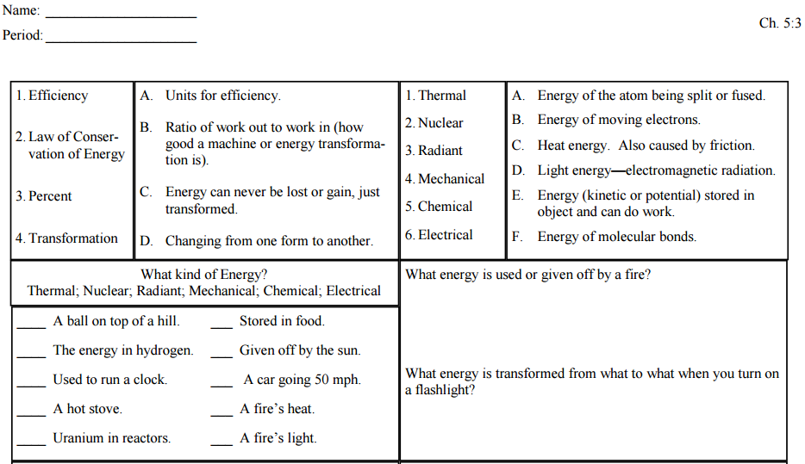
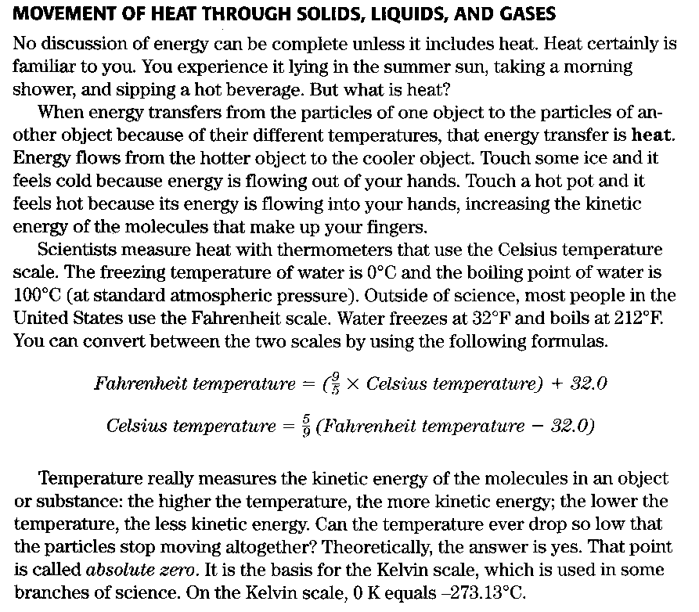

- What is Heat?

- How does Energy flow?

- What does temperature measure?
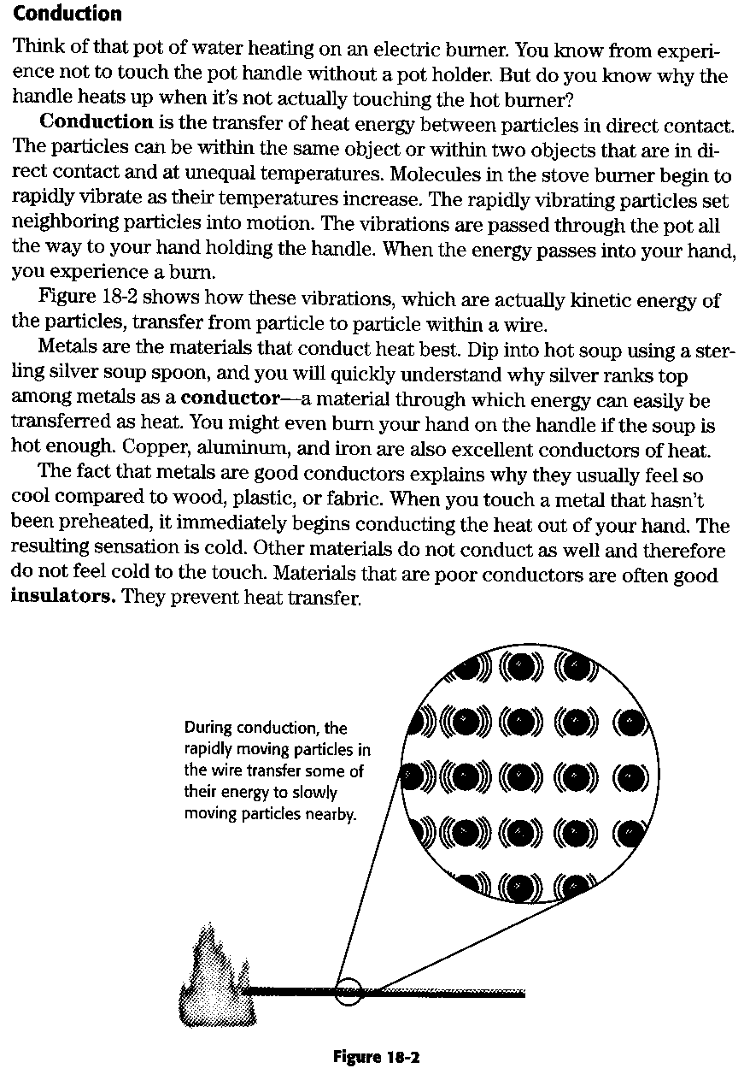
Conduction Reading Questions

Using the preceding reading on conduction, answer the following questions in complete sentences.

- What is conduction?

- Under what conditions does conduction occur?

- Why does metal feel cool to the touch?

- What is an insulator?
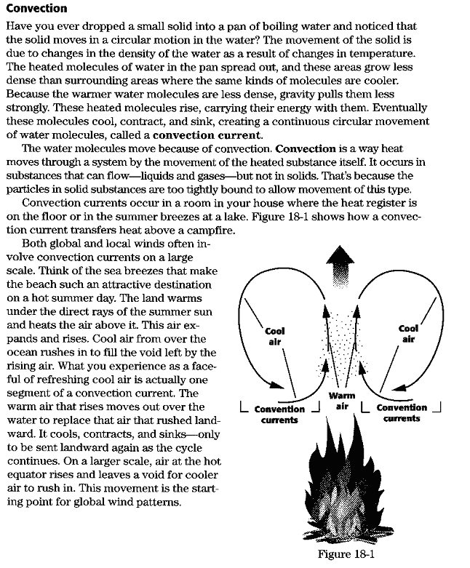

Convection Questions

Using the preceding reading, answer the following questions in complete sentences.

- What is convection?

- Explain how convection currents work?

- How do convection currents keep Baytown cooler in the summer and warmer in the winter?

- Draw and label figure 18-1

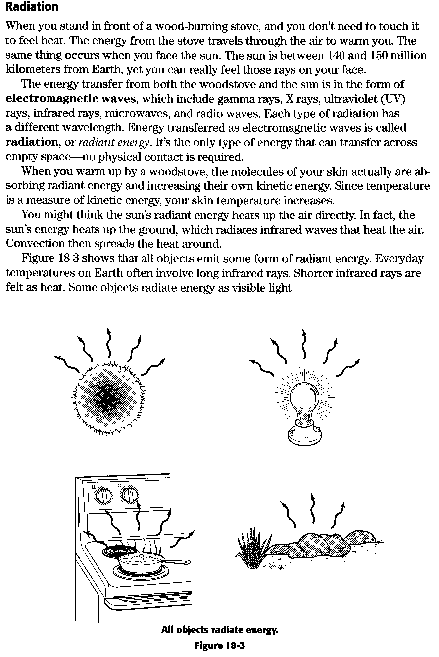
Radiation

Using the preceding reading, answer the following questions in complete sentences.

- What is radiant energy?

- What is a unique characteristic of radiant energy?

- How does radiant energy heat the air?

- Give four examples of radiant energy.

Comparing Insulating Materials

A student is conducting an experiment with three different materials to determine which material is the best insulator. The student fills a baker with 250 mL of boiling water. Then she wraps a 2 cm thick layer of Insulator A around the beaker. The student measures and records the temperature of the water every 30 minutes over a period of 2 hours. She repeats this procedure with two other insulating materials, Insulator B and Insulator C. The date obtained by the student is shown in the data table. Use these data to answer the questions that follow.

Time (min) | Water Temperature ( °C)
 | Insulator A | Insulator B | Insulator C
0 | 100 | 100 | 100
30 | 88 | 96 | 92
60 | 75 | 93 | 85
90 | 63 | 88 | 76
120 | 50 | 85 | 68

  - Plot the data on a graph. Plot time in minutes on the horizontal axis and water temperature in degrees Celsius on the vertical axis. Use different colored pencils to connect the data points for each insulator.

  - Which material would make the best insulator? Explain your answer.

  - Why is a good insulator important for conserving energy in homes during the winter? During the summer?
Title: _______________________________________________________________


The Best Thermos Bottle

The following experiment was performed with four thermos bottles to determine which bottle would make the best thermos bottle.

Bottle A: Silvered, evacuated
Bottle B: Silvered, not evacuated
Bottle C: Not Silvered, evacuated
Bottle D: Not Silvered, not evacuated

Each bottle was filled with boiling water and the temperature of each bottle was taken every 10 minutes at first and later at 20 to 30 minute intervals. The data obtained are shown in the data table below.

Time (min) | Temperature (°C)
0  10  20  30  40  60  90  120  150 | Bottle A | Bottle B | Bottle C | Bottle D
0  10  20  30  40  60  90  120  150 | 100  100  99  99  98  97  96  95  64 | 100  99  95  91  88  83  74  67  61 | 100  97  94  91  88  82  75  68  65 | 100  95  91  86  83  75  67  60  56

- Plot the data on a graph using Time (min) as the horizontal axis and Drop in Temperature (°C) as the vertical axis. Choose the scale of the vertical axis carefully as it represents the drop in temperature for a given time. Use different colored pencils or different symbols to draw the curves for each thermos bottle.

- Which bottle would make the best thermos bottle? Why?

- Which bottle would be least effective as a thermos bottle? Why?

- Which of the two properties tested is the; more important in making a good thermos bottle? Explain your answer.
Review: Heat - A Form of Energy

Key Concepts

Heat is a form of energy caused Heat energy is transferred by
By the internal motion of conduction, convection, and
Molecules of matter. Radiation.

Part I Building Vocabulary Skills

Decide which of the following statements correctly describes heat. If the statement describes heat correctly, write H before the number. If the statement does not describe heat correctly, write N.

_____ 1. Heat is an invisible, weightless fluid.

_____ 2. Heat is a substance called caloric.

_____ 3. Heat is made up of molecules.

_____ 4. Heat moves from a warmer object to a colder object.

_____ 5. Heat can be transferred in only one way.

_____ 6. Heat is a form of energy.

_____ 7. Heat is caused by the internal motion of molecules of matter.

_____ 8. Motion produces heat.

_____ 9. Cold molecules move faster than warm molecules.

_____10. The hotter a substance is, the less energy its molecules have.
Part 2

Decide which of the following materials are conductors and which are insulators. If the material is a conductor, write C before the number. If the material is an insulator, write I.

______1. air

_____ 2. copper wire

_____ 3. rubber

_____ 4. glass

_____ 5. aluminum

_____ 6. silver

_____ 7. iron

_____ 8. wood

_____ 9. plastic

_____10. down

Heat Transfer: Understanding the Main Ideas

Identify the forms of heat transfer that take place in each illustration. Some illustrations may show more than one form of heat transfer.

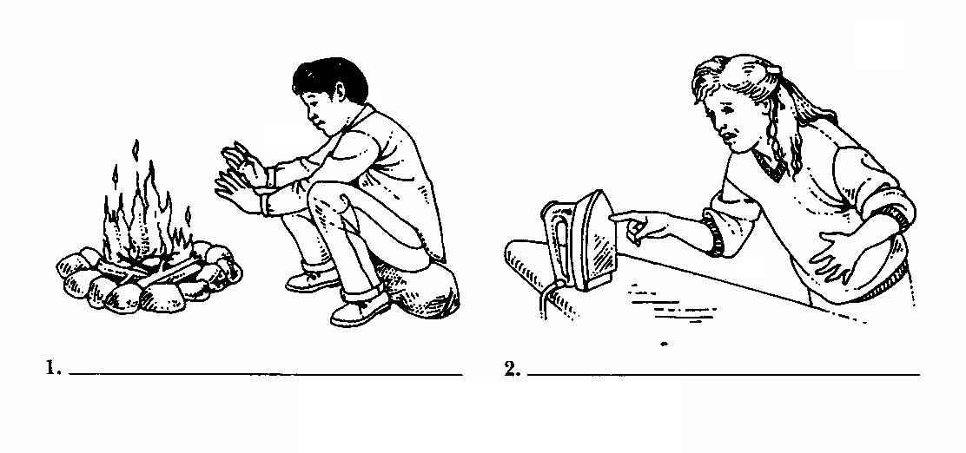

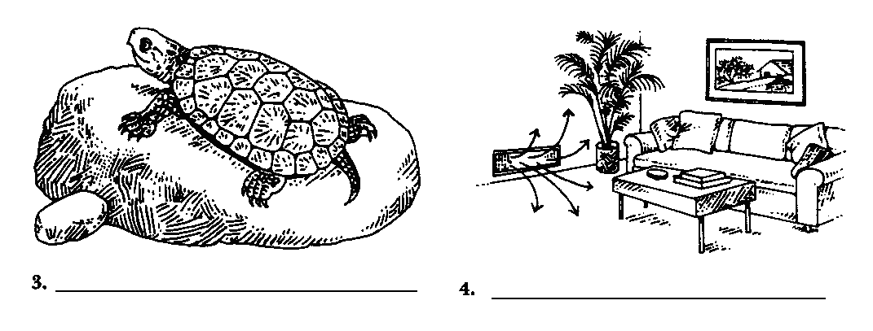
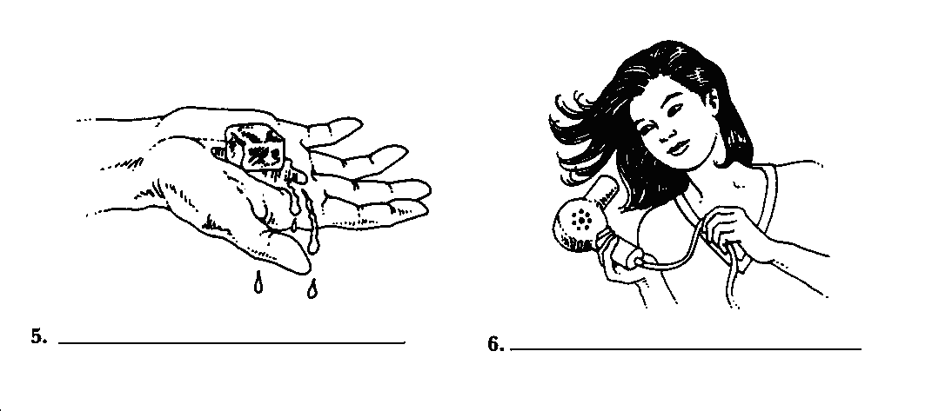
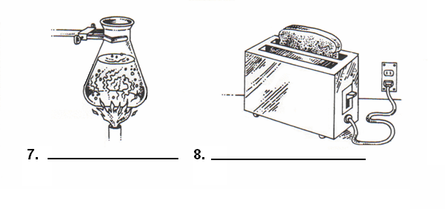

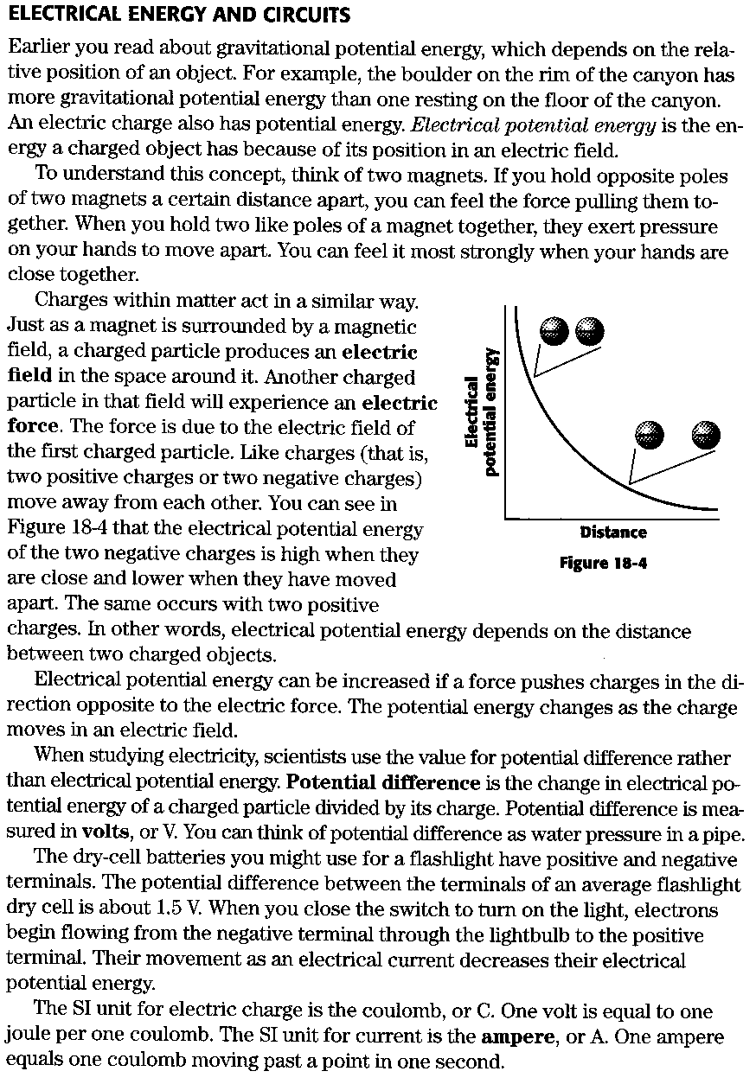
Electrical Energy and Circuits Questions

Answer the following questions in compete sentences.

- What is electrical potential energy?

- How do electric charged particles react?

- What is potential difference?

- How does current flow threw a flashlight?

- What are the SI units for electric charge and current?

Electric Charge and Force

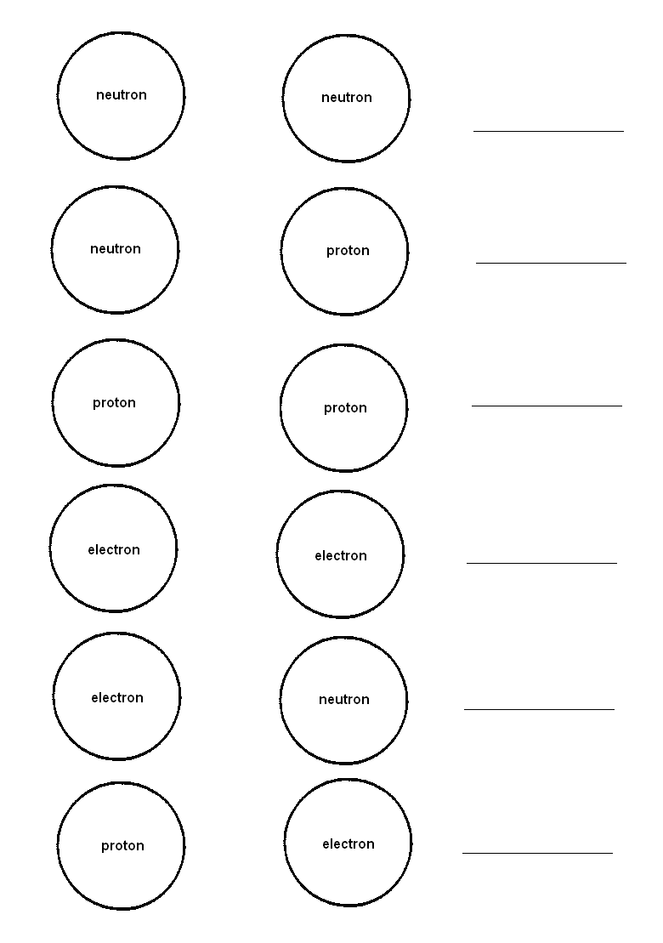
Describe what happens between these pairs of subatomic particles using the terms “attraction”, “repulsion,” or “nothing”. Place the correct term on the line provided next to each figure.
Make a drawing to show what will happen when each pair of particles comes together. Remember that is some cases, nothing may happen.

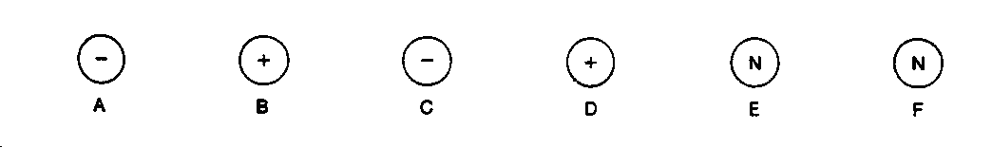

1. A and C 2. B and E

3. C and D 4. A and D

5. E and F 6 B and D

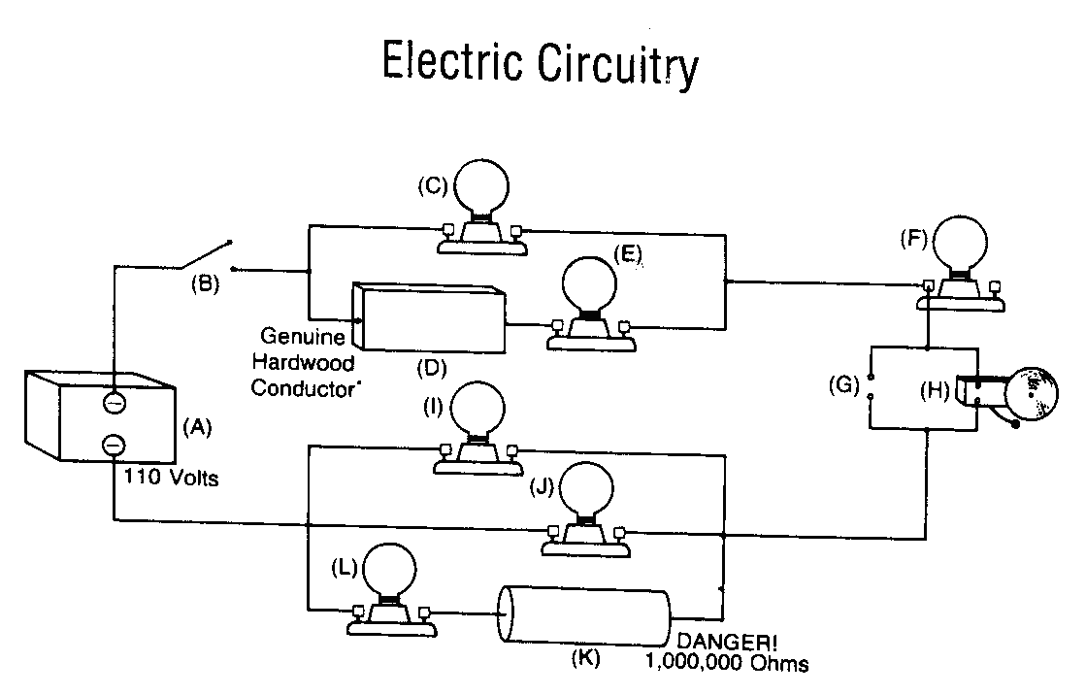

- Five parts of this circuit are not correct. Identify these parts by their letter and explain why they are incorrect.

- Change (A) so that the voltage source will work.

- What must be done to complete the circuit?

For questions 4-8, assume that the electric circuit is complete

- Which lamps will be lit?

- Will electric bell (H) ring?

- Will lamp (C) remain lit if lamp (E) is removed?

- Will lamp (I) be lit if lamp (C) is removed?

- Will lamp (C) be lit if lamp (I) is removed?

- Are lamps (I), (J), and (L) arranged in series or parallel?

- How are lamps (C), (F), and electric bell (H) arranged?

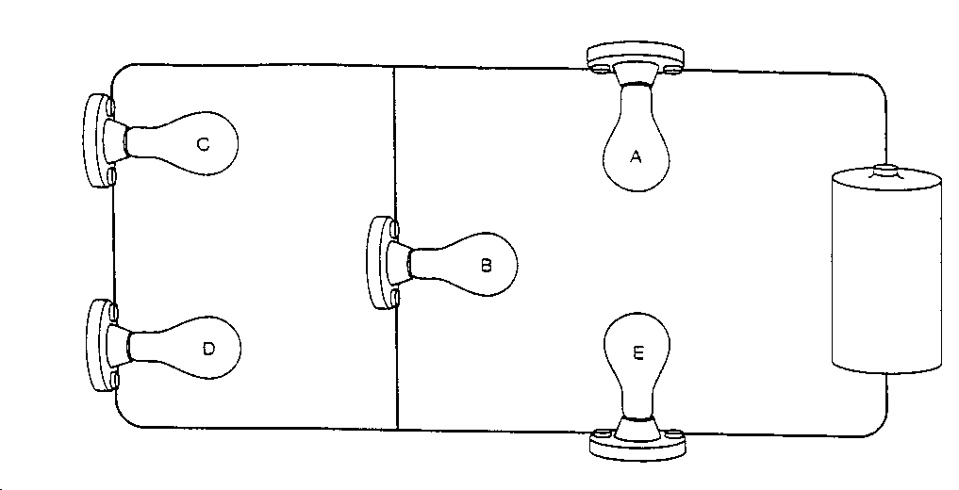
- According to the diagram, which bulbs will continue to light if

  - A blows out? ________________________________________________

  - B blows out? ________________________________________________

  - C blows out? ________________________________________________

  - D blows out? ________________________________________________

  - E blows out? ________________________________________________
- An object with a resistance of 15 ohms has a voltage of 45 volts applied to it:

  - How much electric current is going through this object?

_______________________________________________________________

  - How much power is being produced by the object?

_______________________________________________________________

  - How much electric energy will be needed to operate this object for 10 hours? ____________________________________________________________

  - What is the cost of operating this object for 10 hours at a rate of 8 cents per kilowatt-hour? ____________________________________________

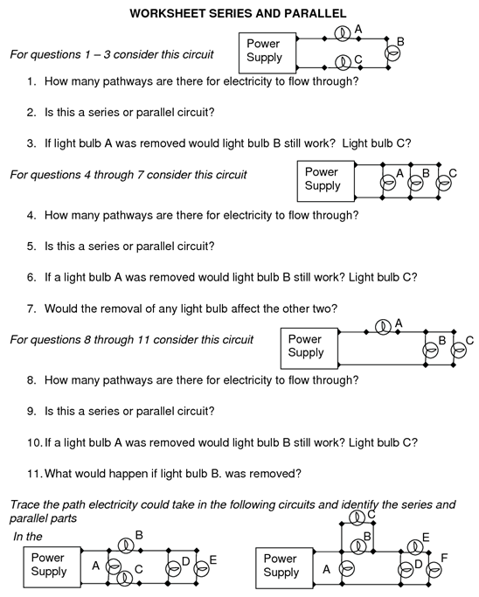
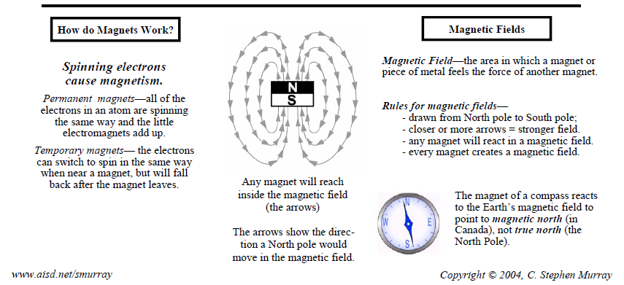
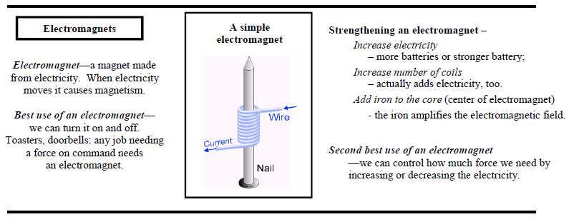
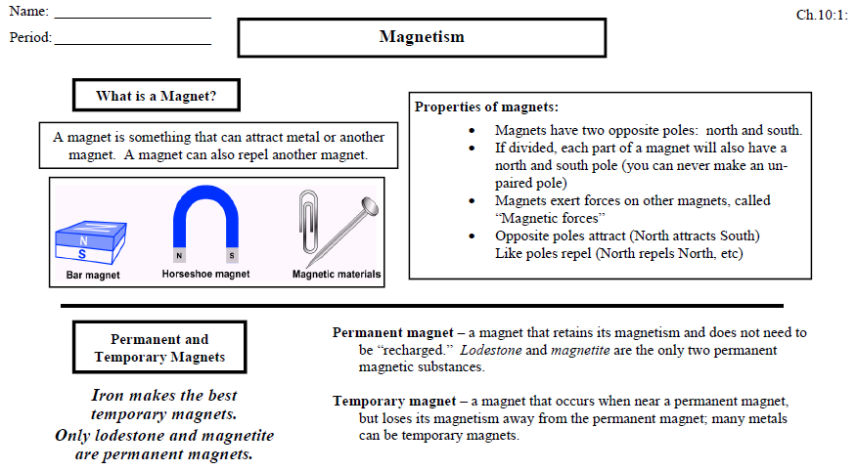
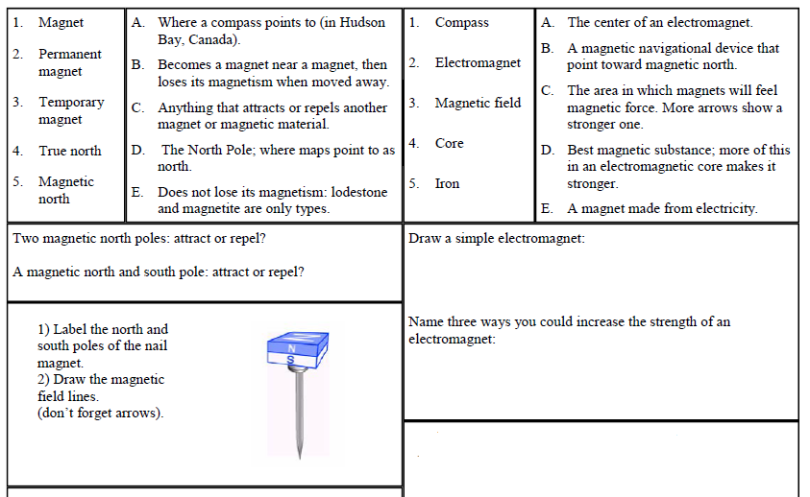

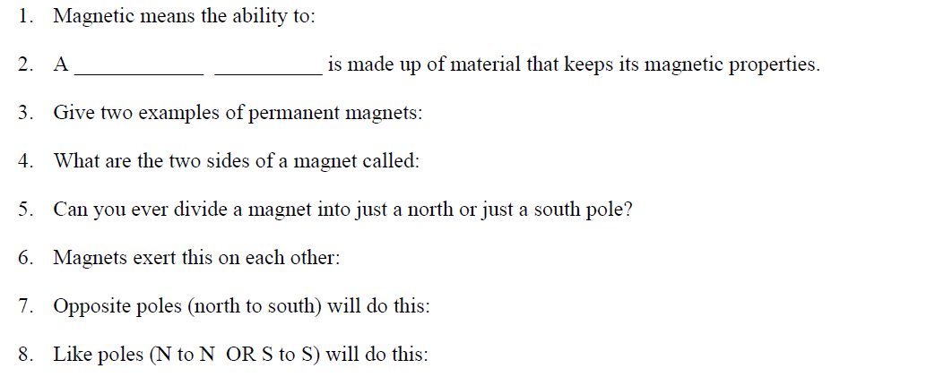

Electricity ↔ Magnetism

Electricity Creates Magnetism

Use the graph grid provided to plot the data on the chart below. Label the horizontal axis “Number of coils of wire” and the vertical axis “Number of paper clips picked up.”

Electromagnet | Number of paper clips Picked UP
A-10 coils | 3
B-20 coils | 6
C-30 coils | 10
D-40 coils | 13
E-50 coils | 17

Inducing a Current

Answer the following questions based on the accompanying diagram.

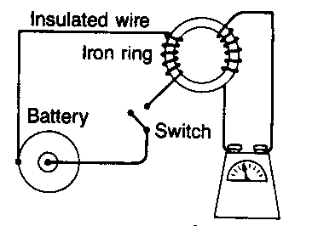

- When the switch is first closed, what happens to the galvanometer needle?

- When the switch is opened, is the galvanometer needle deflected in the same direction?

- If the connections on the dry cell are reversed, how would this affect the direction of swing of the galvanometer needle?

- What happens to the galvanometer needle when the switch remains in the same position for several minutes? Why?

Magnetic Resonance Imaging

Read the following paragraphs, and complete the exercises below.

Doctors who want information about a patient’s bones and joints, spine, or soft tissues of the central nervous system, including the brain, often order a magnetic resonance imaging (MRI) procedure. MRI uses computer technology, magnetic fields, and radio waves to create an image of any part of the body. It is painless and does not require instruments to enter the body.
MRI is possible because the magnetic behavior of hydrogen atoms, which are abundant in the body. During the MRI procedure, a strong magnetic field is applied to the patient’s body. The hydrogen atoms within the body respond to the magnetic field by partly lining up with the field. Next, radio waves are directed at the atoms, causing some of the atoms to flip over briefly. As the atoms flip back they give off radio waves. A sensitive receiver picks up the radio waves, and a computer translates them into three-dimensional map of the patient’s body.
Today’s MRI machines produce images with enough details to show the patient’s body. The computer is able to show these images as across section of any part of the body from any angle. The ability makes MRI even form powerful as a tool in medicine.

Exercises

- What is the purpose of MRI?

- What causes the hydrogen atoms to line up?

- What action produces the radio waves that result in an MRI image?

- An MRI instrument cannot be used on people with pacemakers, metal artificial joints, or other metal implants. Explain why an MRI scan could be dangerous for such a person.
Transformers

Draw in the correct number of turns in the missing coil based on the voltage given. Then identify the type of transformer using the following terms: step-up transformers, step-down transformers, 1 to 1 transformer.

- ___________________________ 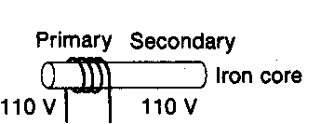

- __________________________ 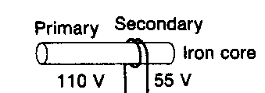

- ____________________________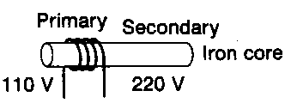

The diagram below shows a transformer. Use the diagram to answer the questions that follow.

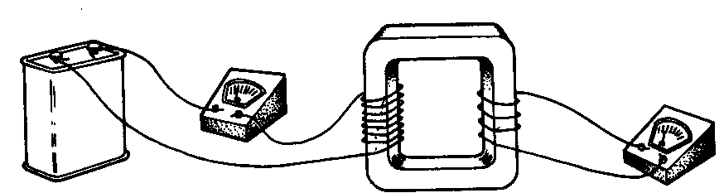

- What type of transformer is shown?

