# correct
Total #?’s
GRADE
Name:________________________________________

Physical & Chemical changes
Chemical Bonding
Balancing Equations

Unit 3
Student Manual

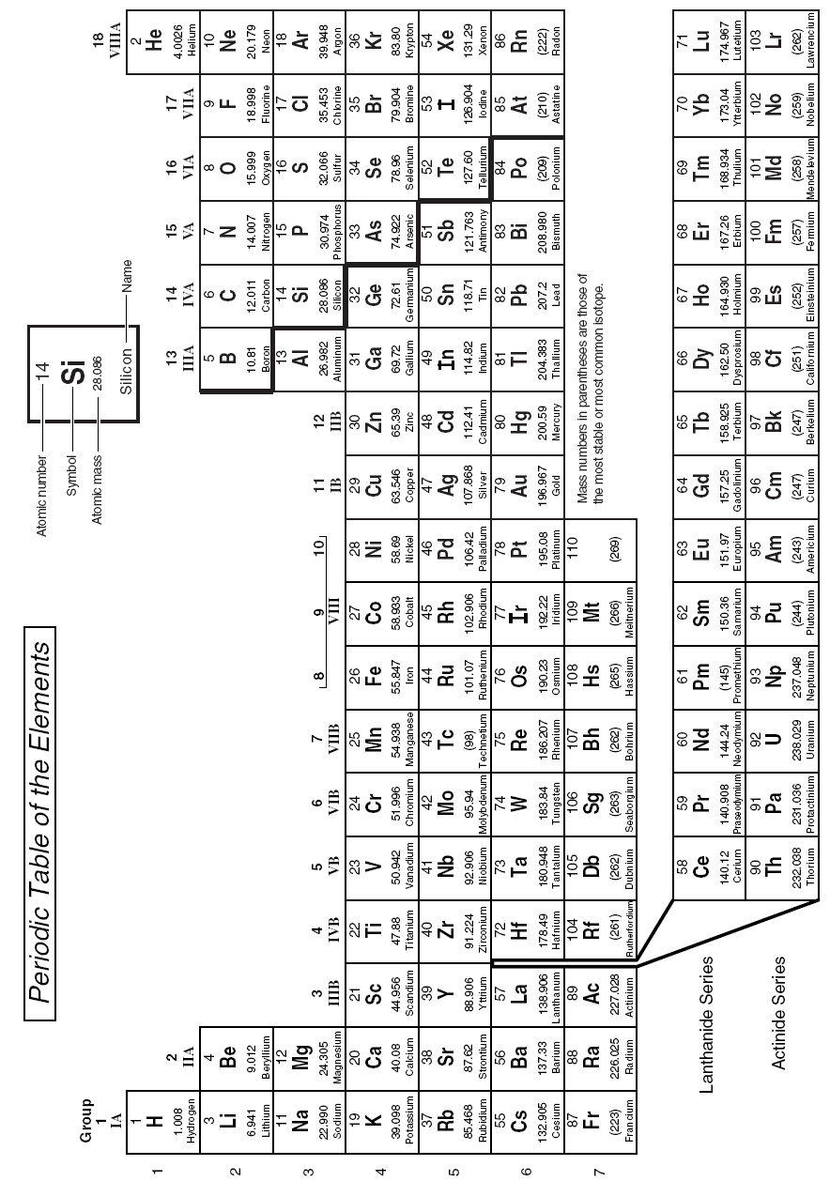

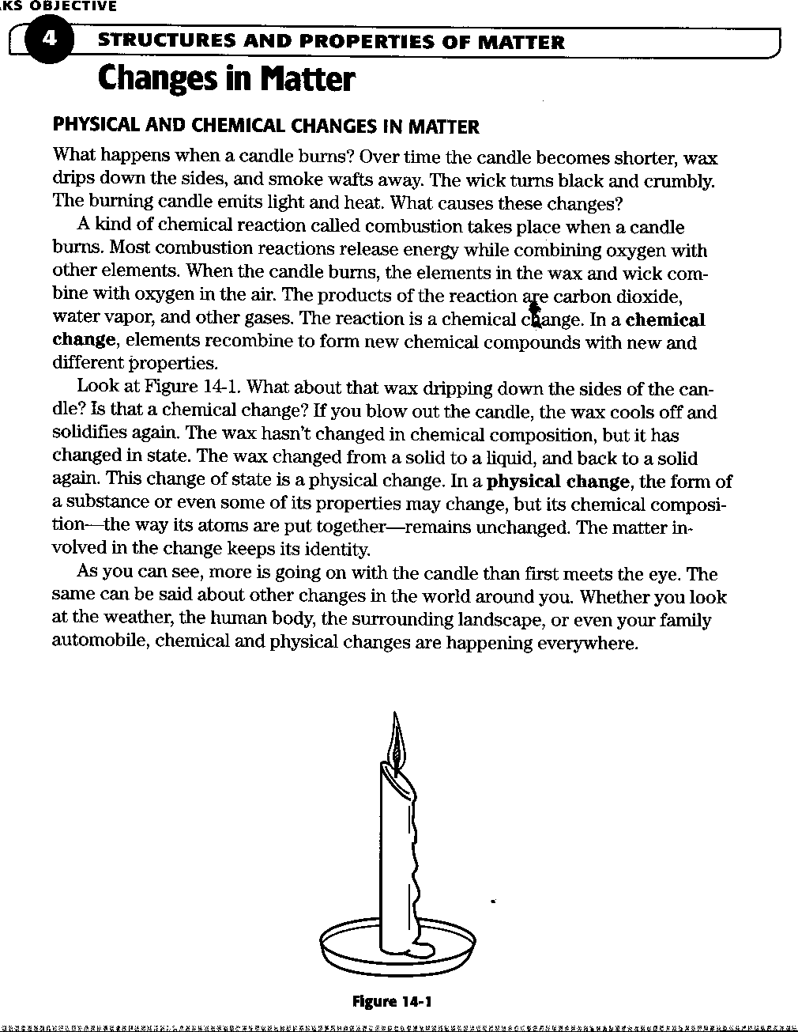
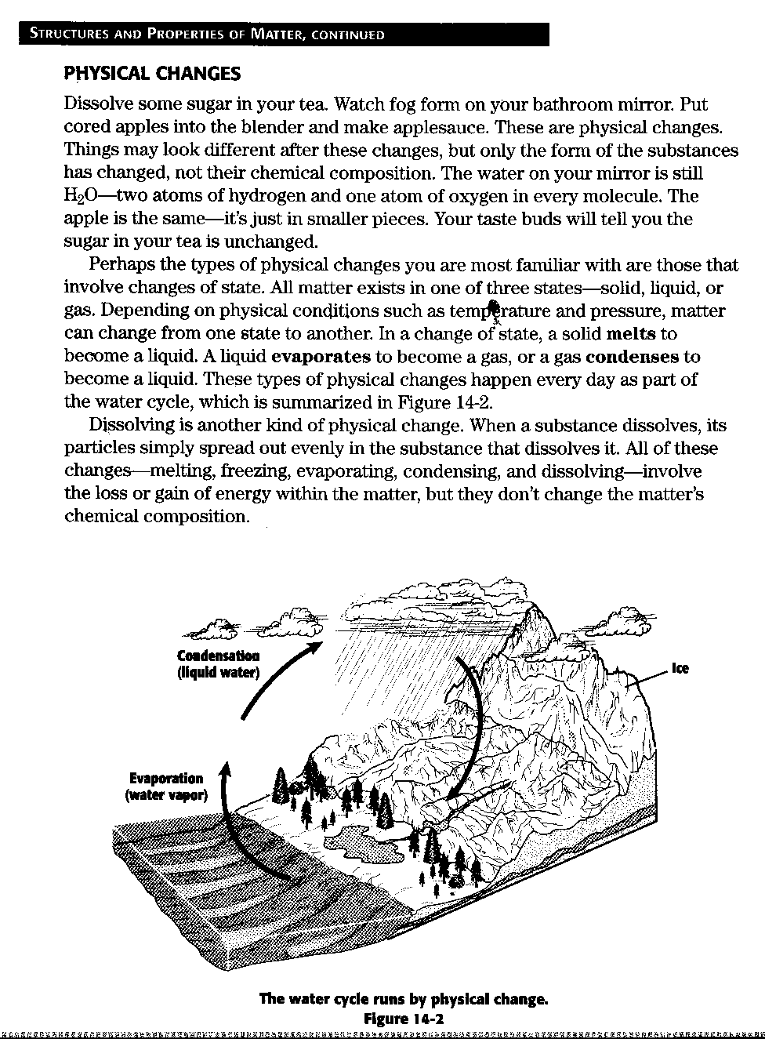

Physical and Chemical Changes in Matter Questions

Read the preceding pages and answer the questions in complete sentences

- What products are produced when burning a candle?

- What happens when a chemical changes takes place?

- Compare a chemical change and a physical change.

- Where do chemical changes occur?

- What is dissolving?

- What does physical changes involve?
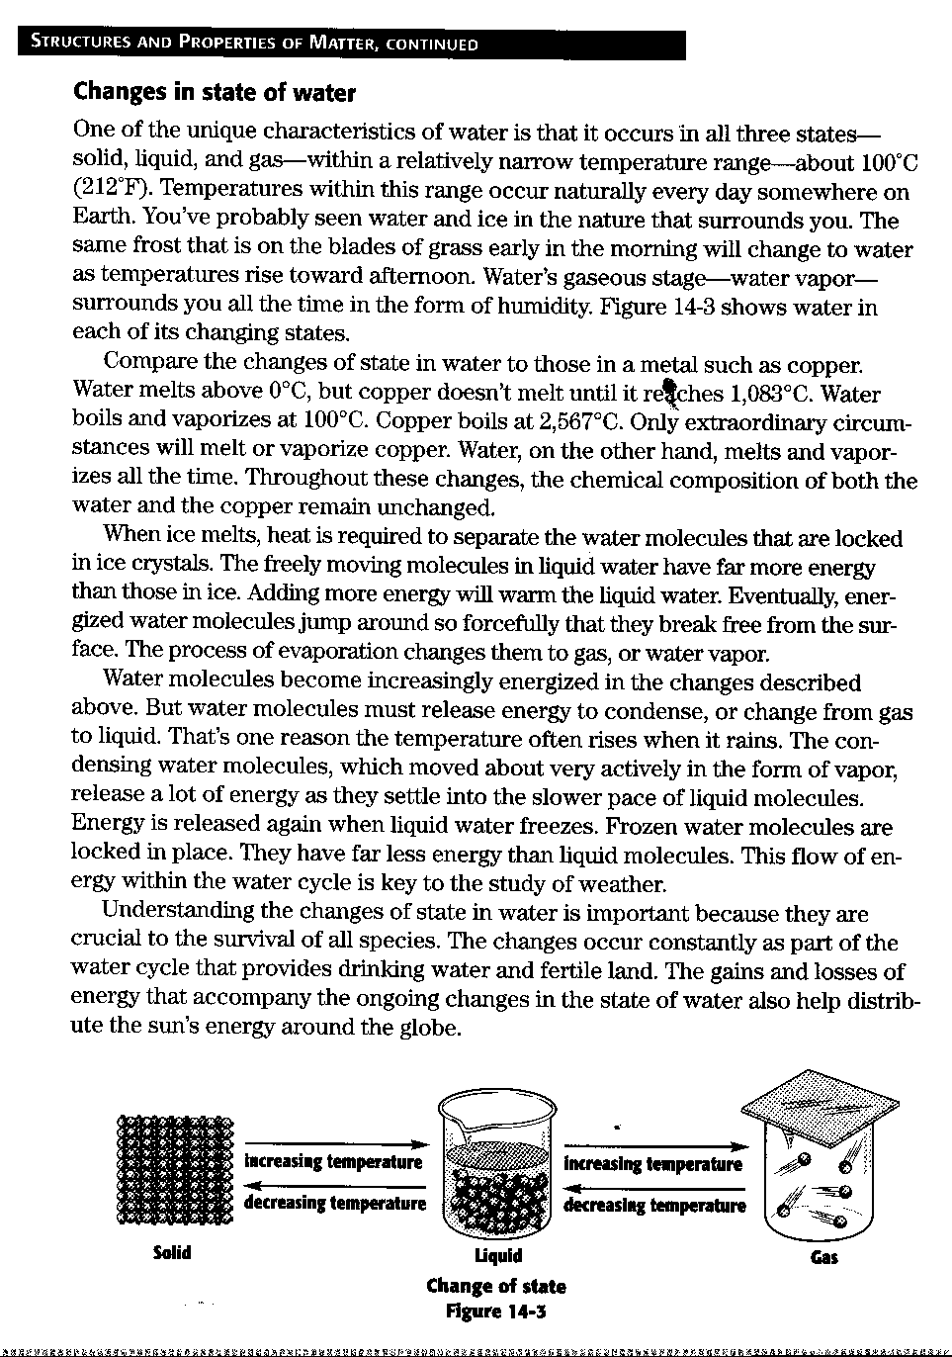

Changes in State of Water

Read the preceding page and answer the following questions in complete sentences

- What do we call water in each of its states?

- At what temperature does water change from one state to another?

- How does ice change to steam?

- What role does energy lay in water changing its state?

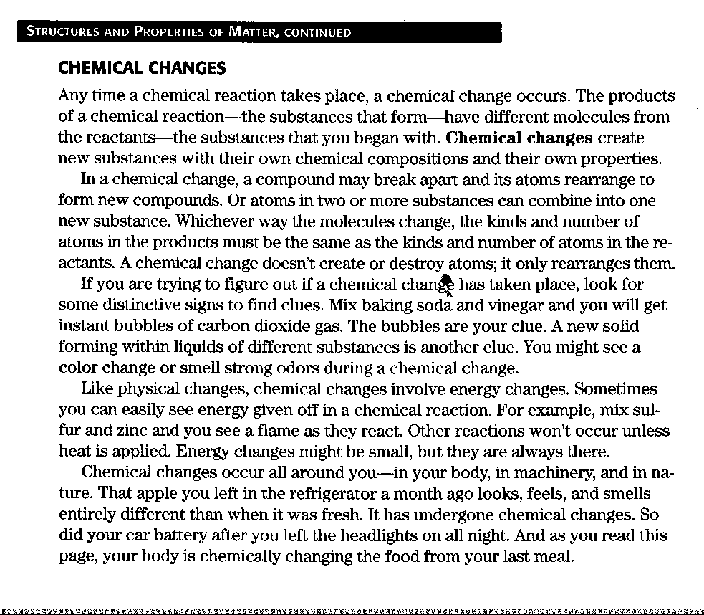

- What is a chemical change?

- What happens in a chemical change?

- What are some indicators that a chemical change is taking place?

- What role does energy play in a chemical change?

Reactions of Matter

Decide whether the changes listed below are chemical or physical. Write your answer in the blank provided.

_______________________________ Dissolving sugar in coffee

_______________________________ Burning coal

_______________________________ Mining coal

_______________________________ Boiling an egg

_______________________________ Boiling water

_______________________________ Heating an iron nail

_______________________________ Adding food coloring to water

_______________________________ Dipping blue litmus paper in lemon juice

_______________________________ Dissolving carbon dioxide in water

_______________________________ Adding vinegar to baking soda to form CO₂

_______________________________ Mixing salt and pepper

_______________________________ Mixing lye and hydrochloric acid

_______________________________ Melting a nail

_______________________________ Letting a nail rust

Study the two drawings and label them either physical or chemical change

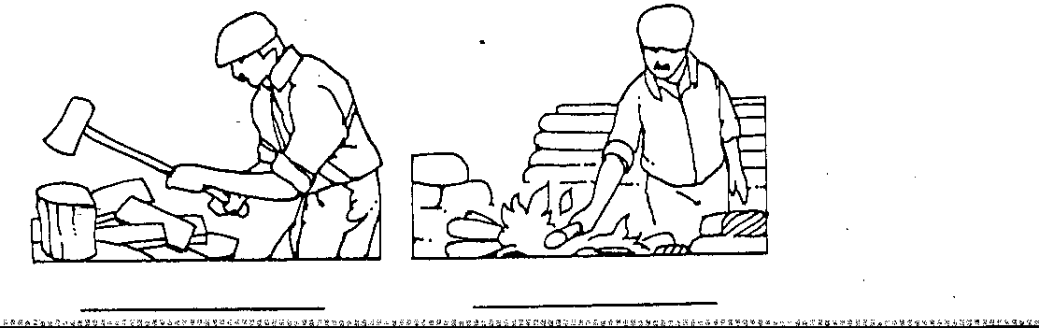
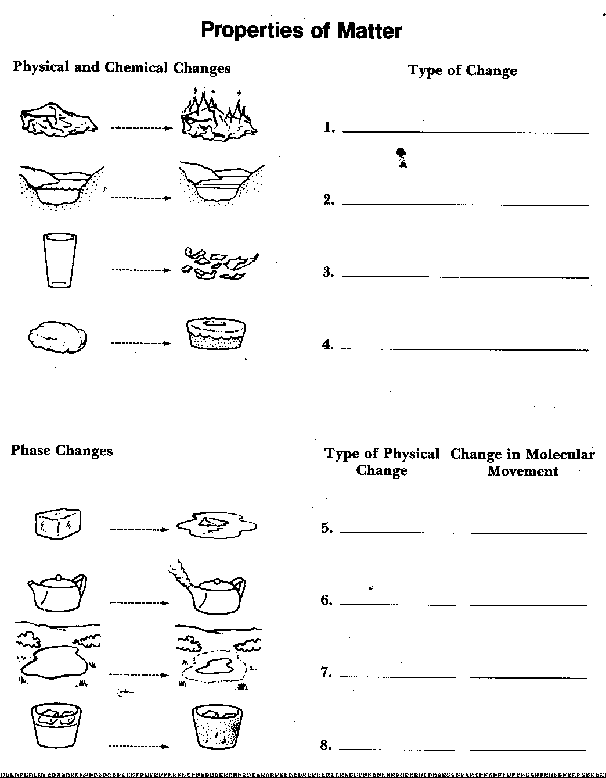
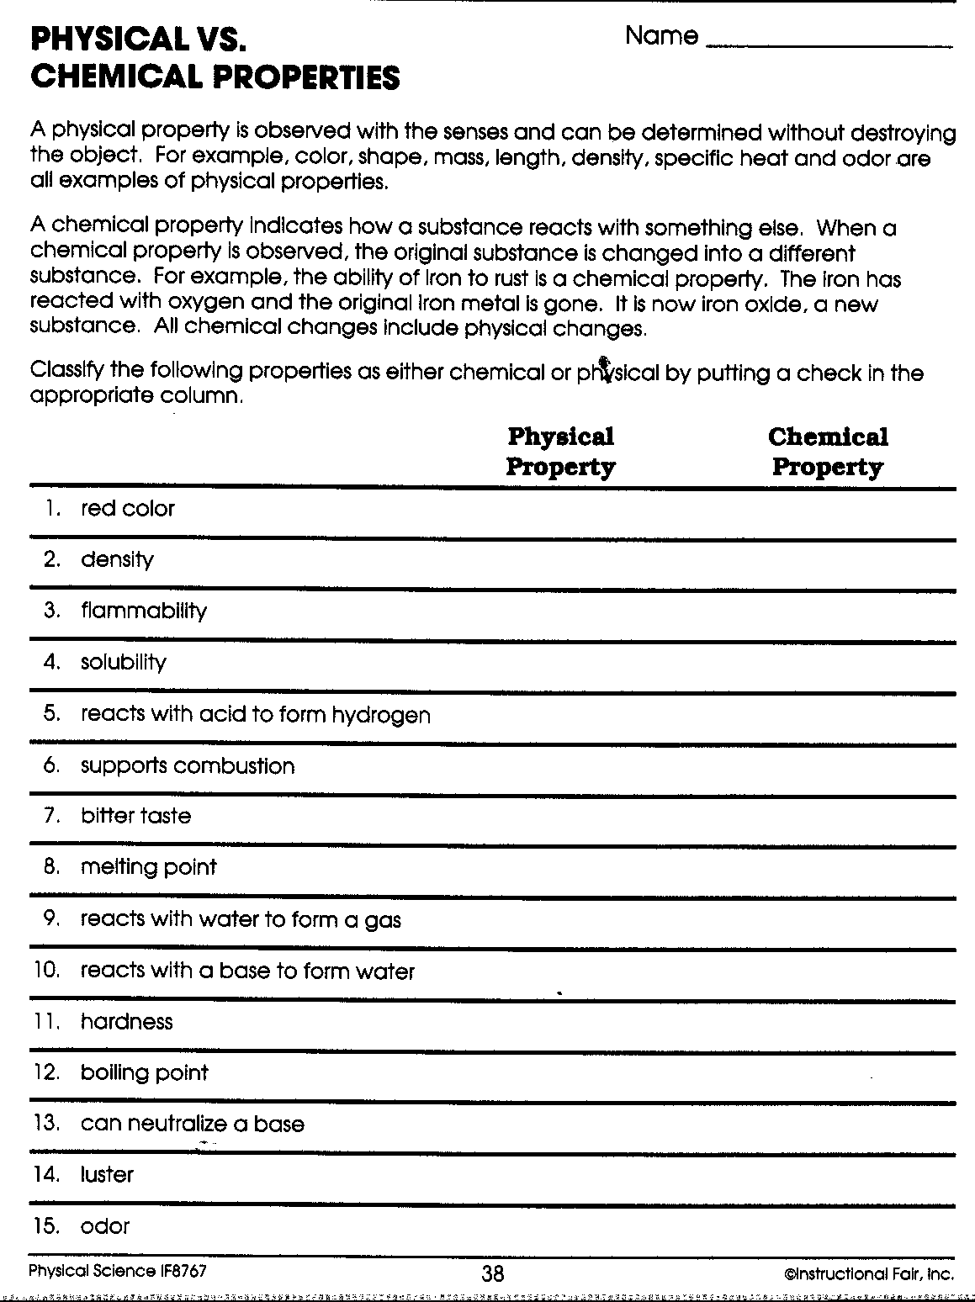
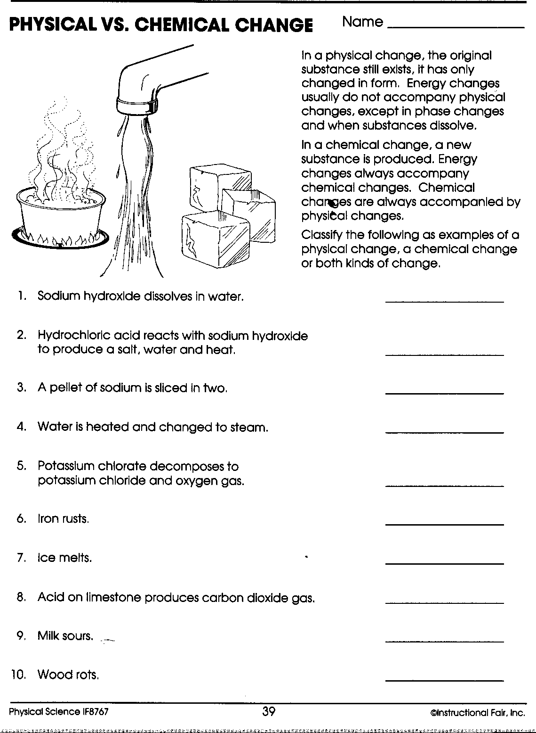
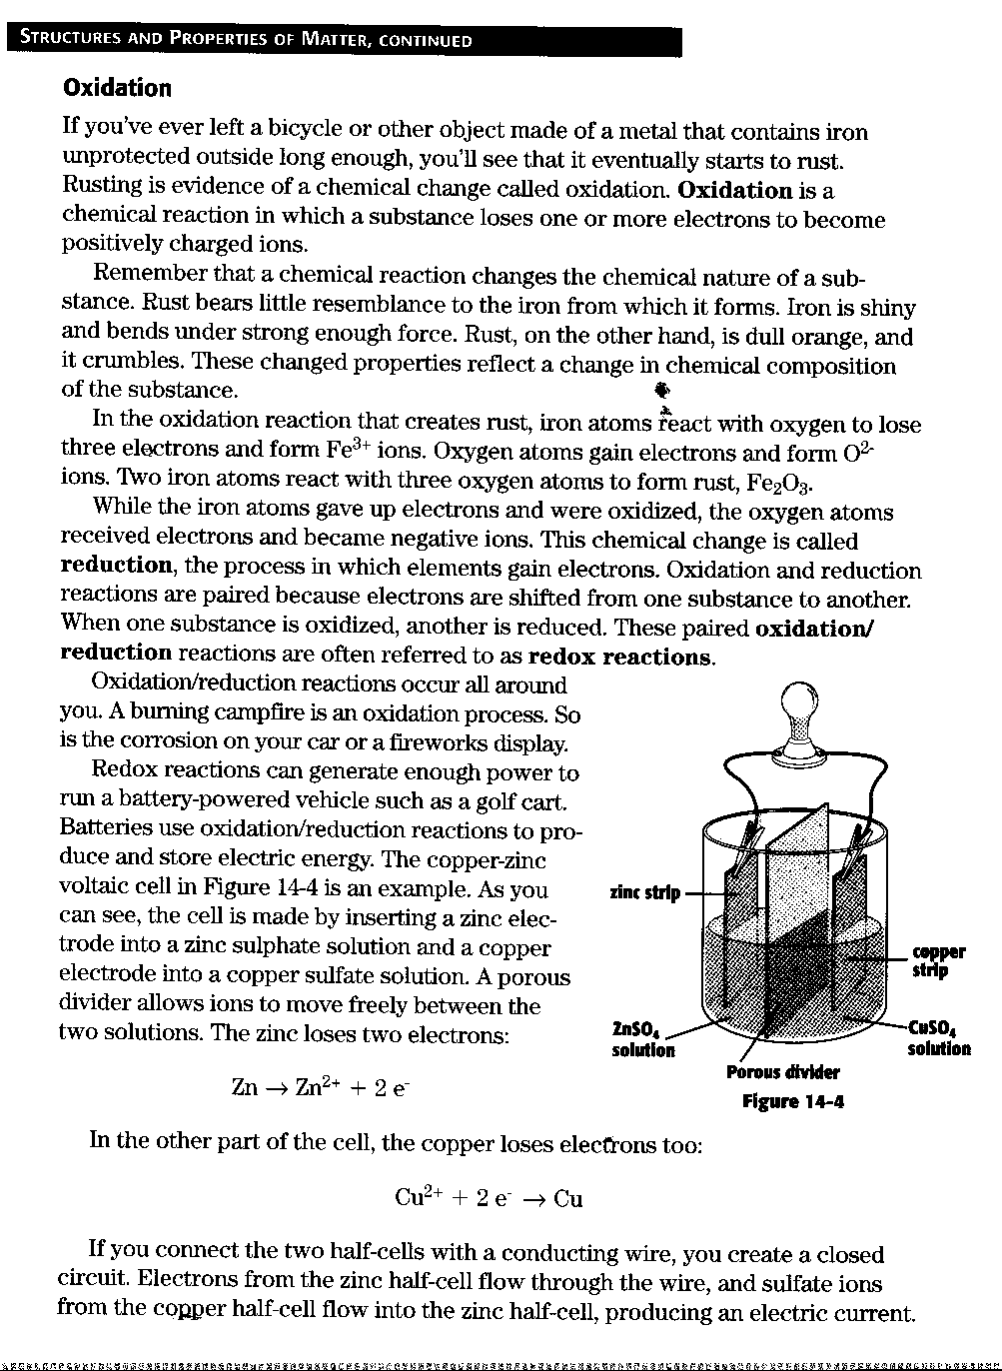

Oxidation

Read the preceding pages and answer the following questions in complete sentences

- What is oxidation?

- What does a chemical reaction do?

- How does an oxidation reaction create iron?

- What is reduction?

- Why are oxidation and reduction reactions paired?

- How does a redox reaction generate energy to run a golf cart?

Naming Compounds

IONIC COMPOUNDS versus MOLECULAR COMPOUNDS

Ionic compound: consist of cations (positive ions) and anions (negative ions) held together by electrostatic attractions
--Usually metal + nonmetal(s)
--Made of monatomic ions, polyatomic ions, and/or both
--Monatomic ions; consist of a single atom
--Polyatomic ions; consist of more than one atom

Molecular compound: consist of nonmetals atoms bonded together by shared electrons (covalent bonding)
--acid: a molecular compound that releases hydrogen ion (H⁺) when dissolved in water

NAMING MONATOMIC CATIONS:

Metal atoms lose valence electrons to form positively charged ions, called cations. An ion formed from an individual atom is a monatomic (or monoatomic) cation.

- Groups IA, IIA, IIIA, elements silver (Ag) and zinc (Zn) form only one type of ion;
  - Group IA elements form +1 ions: H^{+,} Li⁺, Na₊, K⁺
  - Group IIA elements form +2 ions; Be⁺², Mg ⁺², Ca⁺², Sr⁺², Ba⁺²
  - Group IIIA elements form +3 ions; Al⁺³
  - Silver ion = Ag⁺; zinc ion = Zn⁺²

When a Group IA, IIA, IIIA element, silver, or zinc forms an ion, it is named:

Element name + ion

e.g. Na⁺ = sodium ion Sr⁺² = strontium ion Zn⁺² = zinc ion

- The Stock system is used to name transition metals and other metals that form more than one ion:
--iron (Fe) forms two ions: Fe⁺² and Fe⁺³
--lead (Pb) forms two ions: Pb⁺² and Pb⁺⁴

When a metal can form more than one ion, each ion is named:

Element name (charge in Roman numberals) + ion

e.g. Fe⁺² = iron (II) ion Pb⁺² = lead (II) ion Cu⁺ = copper (I) ion
Fe⁺³ = iron (III) ion Pb⁺⁴ = lead (IV) ion Cu⁺² = copper (II) ion

Name each of the following monatomic cations:

Li⁺ = _________________________ Ba⁺² = ___________________________

Ag⁺ = _________________________ Cu⁺² = ____________________________

Al⁺³ = _________________________ Mg⁺² = ____________________________

Mn⁺² = ________________________ Sn⁺⁴ = _____________________________

H⁺ = __________________________ Co⁺³ = ____________________________

Fe⁺³ = ________________________ Na⁺ = _____________________________

K⁺ = __________________________ Ti⁺⁴ = _____________________________

Ca⁺² = ________________________ Ni⁺² = _____________________________

NAMING MONATOMIC ANIONS:

Nonmetal atoms gain valence electrons to form negatively charged ions called anions.

When a nonmetal forms an ion, it is named:

Element stem name + “ide” + ion

e.g. O = oxygen atom → O⁻² = oxide ion
N = nitrogen atom → N⁻³ = nitride ion

Name each of the following monatomic anions:

F⁻ = _________________________________ Cl⁻ = ____________________________

Br⁻ = ________________________________ S⁻² = ____________________________

I⁻ = _________________________________ P⁻³ = ____________________________

NAMING POLYATOMIC IONS:

Ions made up of more than one atom are polyatomic ions:

--only one polyatomic cation: NH₄⁺ = ammonium ion
__many polyatomic anions: see table

NH₄⁺ Polyatomic Ions

OH⁻ = hydroxide ion NO₂⁻ = nitrite ion C₂H₃O₂⁻ = acetate ion

CN⁻ = cyanide ion NO₃⁻ = nitrate ion PO₄⁻³ = phosphate ion

CrO₄⁻²= chromate ion SO₄⁻² sulfate ion MnO₄⁻= permanganate ion

Cr₂O₇⁻²= dichromate ion SO₃⁻² = sulfate ion CO₃⁻² = carbonate ion

HCO₃⁻ = hydrogen carbonate ion or bicarbonate ion

Name each of the following polyatomic ions:

CN⁻ = ____________________________ CrO₄⁻² = ____________________________

SO₄⁻² = ___________________________ NO₃⁻ = _____________________________

OH⁻ = ____________________________ PO₄⁻³ = ____________________________

NH₄⁺= ____________________________ C₂H₃O₂⁻ = ___________________________

WRITING CHEMICAL FORMULAS GIVEN INDIVIDUAL IONS

Compounds must be neutral → total + ve charge = total –ve charge

If the two ions have exactly opposite charges (+1 and -1, +2 and -2, +3 and -3)

→ formula of the compound contains one of each ion

e.g. Na⁺ + Cl⁻ → NaCl K⁺ +NO₃⁻ → KNO₃

Ca⁺² + S⁻² → CaS Ba⁺² + SO₄⁻² → BaSO₄

Al⁺³ + N⁻³ → AlN Fe⁺³ + PO₄⁻³ → FePO₄

Combine each pair of ions to get the formula of the compound they form:

NH₄⁺ + F⁻→_________________________ Li⁺ + CN⁻ →_________________________

Sr⁺² + CO₃⁻² →______________________ Al⁺³ + PO₄⁻³→________________________

Na⁺ + C₂H₃O₂⁻ → ___________________ K⁺ + OH⁻ → _________________________

Ni⁺² + CrO₄⁻² → _____________________ Fe⁺³ + N⁻³ → ________________________

Cu⁺² + SO₄⁻² → _____________________ Co⁺³ + P⁻³ → _________________________

If two monatomic ions have different charges

→ use crossover rule to get formula of the compound

- superscript for cation becomes subscript for anion
- superscript for anion becomes subscript for cation
- simplify subscripts to get lowest ratio of atoms (NOTE: Only the numbers cross down, NOT the signs!)

Na⁺ S²⁻ Ba²⁺ N³⁻ Ti⁴⁺ O²⁻

Na₂S Ba₃N₂ Ti₂O₄
TiO₂ (simplified)

If two ions have different charges and at least one polyatomic ion is involved:

→ use crossover rule to get formula of the compound

--if more than one of polyatomic ion in formula, use parentheses
--simplify subscripts to get lowest ration of atoms (NOTE: Again only the numbers cross down , NOT the signs!)

NH₄⁺ O²⁻ Ca²⁺ NO₃⁻ PB⁴⁺ CO₃²⁻

(NH₄)₂O Ca(NO₃)₂ Pb₂(CO₃)₄
Pb(CO₃)₂ simplified!

Combine each pair of ions to get the formula of the compound they form:

Cu⁺ O⁻² Sn⁺⁴ SO₄⁻² K⁺ P⁻³

Li⁺ CO₃⁻² Fe⁺³ S⁻² Ni⁺² PO₄⁻³

CHEMICAL FORMULAS AND NAMES FROM INDIVIDUAL IONS
Compounds are named from the individual ions they come from.
Name the cation and the anion, then remove “ion from each name:
e.g. Na⁺ = sodium ion
Cl⁻ = chloride ion → NaCl = sodium chloride

K⁺ = potassium ion
CO₃⁻² = carbonate ion → K₂CO₃ = potassium carbonate

Fe⁺³ = iron (III) ion
NO₃⁻ = nitrate ion → Fe(NO₃)₃ = iron (III) nitrate

Ag⁺ = silver ion
S⁻² = sulfide ion → Ag₂S = silver sulfide
Combine each pair of ions to get the chemical formula, then name the compound:
Individual ions Compound Formula Compound Name
Mg⁺² F⁻ ________MgF₂________ __magnesium fluoride
Ni⁺² S⁻² _____________________ __________________
Ca⁺² Br⁻ _____________________ ___________________
Al⁺³ P⁻³ _____________________ ___________________
Co⁺² NO₂⁻ _____________________ ___________________
K⁺ CrO₄⁻² _____________________ ___________________
Fe⁺³ O⁻² _____________________ ____________________

GIVEN THE CHEMICAL FORMULA, NAME THE COMPOUND
If the metal is in Groups IA – IIIA, silver, cadmium, or zinc, then just name the metal cation and the anion:
e.g. NaCl → Na = sodium and Cl = chloride → sodium chloride
BaI₂ → Ba = barium and I = iodide → barium iodide
Al(OH)₃ → Al = aluminum and OH = hydroxide → aluminum hydroxide
ZnSO₄ → Zn = zinc and SO₄ = sulfate → zinc sulfate

If the metal can form more than one ion
- Determine the charge on the cation using the charge on the anion.
- Name the cation and the anion, then remove “ion” from both.
e.g. NiBr₂ → since the ion formed is Br⁻, then 2 Br’s have an overall negative charge of -2. to get an overall charge of zero for the compound, the overall positive charge must be +2. Thus, Ni must have a charge of +2, so the ion nickel forms is Ni⁺².

→ Ni⁺² = nickel (II) ion Br⁻ = bromide ion
→ NiBr₂ = nickel (II) bromide

- If a polyatomic ion is involved, remember that more than one polyatomic is shown in parentheses—i.e. DO NOT multiply the charge of the polyatomic ion with the subscript of the atoms in a polyatomic ion.
CuSO₄ → There is only ONE Cu and ONE SO₄, so get the charge for the Cu based on the SO₄. The formula is SO₄⁻², and there is only ONE SO₄⁻², so Cu’s charge here must be +2 for the compound to have an overall charge of zero.
→ Cu⁺² = copper (II) ion SO₄⁻² = sulfate ion
Then → CuSO₄ = copper (II) sulfate

Give the name for each compound given its chemical formula:

Formula | Individual Ions | Name of Compound
MgCl₂ | Mg⁺² Cl⁻
LiOH
ZnCO₃
K₂S
FePO₄
SnO₂
CuBr₂
Ag₃N
Mn(CN)₂
AgC₂H₃O₂

WRITING CHEMICAL FORMULAS GIVEN THE COMPOUND NAME

Get the individual ions from the name, then combine them using the crossover rule:
e.g. barium chloride → barium = Ba⁺² chloride = Cl⁻
Ba⁺² Cl⁻ → BaCl₂
Aluminum sulfate → aluminum = Al⁺³ sulfate = SO₄⁻²
Al⁺³ SO₄⁻² → Al₂(SO₄)₃

Give the chemical formula for each compound given its name:

Name of Compound | Individual Ions | Formula
Lithium cyanide | Li+ CN- | LiCN
Iron (III) sulfate
Calcium iodide
Tin (IV) dichromate
Silver nitrite
Copper (II) acetate
Zinc carbonate
Lead (II) phosphide
Potassium sulfite
Cobalt (II) nitride
Nickel (II) permanganate

NAMING MOLECULAR COMPOUNDS
Indicate number of atoms of each element with Greek prefix before element name:

# of atoms | Greek Prefix | # of atoms | Greek Prefix
1 | mono (usually omitted) | 6 | hexa
2 | di | 7 | hepta
3 | tri | 8 | octa
4 | tetra | 9 | nona
5 | penta | 10 | deca
For the first element: Greek prefix + element name
For the second element: Greek prefix + element name stem + “—ide”
Note: Mono is generally omitted, except in common names like
CO = carbon monoxide
P₂O₅ SF₆
diphosphorus pentaoxide sulfur hexafluoride
Name the following molecular compounds:
SO₃ = ______________________________ SiBr₄ = ____________________________
XeF₆ = _____________________________ ClF₃ = _____________________________
N₂O₄ = _____________________________ Cl₂O₇ = ___________________________
PCl₅ = ______________________________ P₄O₁₀ = ___________________________

DETERMINING FORMULAS OF MOLECULAR COMPOUNDS

Use Greek prefix(es) to determine number of atoms of each element in formula
Get elements and number of atoms of each from the name:
tetraphosphorus hexasulfide
P₄S₆

Give the formula for each of the following molecular compounds
nitrogen trichloride dibromine heptaoxide dinitrogen pentasulfide

DETERMINING FORMULAS AND NAMES OF ACIDS FROM IONS
Given an ion,
We can get formula of acid by: adding H atoms equal to negative charge on ion
We can name for acid depending on suffix of ion name
Add # of H’s equal
To negative charge
F⁻ = fluoride ion → → → HF (aq) = hydrofluoric acid
Add # of H’s equal
To negative charge
NO₂⁻ = nitrite ion → → → HNO₂ (aq) = nitrous acid
Add # of H’s equal
To negative charge
SO₄⁻² = sulfate ion → → → H₂SO₄ (aq) = sulfuric acid

Name each of the following ions, and determine the formula and name of the corresponding acid that forms from the ion.

Name of ion Formula of Acid Name of Acid
CO₃⁻² = carbonate ion → H₂CO₃ _____ → carbonic acid_________

Cl⁻ = ______________→ _______________ → _____________________

SO₃⁻² = ______________→ _______________ → _____________________

PO₄⁻³ = ______________→ _______________ → ____________________

NO₃⁻ = _____________ → _______________ → _____________________
Name each of the following acids:
HBr (aq) = _______________________________ H₂CrO₄ (aq) ___________________
H₂S (aq) = _______________________________ HC₂H₃O₂ (aq) = _________________
HF (aq) = ________________________________ H₂SO₄ (aq) = ___________________
Give the formula for each of the following acids: [Don’t forget to indicate (aq)!]
phosphoric acid = ______________________ nitrous acid = _______________________
hydroiodic acid = ______________________ carbonic acid = _____________________
sulfurous acid = _______________________ nitric acid = ________________________

PUTTING IT ALL TOGETHER:
Name each of the following compounds:
BaCl₂ ____________________________ NiBr₂ ________________________

HNO₃ (aq) ________________________ SO₂ _________________________

AgF _____________________________ PbS₂ ________________________

CuSO₃ ___________________________ PF₅ _________________________

K₂SO₄ ___________________________ Cr(C₂H₃O₂)₃ _________________

FeP ______________________________ Al₂(CO₃)₃ ___________________

NiSO₄ ___________________________ ZN(OH)₂ _____________________
KMnO₄ __________________________ Sn(CN)₂ ______________________
WRITING BINARY FORMULAS
Write the formulas for he compounds formed from the following ions.

- Na⁺, Cl⁻ ____________________
- Ba⁺², F⁻ ____________________
- K⁺, S-2 ____________________
- Li⁺, Br⁻ ____________________
- Al⁺³, I⁻ ____________________
- Zn⁺², S⁻² __________________
- Ag⁺, O⁻² __________________
- Mg⁺², P⁻³___________________
- Ni⁺², O⁻²___________________
- Ni⁺³, O₋₂___________________

- Fe⁺², O⁻² ___________________
- Fe⁺³, O⁻² __________________
- Cr⁺², S⁻² ___________________
- Cr⁺³, S⁻² ___________________
- Cu⁺, Cl⁻ ___________________
- Cu⁺², Cl⁻ ___________________
- Pb⁺², O⁻² __________________
- Pb⁺⁴, O⁻² __________________
- Mn⁺², Br⁻ __________________
- Mn⁺⁴, Br⁻ __________________

NAMING BINARY COMPOUNDS (IONIC)

- BaCl₂ _____________________
- NaF _______________________
- Ag₂O _____________________
- CuB ______________________
- CuBr₂_____________________
- FeO _______________________
- Fe₂O₃ _____________________
- MgS ______________________
- Al₂O₃______________________
- CaI₂ ______________________
- K₂S _______________________
- CrCl₂______________________
- CrCl₃ _____________________
- CaO ______________________
- Ba₃P₂ _____________________
- Hg₂I₂ ______________________
- Na₂O ______________________
- BeS _______________________
- MnO ______________________
- Mn₂O₃ ____________________

NAMING BINARY COMPOUNDS (COVALENT)
Name the following compound using the prefix method.
- CO ____________________________________________________________
- CO₂ __________________________________________________________________________________________
- SO₂ __________________________________________________________________________________________
- NO₂ __________________________________________________________________________________________
- N₂O ____________________________________________________________
- SO₃ __________________________________________________________________________________________
- CCl₄ __________________________________________________________________________________________
- NO ____________________________________________________________
- N₂O₅ __________________________________________________________________________________________
- P₂O₅ __________________________________________________________________________________________
- N₂O₄ __________________________________________________________________________________________
- CS₂ __________________________________________________________________________________________
- OF₂ __________________________________________________________________________________________
- PCl₃ __________________________________________________________________________________________
- PBr₅ __________________________________________________________________________________________
FORMULAS WITH POLYATOMIC IONS

Matching the horizontal and vertical axes, write the formulas of the compounds with the following combination of ions. The first one is done for you.

 | OH⁻ | NO₃⁻ | CO₃⁻² | SO₄⁻² | PO₄⁻³
H⁺ | HOH  (H₂O) | HNO₃ | H₃CO₃ | H₂SO₄ | H₃PO₄
Na⁺

Mg⁺²

NH₄⁺

Ca⁺²

K⁺

Al⁺³

Pb⁺⁴

NAMING COMPOUNDS (MIXED)

Name the following compounds.

- NaCl ___________________________________________________________
- MnS ___________________________________________________________
- K₂O ___________________________________________________________
- CuBr₂ ________________________________________________________________________________________
- CuBr ___________________________________________________________
- CO₂ ________________________________________________________________________________________
- PbSO₄ ________________________________________________________________________________________
- Li₂CO₃ ________________________________________________________________________________________
- Na₂CO₃ __________________________________________________________
- NO₂ ________________________________________________________________________________________
- N₂O₄ ________________________________________________________________________________________
- Ca(OH)2 ______________________________________________________________________________________
- NH₄Cl ___________________________________________________________
- SO₃ ________________________________________________________________________________________
- AlPO₄ ________________________________________________________________________________________
- CCl₄ ________________________________________________________________________________________
- CaS ___________________________________________________________
- NH₃ ________________________________________________________________________________________
- MgI₂ ________________________________________________________________________________________
- K₃PO₄ ________________________________________________________________________________________

WRITING FORMULAS FROM NAMES
Write the formulas for the following compounds.
- carbon monoxide ________________________________________________
- sodium chloride ________________________________________________
- carbon tetrachloride ________________________________________________
- magnesium bromide ________________________________________________
- aluminum iodide ________________________________________________
- hydrogen hydroxide ________________________________________________
- iron (II) fluoride ________________________________________________
- carbon dioxide ________________________________________________
- sodium carbonate ________________________________________________
- ammonium sulfide ________________________________________________
- iron (II) oxide ________________________________________________
- iron (III) oxide ________________________________________________
- magnesium sulfate ________________________________________________
- sodium phosphate ________________________________________________
- dinitrogen pentoxide ________________________________________________
- phosphorus trichloride _______________________________________________
- aluminum sulfite ________________________________________________
- copper (I) carbonate ________________________________________________
- potassium hydrogen carbonate _________________________________________
- sulfur trioxide ________________________________________________

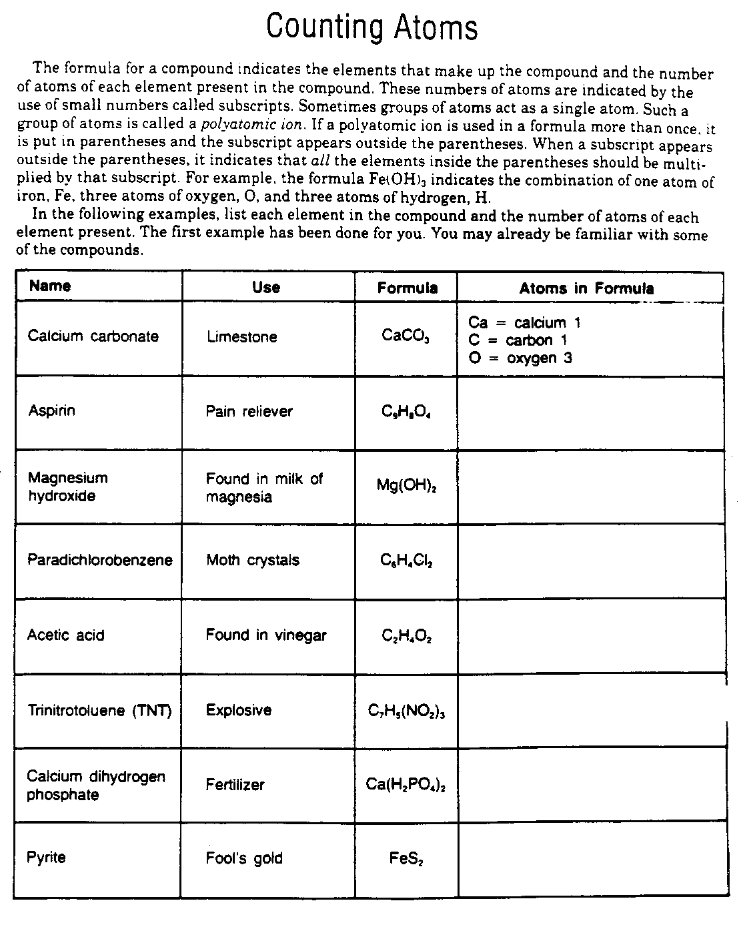
Counting Atoms
Calculate how many atoms of each element are present in the following compounds.
- NaHCO₃

- C₂H₄O₂

- Mg(OH)₂

- 3H₃PO₄

- 2H₂SO₄

- (NH₄)₃PO₄

- C₆H₁₂O₆

- 4CaCO₃

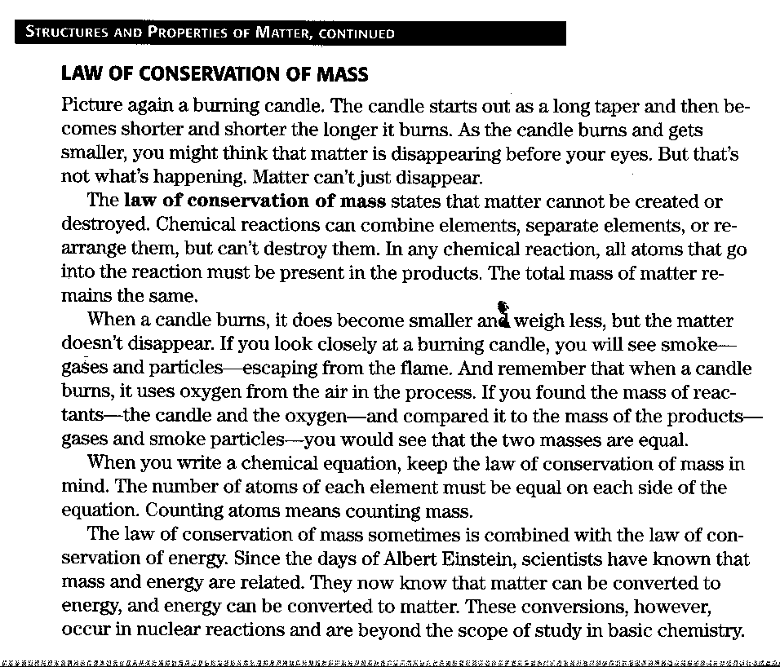

Law of Conservation of Mass
Read the preceding page and answer the following questions in complete sentences.

- State the Law of Conservation of Mass.

- How does the Law of Conservation of Mass apply to chemical reactions?

- How does the Law of Conservation of Mass apply to writing chemical formula?

- How are mass and energy related?
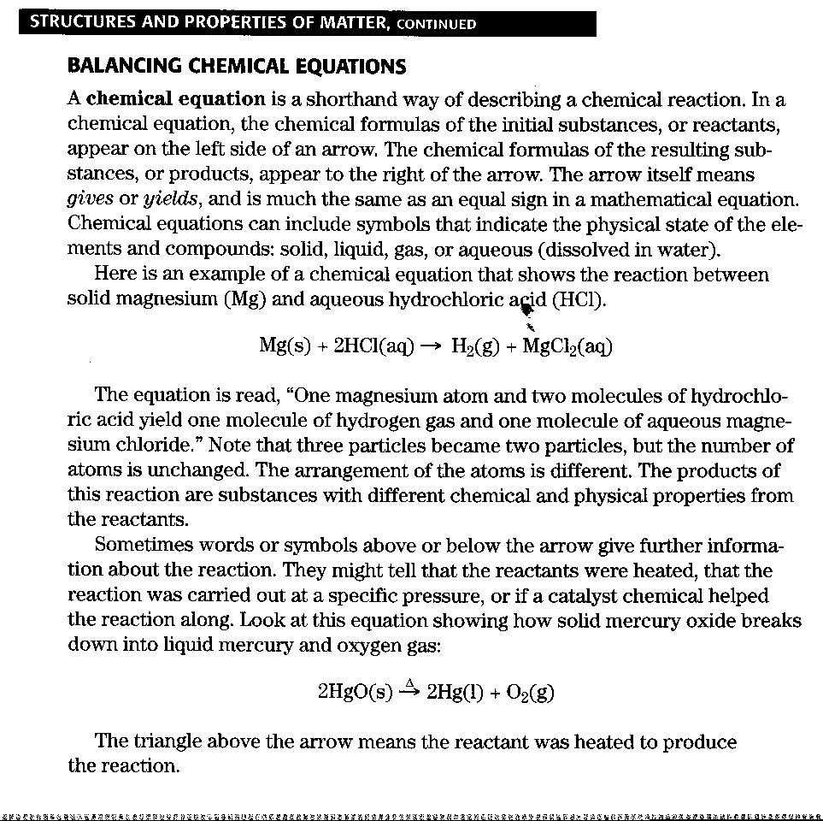

Balancing Chemical Equations
Read the preceding page and answer the following questions in complete sentences.

- What is a chemical equation?

- Name the parts of a chemical equation and explain each.

- Compare the atoms in a reactant to the atoms in the product.

- Why are there words or symbols above the arrow in some chemical equations?

BALANCING EQUATIONS

Part A Chemical Equations

Texas has one of the largest reserves of natural gas (methane) in the country. Natural gas is often used in homes as the primary source of heat, for cooking, and for providing hot water. When methane combines with oxygen during combustion, it produces carbon dioxide and water. The balanced chemical equation for the combustion reaction of methane is shown below.

CH₄ + 2O₂ → CO₂ + 2H₂O

Methane + oxygen → carbon dioxide + water

REACTANTS → PRODUCTS

The substances present before the reaction occurs are called the reactants. The reactants in this reaction are methane (CH₄) and oxygen (O₂). The products in a chemical equation are the substances produced by the reaction. The products in this reaction are carbon dioxide (CO₂) and water (H₂O).
In between the products and reactants, you see an arrow called the yield sign. The direction of the arrow shows the direction of the reaction and always points toward the products. The yield sign is similar to the equal sign in a mathematical equation. In a chemical equation, the reactants are always found to the left of the yield sign, while the products are always found to the right.
The numbers in front of the chemical formulas in the chemical equation are called coefficients. The coefficients indicate the number of atoms or molecules of a substance involved in the reaction. In this reaction, two molecules of oxygen were used as reactants and two molecules of water were formed as products. If no number appears in front of the formulas (as in CH4 and CO2), it means that only one molecule is present.

Problems

Use the following balanced chemical equation to answer problems 1-4

2H₂ + O₂ → 2H₂O

Hydrogen + oxygen → water

- Name the product(s) in the reaction. ____________________________________

- Name the reactant(s) in the reaction. ____________________________________

- What is the coefficient of the product? What is the coefficient of oxygen? ______
_____________________________________________________________________

- What does the yield sign tell you about the reaction? _______________________

Part B Balancing Chemical Equations

In a balanced chemical equation, the number and kind of atoms that are present as reactants must be present as products. For example, Figure A represents the chemical reaction between hydrogen and oxygen to form water.

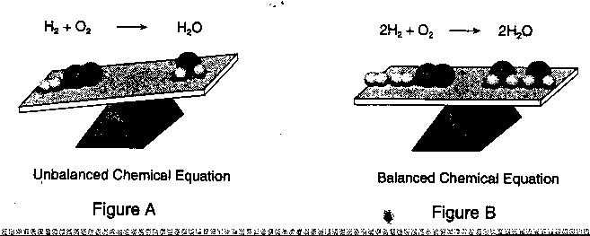

Notice that in the reactants there are 2 atoms of hydrogen and 2 atoms oxygen. In the products, however, there are 2 atoms of hydrogen, but only 1 atom of oxygen. This chemical equation is not balanced. To balance the equation, you add coefficients in front of the chemical formulas where they are needed. How can you make the number of oxygen atoms on the right equal the number on the left while keeping the hydrogen balanced? You can put a 2 in front of the formula for hydrogen and a 2 in front of the formulas for water. Figure B shows the balanced chemical equation for the reaction. Notice that the number of hydrogen and oxygen atoms in the reactants are the same as in the products.

Problems

- Balance the following chemical equation

  - _____ H₂ + _____Cl₂ → _____HCl

  - What are the reactants? ________________________________________

  - What are the products? ________________________________________

- Balance the following chemical equation

  - ______Br₂ + ______KI → ______KBr +______ I₂

  - What are the reactants? ________________________________________

  - What is the coefficient of KI in the balanced equation? _______________

A Case of Balance – Reinforcement

Fill in the blanks to review how to balance equations.

- To balance an equation, you need to use ___________________________ , which are numbers placed in front of chemical symbols or formulas.

- The first step to balancing an equation is counting the atoms. To do this, you multiply each element’s ____________________________ by its __________________________ . Do this for each element on either side of the equation.

- If an element has no subscript beside it, what number would you multiply its coefficient by? ____________________________________________

- If an element has no coefficient in front of it, what number would you multiply its subscript by? ______________________________________

- The ___________________________________ are on the left side of an equation, and the _____________________________________ are on the right side.

Try balancing this equation: 4Fe + 3O₂ → Fe₂O₃

- First, count the atoms on the reactants side, so you need to multiply them by some number to equal the number of atoms on the reactants side.

Reactants → Products

Fe = ____________, O = ___________, Fe = _____________, O = ________

- There are fewer atoms on the products side, so you need to multiply them by some number to equal the number of atoms on the reactants side.

- Write the whole equation, using your last answer as a coefficient. _____________

- To check your work, recount the atoms using he new coefficient.

Reactants: Fe = _________________, O = _______________________

Products: Fe = _________________, O = _______________________

- Are there the same number of atoms for each element on both sides of the equation? _______________________________

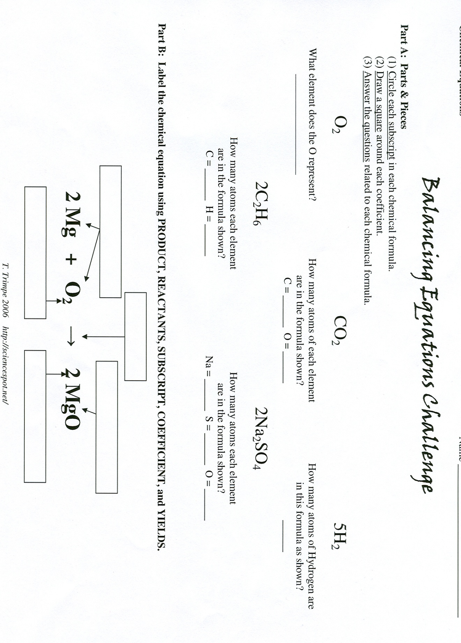

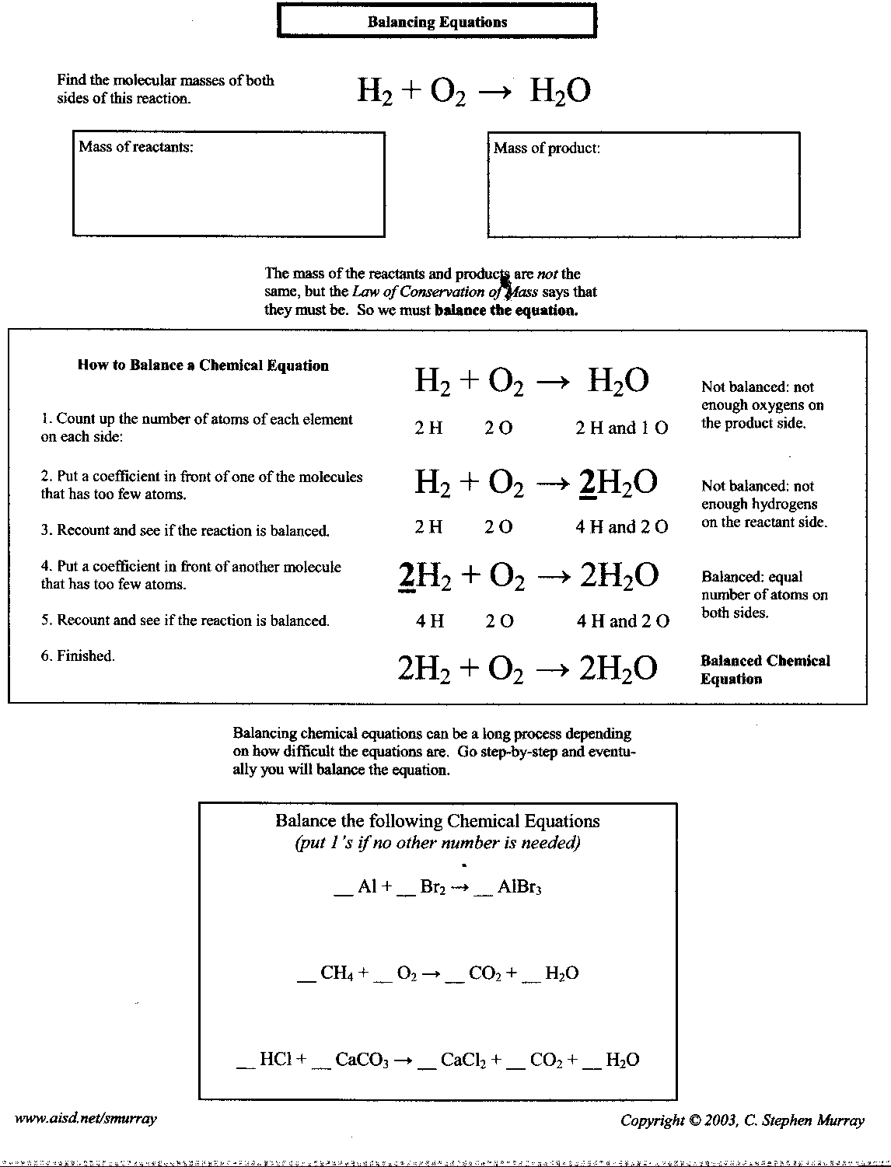
Name ____________________________

Balancing Equations Practice

Part A: Identify the following parts of each chemical formula by circling the subscripts and drawing a square around the coefficients.

H2 2HCl 4O2 CH4

3CO3 2NaOH

Part B: List the symbols for the atoms in each formula and give the number of each.
C2H6 2MgO 4P4O10

NH3 3Al(OH)3 2H2O2

Part C: Count the atoms on each side of the equation.

P + O2 → P4O10 Mg + O2 → MgO

P = P = Mg = Mg =

O = O = O = O =

BaCl2 + H2SO4 → BaSO4 + HCl
Ba = Ba =

Cl = Cl =

H = H =

S = S =

O = O =
Part D: Choose which coefficients balance the equations

_Cl2 + _NaBr → _NaCl + _Br2 __H2 + _N2 → _NH3

a. 2,2,2,1 a. 3,2,1
b. 3,2,1,1 b. 3,1,2
c. 1,2,2,1 c. 1,2,3
d. 1,1,2,3 d. 1,1,2

_Na + _Br2 → _NaBr _CuCl2 + _H2S → _CuS + _HCl

a. 2,1,1 a. 2,1,2,1
b. 1,2,2 b. 1,1,1,2
c. 1,1,2 c. 2,2,1,1
d. 2,1,2 d. 1,2,1,2

_HgO + _Cl2 → __HgCl + _O2 __C + _H2 → _CH4

a. 1,2,1,2 a. 1,2,1
b. 2,2,1,1 b. 2,1,2
c. 2,1,2,1 c. 1,1,2
d. 1,1,1,2 d. 2,2,1
Name _____________________________________ Date ___________________

Balancing Equations

Multiple Choice. Choose the correct numbers to balance out the equation. Once it is balanced count the atoms to check your answer.

- _____Na + _____O₂ → _____Na₂O
  - 2, 1, 2
  - 4, 1, 2
  - 2, 1, 1

- _____H₂ + _____O₂ → _____H₂O
  - 1, 2, 1
  - 2, 2, 2
  - 2, 1, 2

- _____Na₂SO₄ + _____CaCl₂ → _____CaSO₄ + _____NaCl
  - 1, 1, 1, 2
  - 2, 1, 1, 4
  - 1, 2, 1, 2

- _____Al₂O₃ → _____Al + _____O₂
  - 1, 2, 2
  - 2, 3, 4
  - 2, 4, 3

- _____N₂ + _____ H₂ → _____NH₃
  - 1, 2, 3
  - 2, 3, 1
  - 1, 3, 2

- _____Fe + _____H₂O → _____Fe₃O₄ + _____H₂
  - 3, 4, 1, 4
  - 3, 4, 2, 1
  - 3, 3, 1, 4

- _____P₄ + _____O₂ → _____P₄O₁₀
  - 2, 3, 2
  - 1, 5, 2
  - 1, 5, 1

- _____SiCl₄ → _____Si + _____Cl₂
  - 1, 1, 4
  - 1, 1, 2
  - 1, 2, 2
Balancing equations

1. 2.

_HgO + _Cl2 → __HgCl + _O2 __C + _H2 → _CH4

a. 1,2,1,2 a. 1,2,1
b. 2,2,1,1 b. 2,1,2
c. 2,1,2,1 c. 1,1,2
d. 1,1,1,2 d. 2,2,1

- 4.

_Na + _Br2 → _NaBr _CuCl2 + _H2S → _CuS + _HCl

a. 2,1,1 a. 2,1,2,1
b. 1,2,2 b. 1,1,1,2
c. 1,1,2 c. 2,2,1,1
d. 2,1,2 d. 1,2,1,2

5. 6.

_Cl2 + _NaBr → _NaCl + _Br2 __H2 + _N2 → _NH3

a. 2,2,2,1 a. 3,2,1
b. 3,2,1,1 b. 3,1,2
c. 1,2,2,1 c. 1,2,3
d. 1,1,2,3 d. 1,1,2

7.
__Na₂SO₄ + __CaCl₂ → __CaSO₄ + __NaCl

- 1, 1, 1, 2
- 2, 1, 1, 4
- 1, 2, 1, 2
- 2, 2, 1, 3

Balancing Equations

Balance the following chemical equations

- CH₄ + O₂ → CO₂ + H₂0

- Na + I → NaI

- N₂ + O₂ → N₂0

- N₂ + H₂ → NH₃

- KI + Cl₂ → KCl + I₂

- HCl + Ca(OH)₂ → CaCl₂ + H₂O

- KClO₃ → KCl + O₂

- K₃PO₄ + HCl → KCl + H₃PO₄

- S + O₂ → SO₃

- KI + Pb(NO₃)₂ → KNO₃ + PbI₂

- CaSO₄ + AlBr₃ → CaBr₂ + Al₂(SO₄)₃

- H₂O₂ → H₂O + O₂

- Na + H₂O → NaOH + H₂

- C₂H₆ + O₂ → CO₂ + H₂O

- Mg(NO₃)₂ + K₃PO₄ → Mg₃(PO₄)₂ + KNO₃

