Name: ___________________________
# correct
Total #?’s
GRADE

FORCE
AND
MOTION
Unit 3
Student Manual

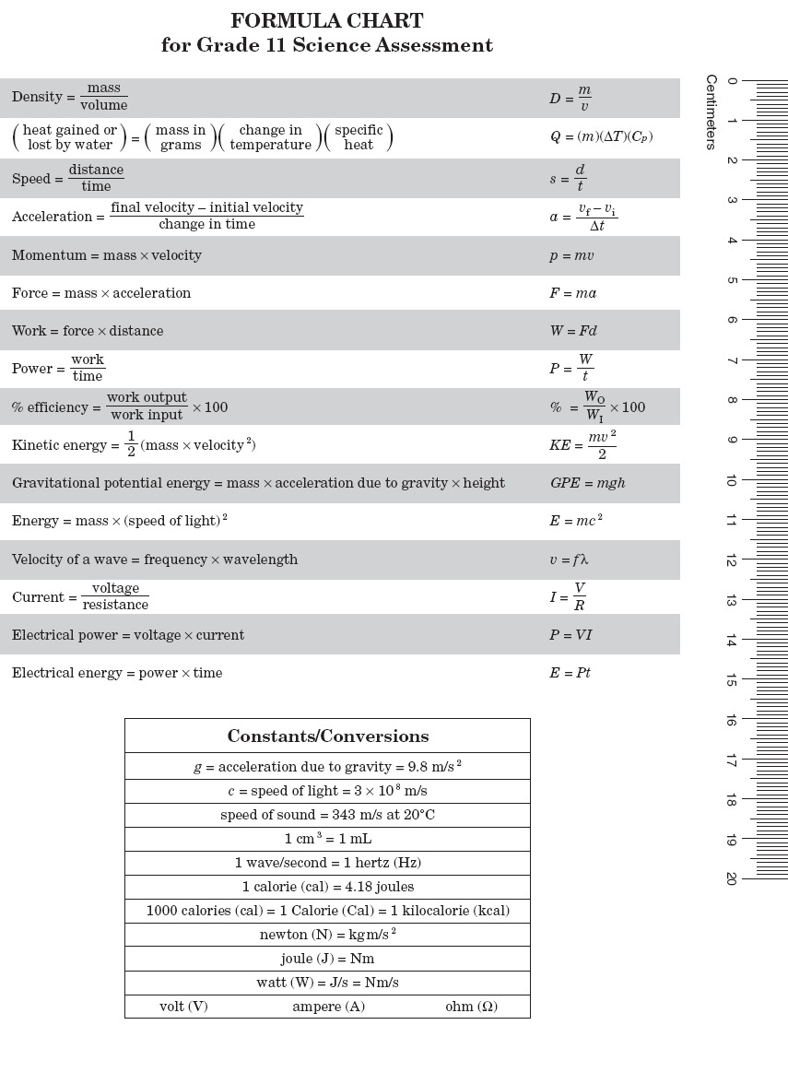

Speed

Imagine three students walking down the hall. One is walking as fast as he can without getting in trouble. The other is walking somewhat more slowly than but not as slow as the last student. Which student is demonstrating speed? How would you define speed?
According to the scientific definition of speed, all three students demonstrated speed. Speed represents a rate or the amount of time it takes to cover a certain amount of distance. The actual scientific formula for speed is distance covered divided by the time or
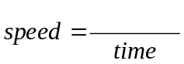
distance

or in shorthand, 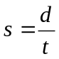.

The standard unit for speed is meters per second (m/s) when distance is measured in meters and time is in seconds. Scientists sometimes find it more useful to define a new term that also includes the direction so that 60 mph south is different from 60 mph east. The new term is velocity. It is calculated just like speed, but if 25 mph east is considered to be a positive number, 25 mph west would be negative. Since speed and velocity are often the same, scientists get sloppy and use the words interchangeably.
So what do we mean when we say speed is relative? When we re reading in a car, the book does not appear to be moving at 50 or 60 mph, but that is because we are also moving at the same speed. When we see pictures in space of astronauts on spacewalks, everything seems to be moving very slowly. But, even though these objects are moving slowly relative to each other while in orbit, they are actually traveling about 17,500 mph. You and your desk (and the rest of the planet) are traveling around the sun at about 66,500 mph, as well.

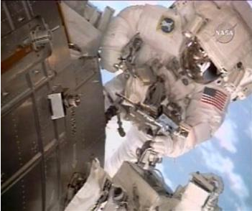

Did you know that the Atlantic Ocean is growing at about the same speed as your fingernails? Magma rises at the Mid-Atlantic Ridge and creates about 1 cm of new ocean floor each year. That’s approximately the length of fingernail you’ll trim off in a year. Sunlight takes about 8 minutes to travel from the sun to the earth. Light travels at 300,000 km/s in space. Notice, both these examples include both distance and time.
If an object travels equal distances in equal amounts of time it is traveling at a constant speed. Since a picture is worth a thousand words, we often show the relationship between speed and time using a graph like the one pictured below. Notice that the lines are all straight. This means each of the objects pictured in the graph travel the same distance each second which in turn means they are traveling at a constant speed. The lines slope upward which indicates that distance is increasing as time is increasing. They are moving away from the starting point.
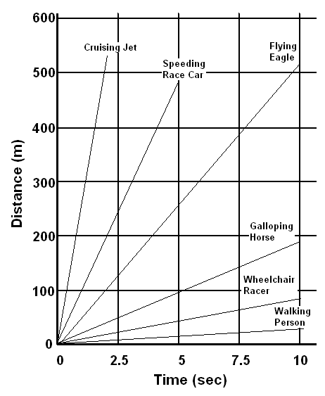

If the store is 5 km from you house and it took you 10 minutes to get there, you traveled 5 km in 10 minutes. Your average speed is:
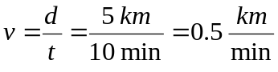
Interpreting Distance vs. Time Graphs

Consider the graph below.
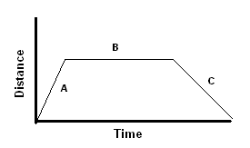
- It is made up of three line segments labeled A, B, and C. Which of the line segments represents an object moving away from the starting point?

- Why?

- Which line segment represents the object not moving?

- Why?

- What does the last line segment represent?

- Which segment represents the object moving at the greatest speed?

- Why?

- What does the slope of the line represent?

- How would the graph of a speed of 5 m/s look different from one of 15 m/s if the scale remained the same?

The Bus Ride



Imagine the following scenario. On the graph below, draw a graph of each segment of the trip. Be sure to label your axes and each phase of the trip.
- In order to get to school in the morning, you leave your house and walk 1/2 mile to the bus stop. The walk takes you 8 minutes.
- At the bus stop you wait 10 minutes for the bus to arrive.
- You then get on the bus and it takes you 12 minutes to get to the school, which is 8 miles away.
- After you get off the bus, it takes another 7 minutes to walk 1/8 mile to your classroom while you talk to your friends.

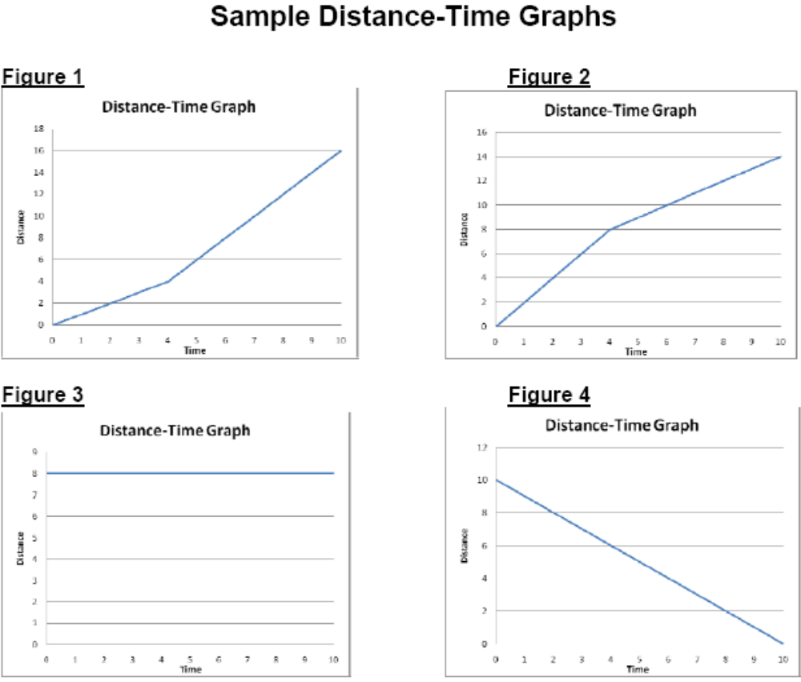
In your own words, describe the motion occurring in each of the graphs above.

Figure 1

Figure 2

Figure 3

Figure 4
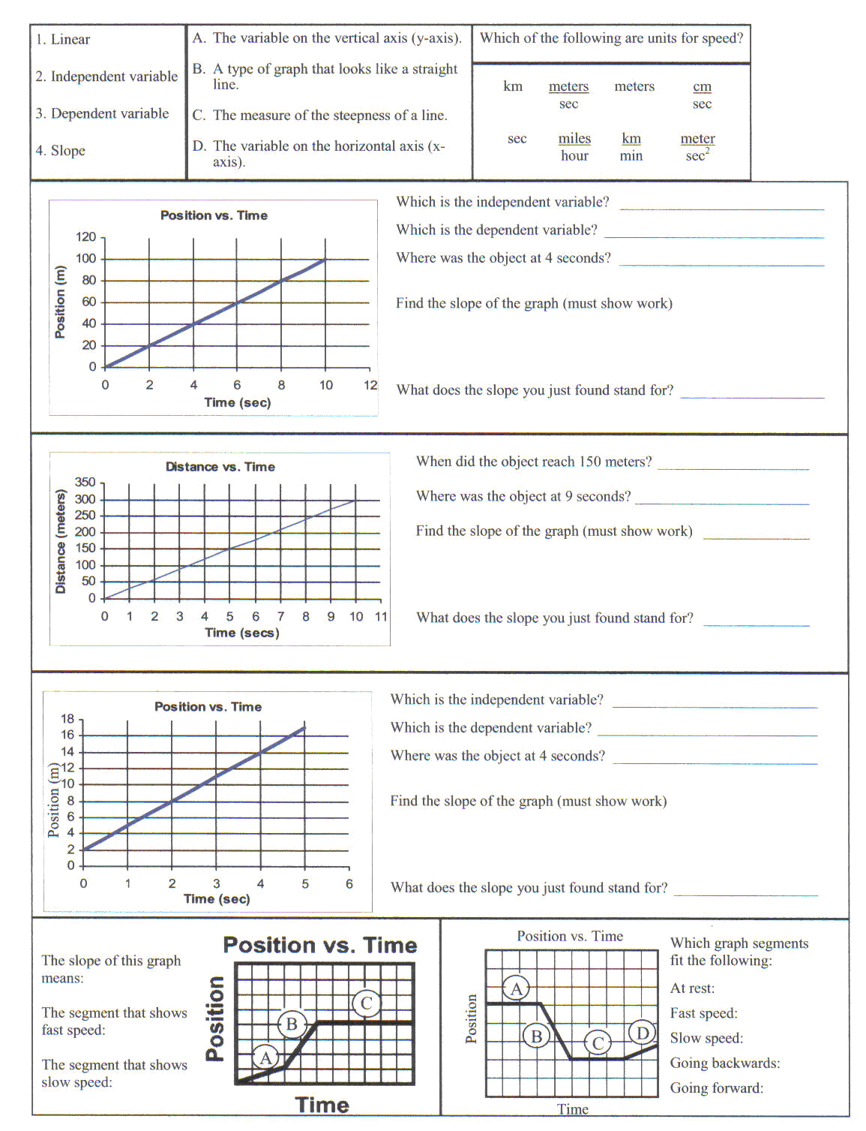

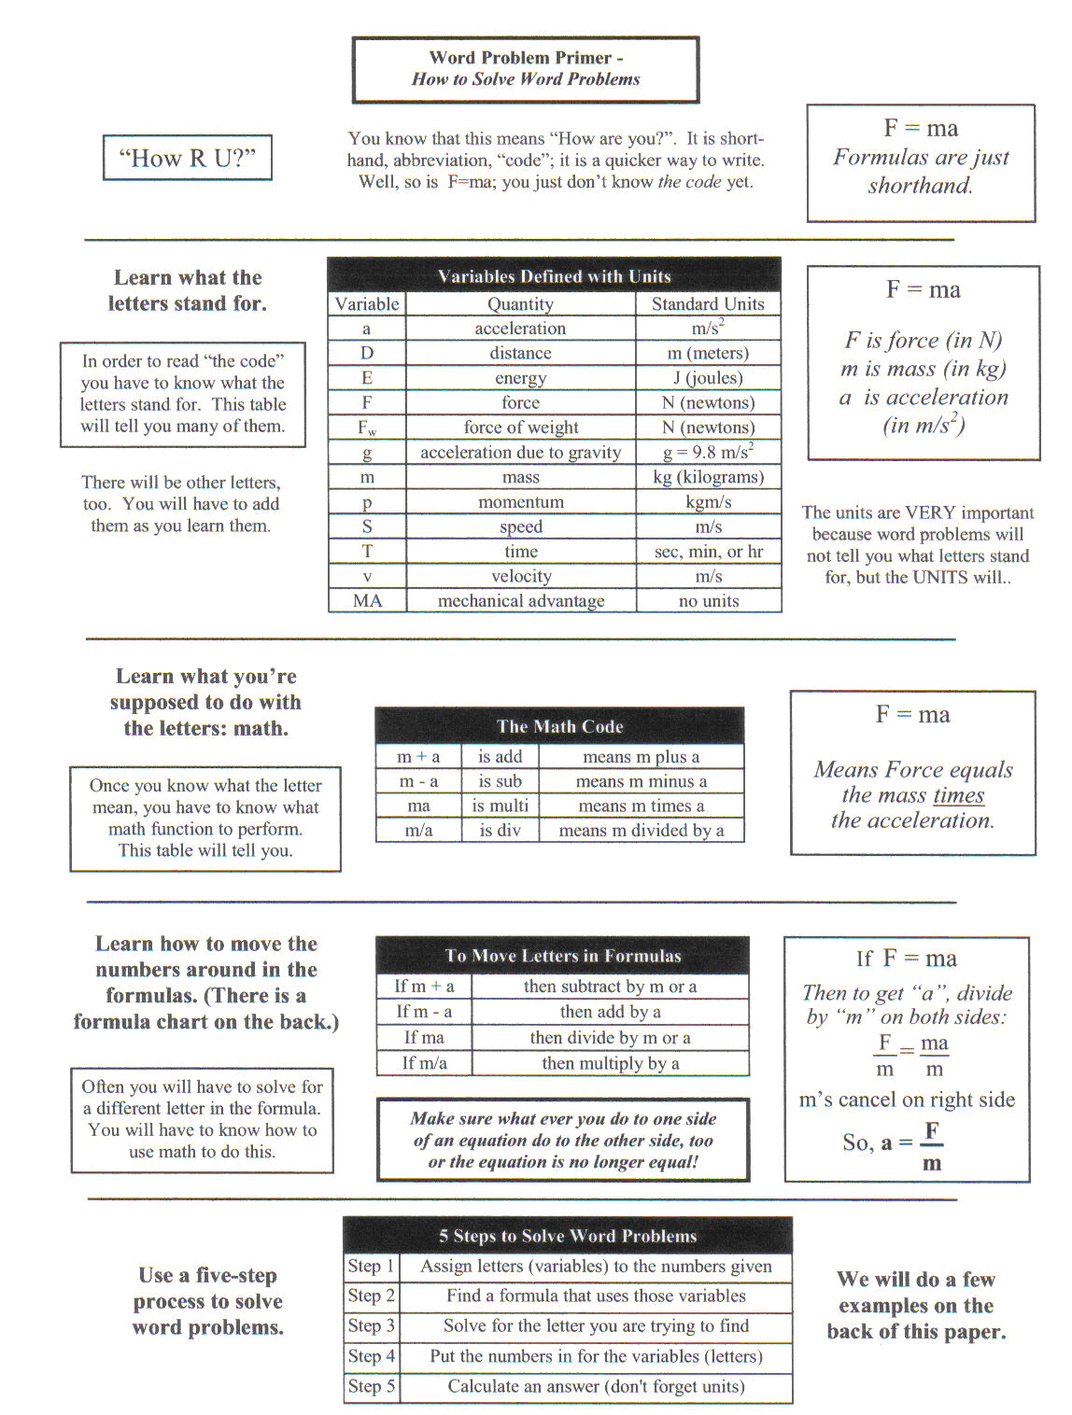
Speed and Velocity

It is the job of physics to explain why things happen. But the first task is to describe what happens. We are going to use algebra to write mathematical descriptions of the way things move. We must begin by defining our variables carefully. The formula for speed is distance divided by time and the units are meters per second.

Formulas:  distance | Abbreviations: | Units:
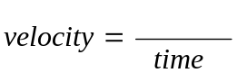 | 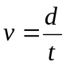 | Meters per second (m/s)
distance    distance | d = v x t | meters (m)
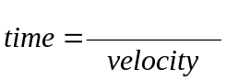 | 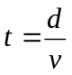 | seconds (s)

Example: Metal stakes are sometimes placed in glaciers to help measure a glacier’s movement. For several days in 1936, Alaska’s Black Rapids glacier surged as swiftly as 89 m per day down the valley. Find the glacier’s velocity in meters per second.

Formula and Work Set- Up
v = ? 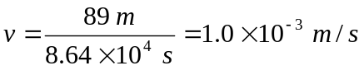
d = 89 m
t = 1 day = 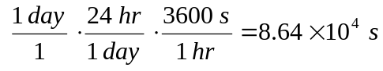

Ans: v = 1.0 x 10⁻³ m/s down the valley

- Find the velocity in meters per second of a runner who runs 100 m toward the finish line in 4.8 s.
Formula and Work Set- Up
v =

d =

t =

Ans: ____________________

- Find the velocity of a baseball thrown 38 m from third base to first base in 1.7 s.
Formula and Work Set- Up
v =

d =

t =

Ans: ____________________

- If a car travels on Hwy 146 at 24 m/s, how far will the car go in 3600 s?
Formula and Work Set- Up
v =

d =

t =

Ans: ____________________

- 1If you travel southeast from one city to another city that is 31,400 m away and the trip takes 4 hours, what is your average velocity?
Formula and Work Set- Up
v =

d =

t =

Ans: ____________________

- The land speed record was broken with a velocity of 341.11 m/s. How long would it take to travel 4.5 km?
Formula and Work Set- Up
v =

d =

t =

Ans: ____________________

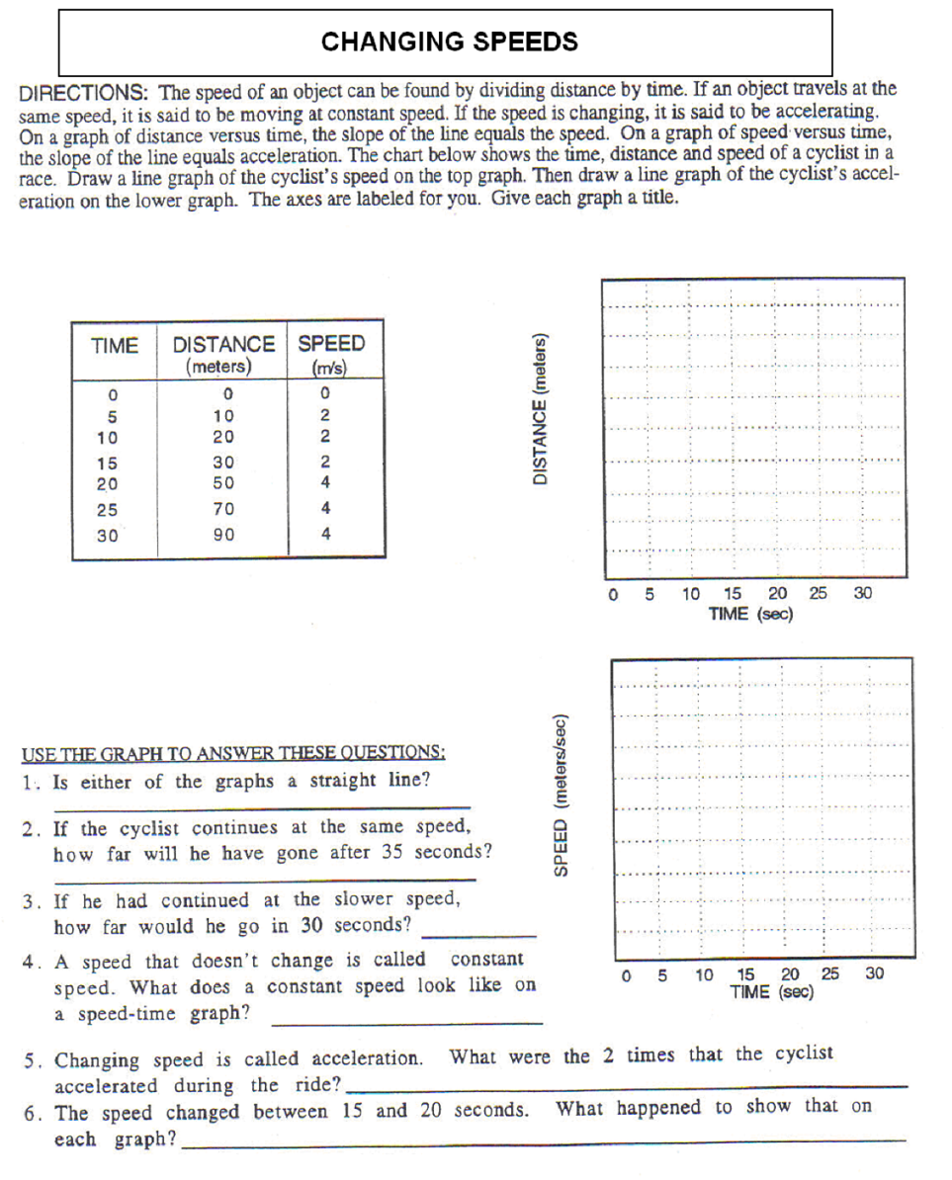
MOMENTUM

Movie sets use boulders made of foam rubber. These large foam “rocks” look just like real rocks, but you can throw them and catch them without hurting yourself or others. You can easily catch a foam rubber boulder because it has far less momentum than the real thing. Momentum is a property of a moving object that depends on its mass and velocity.

For an object moving in a straight line, momentum can be found by multiplying an object’s mass times its velocity, or

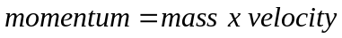

It’s important to remember that because momentum involves velocity, it includes an object’s direction. The momentum of an object is always in the same direction as its velocity. The SI units for momentum are kg∙m/s. Sometimes in science, when units get complicated like this, we “rename” them in honor of some scientist who did a lot of work in the area. However, the units for momentum have never been “renamed”. It is just the units for mass (kg) times the units for velocity (m/s).

A foam rubber boulder has less mass than a stone boulder, so it has less momentum as well. But since momentum also involves velocity, if the foam rubber boulder was going very fast, it could have equal momentum to the stone boulder if it was going super slowly. A bullet has only a little mass, but its extreme velocity gives it deadly momentum. The tectonic plates move mere centimeters per year. But even with that slow speed, they have tremendous momentum because of their mass.

We have not always understood the concept of momentum. Isaac Newton was the first one to develop it in the 1600’s. Since then many inventions have been designed using momentum (as well as other concepts). Your bike wheels are an example. We use the variable letter p in the formula for momentum. The shorthand form of it is

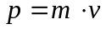

When one of Newton’s rivals was introduced to the concept of momentum, he exclaimed, “Now that’s progress.” The variable for momentum has been p ever since.

Name: Date: Period:

Momentum

Answer the following questions in complete sentences.

- What is momentum?

- What does velocity refer to?

- How could the momentum of a replica equal the real thing?

- What is the formula and units for momentum?

Momentum Math I
Momentum is a quantity defined as the product of an object's mass and its velocity. Momentum is affected by mass and velocity. If velocity is constant, and mass is increased, then momentum will be increased

Formula:
Formulas: | Abbreviations: | Units:
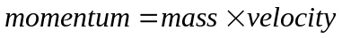 | p = m x v | kilogram ∙ meters per second (kg∙m/s)
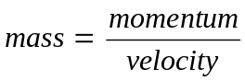 | 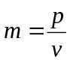 | kilogram (g or kg)
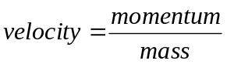 | 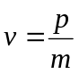 | meters per second (m/s)

Read each problem below and solve. Show the formula used and all work. This will count for 50% of the problem

1 .Calculate the momentum of a 75kg speed skater moving forward at 6m/s
Formula and Work Set- Up
p =

m =

v =

Ans: ____________________

2. Calculate the momentum of a 135 kg ostrich running north at 16.2 m/s
Formula and Work Set- Up
p =

m =

v =

Ans: ____________________

3. Calculate the momentum of a 5.0 kg baby on a train moving eastward at 72 m/s.
Formula and Work Set- Up
p=

m=

v =

Ans: ____________________

4. A pitcher in a professional baseball game throws a fastball, giving the baseball a momentum of 5,83 kg∙m/s. Given that the baseball has a mass of 0.145 kg what would be the velocity of the ball?
Formula and Work Set- Up
p=

m=

v =

Ans: ____________________

5. The momentum of a baseball is 5.06 kg∙m/s away from home plate. The ball is moving with a velocity of 3.75 m/s. What is the mass the mass of the ball?
Formula and Work Set-Up
p=

m=

v=

Ans: ____________________

6. The momentum of a jogger along the highway is 230 kg∙m/s northeast. He is traveling at a velocity of 2.65m/s. What is his mass?
Formula and Work Set- Up
p=

m =

v =

Ans: ____________________
Name Period

Momentum Math II
1. A pitcher in a professional baseball game throws a fastball, giving the baseball a momentum of 5.83 kg∙m/s. Given that the baseball has a mass of 0.145 kg, what is its speed?
Formula and Work Set- Up
p=

m =

v =

Ans: ____________________

2. The maximum speed measured for a golf ball is 273 km/h. If a golf ball with a mass of 47 g had a momentum of 5.83 kg∙m/s, the same of baseball in the previous problem, what would its speed be?
Formula and Work Set- Up
p=

m =

v =

Ans: ____________________

3. The World Solar Challenge in 1987 was the first car race in which all the vehicles were solar powered. The winner was the GM Sunraycer, which had a mass of 177.4 kg, not counting the driver’s mass. Assume that the driver had a mass of 61.5 kg, so that the total momentum of the car and driver was 4,416 kg∙m/s. What was the car’s speed in m/s?

Formula and Work Set- Up
p=

m =

v =

Ans: ____________________
4. The lightest pilot-driven airplane ever built was the Baby Bird. Suppose the Baby Bird moves along the ground without a pilot at a speed of 88 km/h. Under these circumstances, the momentum of the empty plane would be only 2790 kg⋅m/s. What is the mass of the plane?
Formula and Work Set- Up
p=

m =

v =

Ans: ____________________

5. The most massive automobile to be manufactured on a regular bases was the Russian-made Zil-41047. If one of these cars were to move at just 8.9 m/s, its momentum would be 26,700 kg⋅m/s. Use this information to calculate the mass of the Zil-41047,

Formula and Work Set- Up
p=

m =

v =

Ans: ____________________

6. The Japanese high speed bullet train consists of 16 steel cars that have a combined mass of 25,000 kg. The top speed of the train is 61.1 m/s. What is the momentum of the train when traveling at top speed?
Formula and Work Set- Up
p=

m =

v =

Ans: ____________________

Acceleration

The next step in our study of force and motion is to examine acceleration. We will develop a highly sophisticated test for determining if acceleration has occurred. The test is called the “Big Drink Test”. Imagine that you have gone into a convenience store. In an attempt to get the best value possible, you have purchased a drink and filled it to the point of overflowing just like the one in the picture. Somehow you have been able to get into the passenger seat of a car without spilling any and the driver is about to start the car moving.

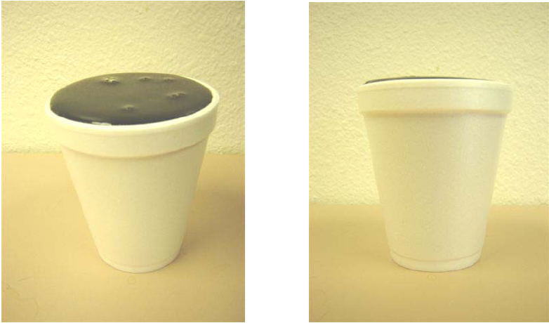

Even if you hold the drink as still as possible, what will happen to the drink if:
- The driver floors it?
- The driver steps on the breaks?
- The driver turns hard left?
- The driver turns hard right?
- The driver hit a deep pothole?
- The driver hits a large speed bump?

Anytime the drink would spill indicates acceleration.

Acceleration is a change in velocity (speed or direction). In each case the speed or direction of the overfull drink changed. If the velocity of the cup changes, we know the cup is accelerating. Officially, the definition of acceleration is the change in speed divided by the time or

In shorthand, 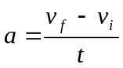
The units for acceleration are slightly different than the units for velocity. Velocity (or speed) has units of m/s. Acceleration has units of m/s². You have actually divided distance by time to get velocity, then divided by time again to get acceleration. That’s why the seconds in the denominator of the units is squared.
Just like with speed, a picture is worth a thousand words so we use a graph to represent a situation. This time the vertical (left) axis is not distance, but velocity. So if the graph rises, it is not representing an increasing distance, but an increasing speed. A graph of your car going from 0-60 mph in 5 seconds, then slowing down to a stop in the next 7 seconds would look something like this:
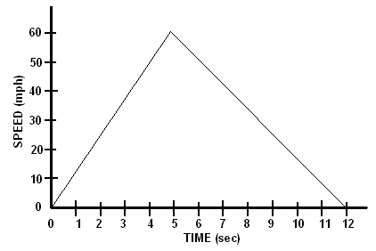
Note again, that the vertical axis is speed and not distance like before.
What would traveling at a constant speed look like on the graph?

A Trip to the Mall

Imagine the following scenario. On the graph below, draw a graph of each segment of the trip. Be sure to label your axes and each phase of the trip.

- One day your family decides to do some shopping at the mall.
- You get in your car and take 10 seconds to speed up to 25 mph.
- You drive at this speed for 3 minutes until you come to a stop sign at Socorro Rd.
- It takes 5 seconds to slow down and stop.
- There is a police officer who makes you wait 4 minutes, so some emergency vehicles can pass.
- Next, you turn onto Socorro Road and take 12 seconds to speed up to 45 mph.
- You continue at this speed for 15 minutes until you reach Americas Ave.
- It takes you 7 seconds to slow down and stop at the red light.
- The light stays red for 3 minutes.
- Then you take 13 seconds to speed up to 55 mph and maintain that speed while you drive to the freeway and get on.
- The traffic is fairly heavy, so it takes 10 minutes to speed up to 60 mph.
- You set the cruise control and drive for 12 more minutes to get to the exit for the mall.
- It takes another seven minutes to exit from the freeway and find a parking space.
- Finally, your car is parked at the mall.

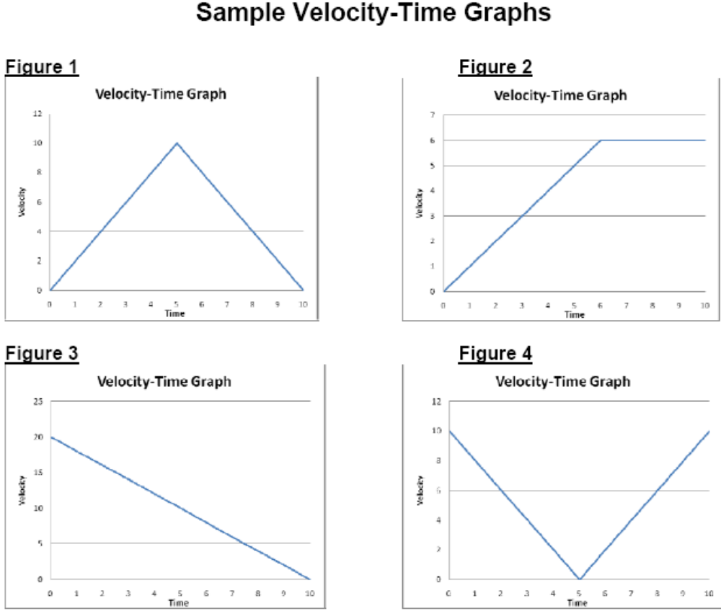
In your own words, describe the motion that is occurring in each of the graphs above.

Figure 1

Figure 2

Figure 3

Figure 4

Acceleration Problems
Formula:

Formulas: | Abbreviations: | Units:
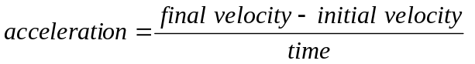 | 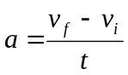 | meters per second squared (m/s²)

- What is the acceleration of a ball that starts from rest (0 m/s) and rolls down a ramp so that it is traveling 25 m/s 5 seconds later?
Formula and Work Set- Up

v_{i} =
v_{f} =
t =
a =

Ans: = ______________

- Johnny Hotfoot slams on the brakes of his car moving at 27 m/s and skids to a stop (0 m/s) in 4 seconds. What is his acceleration?
Formula and Work Set- Up

v_{i} =
v_{f} =
t =
a =

Ans: = ______________

- Kenny drops (0 m/s) his physics book off his aunt’s high-rise balcony. It hits the ground 1.5 seconds later traveling at a velocity of 11.25 m/s. What was the book’s acceleration?
Formula and Work Set- Up

v_{i} =
v_{f} =
t =
a =

Ans: = ______________
Acceleration Calculations

Acceleration means a change in speed or direction. It can also be defined as a change in velocity per unit of time.

Formulas: | Abbreviations: | Units:
 |  | meters per second squared (m/s²)

Calculate the acceleration of the following data.

Initial Velocity Final Velocity Time Acceleration

1. 0 km/hr 24 km/hr 3 s _______________

2. 0 m/s 35 m/s 5 s _______________

3. 20 km/hr 60 km/hr 10 s _______________

4. 50 m/s 150 m/s 5 s _______________

5. 25 km/hr 1200 km/hr 2 min _______________

6. A car accelerates from a standstill to 60 km/hr in
10 seconds. What is its acceleration? _______________

7. A car accelerates from 25 km/hr to 55 km/hr in
30 seconds. What is its acceleration? _______________

8 A train is accelerating at a rate of 0.81 m/s². If
Its initial velocity is 20 km/hr, what is its velocity
after 30 seconds? ______________

9. A runner achieves a velocity of 11.1 m/s, 9 s after he begins.
What is his acceleration? ______________

Acceleration Math

Acceleration is defined as the change in velocity divided by the change in time.

Formulas: | Abbreviations: | Units:
meters per second squared
(m/s²)
 | 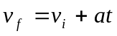 | meters per second (m/s)
 | 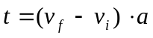 | seconds (s)

Please solve the following problems. Be sure to list all of your variables, formulas and show all your work.

- Natalie accelerates her skateboard along a straight path from 0 m/s to 4.0 m/s in 2.5 s. Find her average acceleration.
Formula and Work Set- Up

v_{i} =
v_{f} =
t =
a =

Ans: = ______________

- A turtle swimming in a straight line toward shore has a speed of 0.50 m/s. After 4.0 s, its speed is 0.80 m/s. What is the turtle’s average acceleration?
Formula and Work Set- Up

v_{i} =
v_{f} =
t =
a =

Ans: = ______________

- Find the average acceleration of a northbound subway train that slows down from 12 m/s to 9.6 m/s in 0.8 s.
Formula and Work Set- Up
v_{i} =
v_{f} =
t =
a =

Ans: = ______________

- Marisa’s car accelerates at tan average rate of 2.6 m/s². Calculate how long it takes her car to accelerate from 24.6 m/s to 26.8 m/s.

Formula and Work Set- Up
v_{i} =
v_{f} =
t =
a =

Ans: = ______________

- Simpson drives his car with an average velocity of 85 km/hr toward the east. How long will it take him to drive 560 km on a perfectly straight highway?
Formula and Work Set- Up
v_{i} =
v_{f} =
t =
a =

Ans: = ______________

- How long will it take a cyclist with a forward acceleration of -0.5 m/s² to bring a bicycle with an initial forward velocity of 13.5 m/s to a complete stop?
Formula and Work Set- Up
v_{i} =
v_{f} =
t =
a =

Ans: = ______________

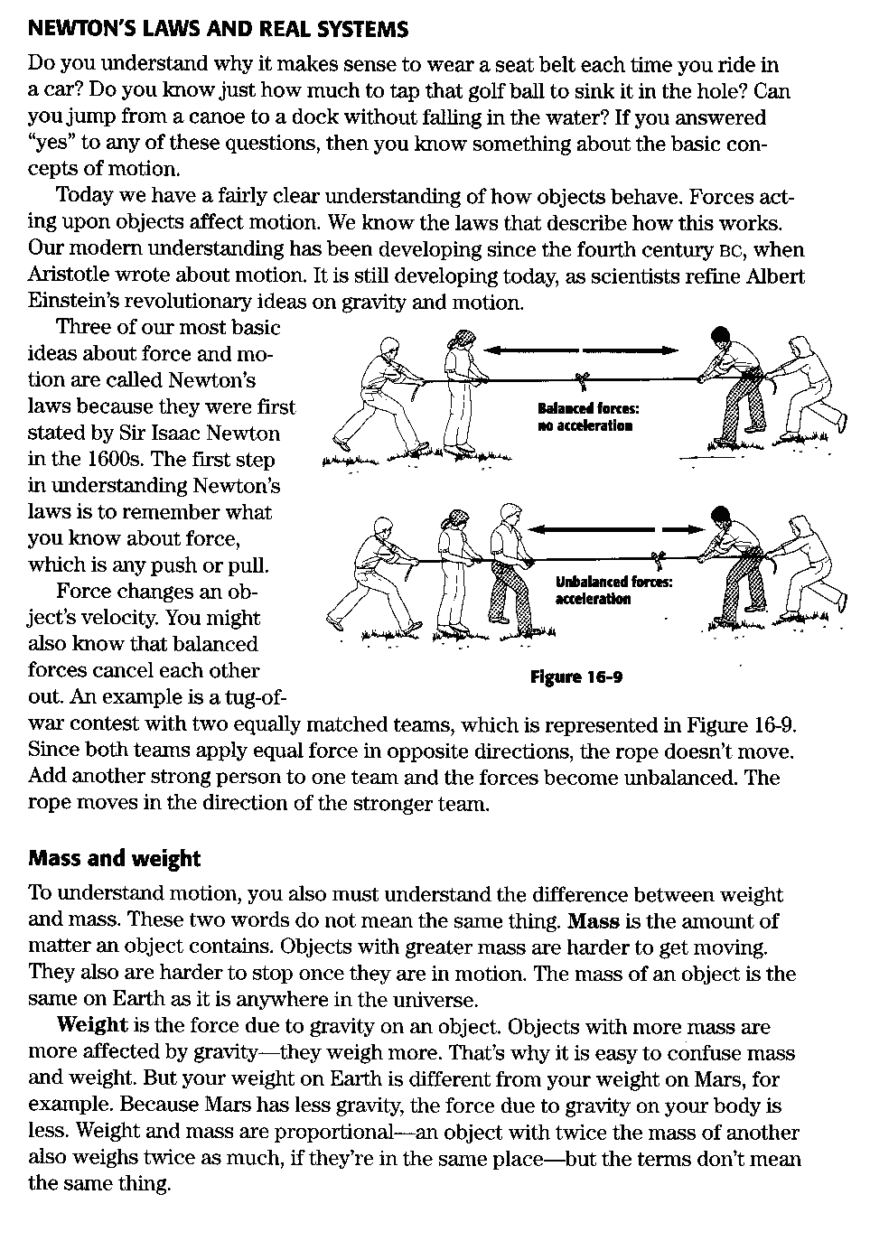
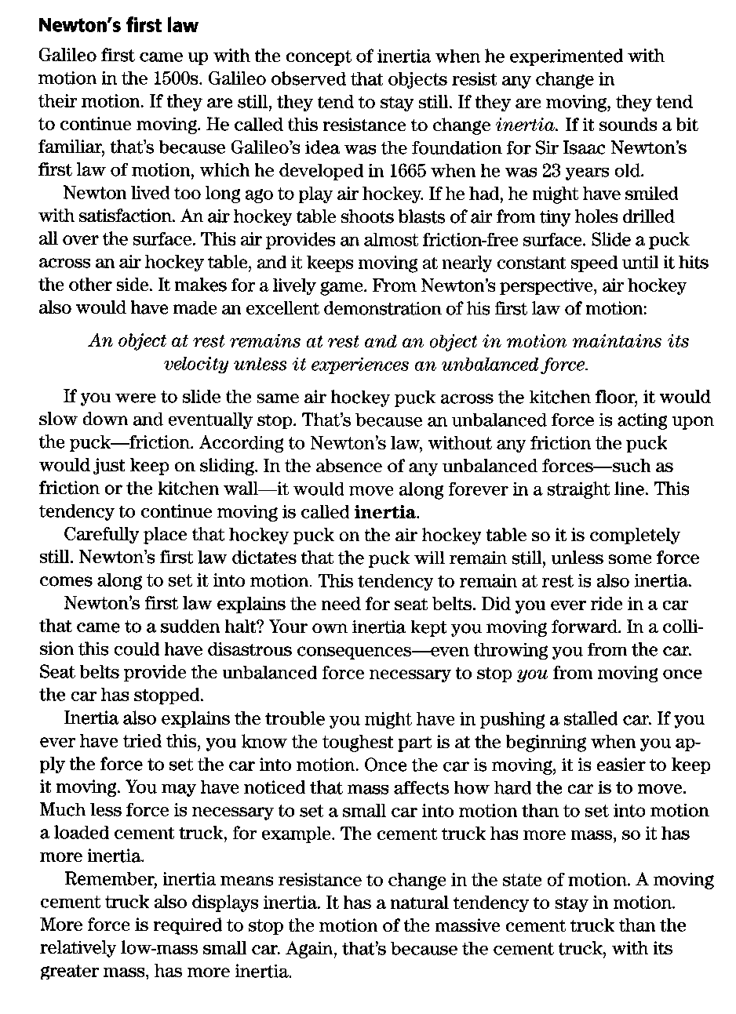

Name: Date: Period:

Newton’s Laws of Motion

Read the text pages and answer the following questions in complete sentences.

- How did Galileo come up with the concept of inertia?

- How does air hockey apply Newton’s first law of motion?

- What does inertia mean?

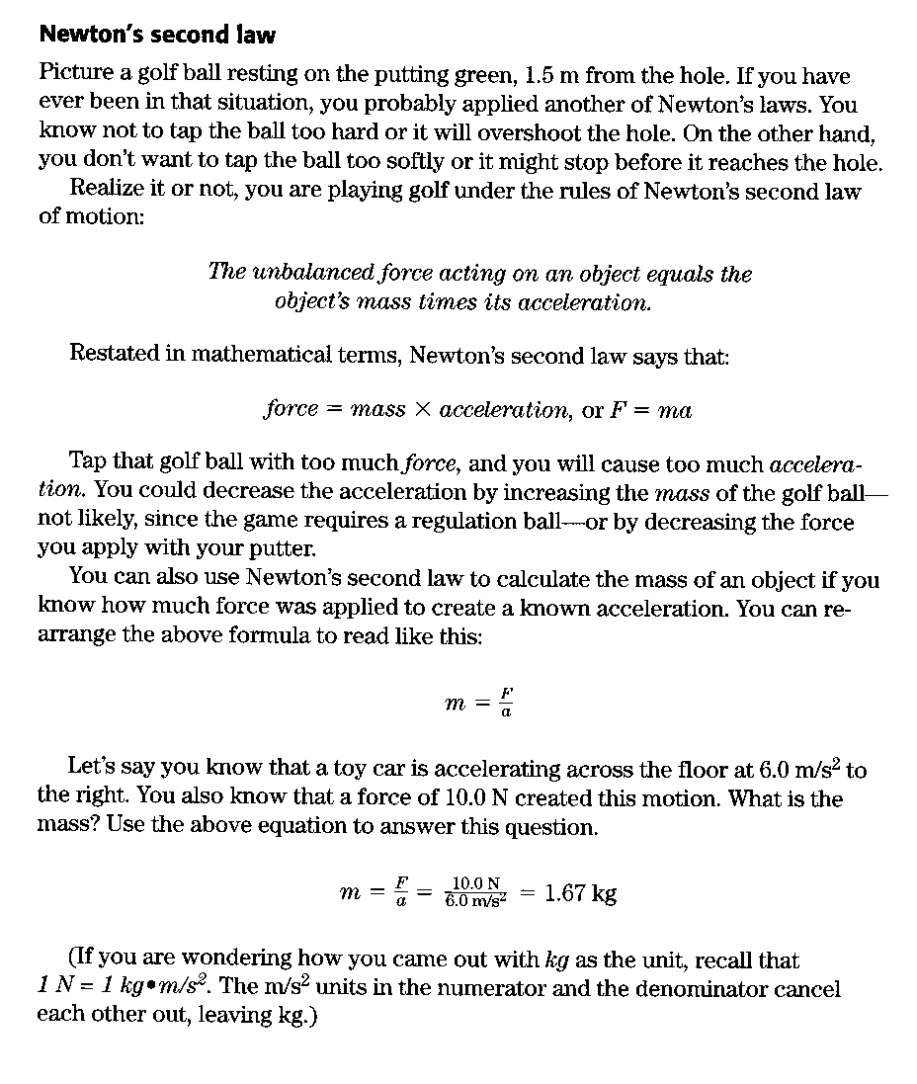

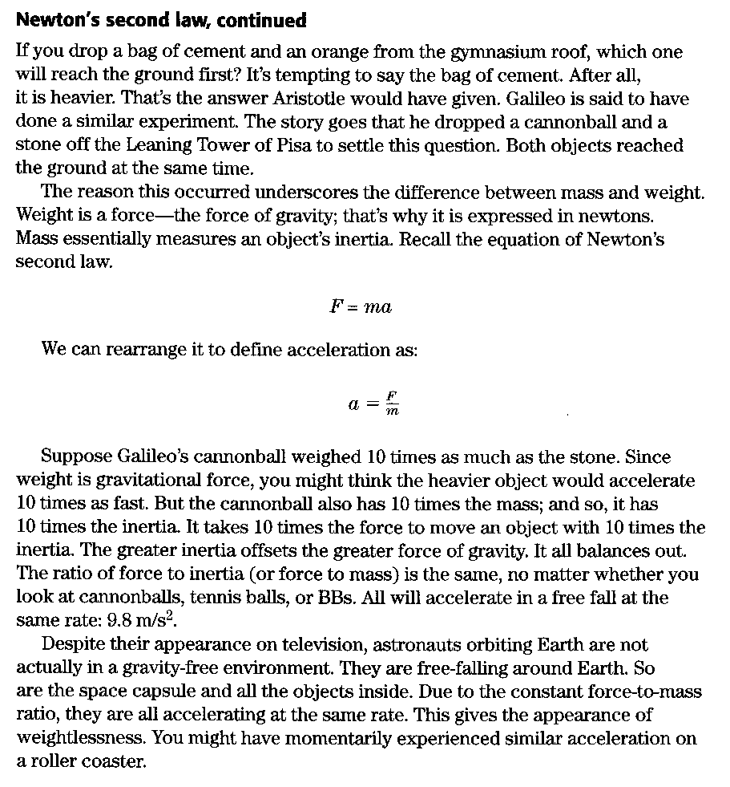
Newton’s Second Law question

  - How does Newton’s second Law apply to golf?

  - State Newton’s second Law mathematically. Include the units.

  - What is the difference in mass and weight?

  - Explain why astronauts give the appearance of weightlessness.
Force
A force is a push or pull. To calculate force, we use the following formula:

Formulas: | Abbreviations: | Units:
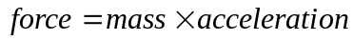 | 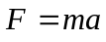 | Newtons (N)
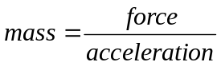 | 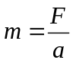 | Kilograms (kg)
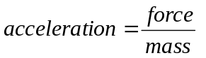 | 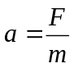 | meters per second squared (m/s²)

Example: With what force will a rubber ball hit the ground if it has a mass of 0.25 kg?

Formula: F = ma
F = ? F = ma
m = 0.25 kg F = (0.25 kg)(9.8 m/s²)
a = 9.8 m/s² F = 2.45 N

- What is the net force necessary for a 2.5 x 10³ kg train to accelerate forward at 2.0 m/s²?

Formula and Work Set-Up
F =

m =

a =

Ans: _______________________

- A tennis ball accelerates downward to 9.8 m/s². If the gravitational force acting on the baseball is 2.8 N, what is the baseball’s mass?

Formula and Work Set-Up
F =

m =

a =

Ans: _______________________
- A sailboat and its crew have a combined mass of 1200 kg. If the sailboat experiences unbalanced forces of 1500 N pushing it forward what is the sailboats acceleration?
Formula and Work Set-Up
F =

m =

a =

Ans: = ______________

- With what force does a car hit a tree if the car has a mass of 3000 kg and it is accelerating at a rate of 2 m/s²?
Formula and Work Set- Up
F =

m =

a =

Ans: = ______________

- A 10 kg bowling ball would require what force to accelerate it down an alleyway at a rate of 3 m/s²?
Formula and Work Set- Up
F =

m =

a =

Ans: = ______________

- What is the mass of a falling rock if it hits the ground with a force of 147 N?
Formula and Work Set- Up
F =

m =

a =

Ans: = ______________

- What is the acceleration of a softball if it has a mass of 10.50 kg and hits the catcher’s glove with a force of 25 N?
Formula and Work Set- Up
F =

m =

a =

Ans: = ______________

- What is the mass of a truck if it is accelerating at a rate of 5 m/s² and hits a parked car with a force of 14,000 N?
Formula and Work Set- Up
F =

m =

a =

Ans: = ______________

Newton’s Second Law Math – Weight

Weight is a force of gravity pulling down on a mass. Weight can change based on location but mass cannot. Solve the following weight problems and show all of your work.

Formulas: | Abbreviations: | Units:
 | 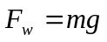 | Newtons (N)
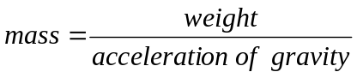 | 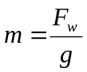 | Kilograms (kg)
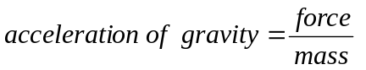 | 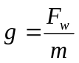 | meters per second squared (m/s²)

  - A girl has a mass of 50 kg on earth where the acceleration due to gravity is 9.8 m/s². Calculate her weight.
Formula and Work Set- Up
m =

g =

F_{w} =

Ans: = ______________

  - A rock on Pluto has a weight of 5000 N and a mass of 250 kg. What is the acceleration due to gravity on Pluto?
Formula and Work Set- Up
m =

g =

F_{w} =

Ans: = ______________

  - An astronaut weighs about 1000 N on earth lands on the moon. What is his mass? (acceleration due to gravity = 9.8 m/s²)
Formula and Work Set- Up
m =

g =

F_{w} =

Ans: = ______________

  - Calculate your weight of a man who weighs 100 lbs. on Earth in Newton’s. To find mass take the weight and divide by 2.2. This will give you the mass in kg.
Formula and Work Set- Up
m =

g =

F_{w} =

Ans: = ______________
Newton’s third law

Suppose you try jumping from a canoe onto a dock. Your attempt to propel yourself forward with one foot while the other foot reaches out toward the dock backfires. Instead it propels the canoe away from the dock. You land in the water. Newton’s third law of motion is to blame for this embarrassing scene.

For every action force, there is an equal and opposite reaction force.

Your foot pushes back on the canoe to propel you forward. The canoe simultaneously pushes forward on your foot to propel itself backward. The force your foot exerts on the canoe is the action force; the force the canoe exerts on our foot is the reaction force.
Think about swimming. Your paddling pushes the water backward and the water pushes your forward.
The figure below shows how rockets take advantage of Newton’s third law for propulsion. Hydrogen and oxygen gases combine and combust. This sustained reaction forces gas from the back of the rocket. The rocket pushes the gases backward; the gases push the rocket forward.

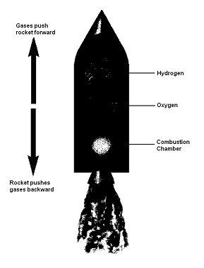

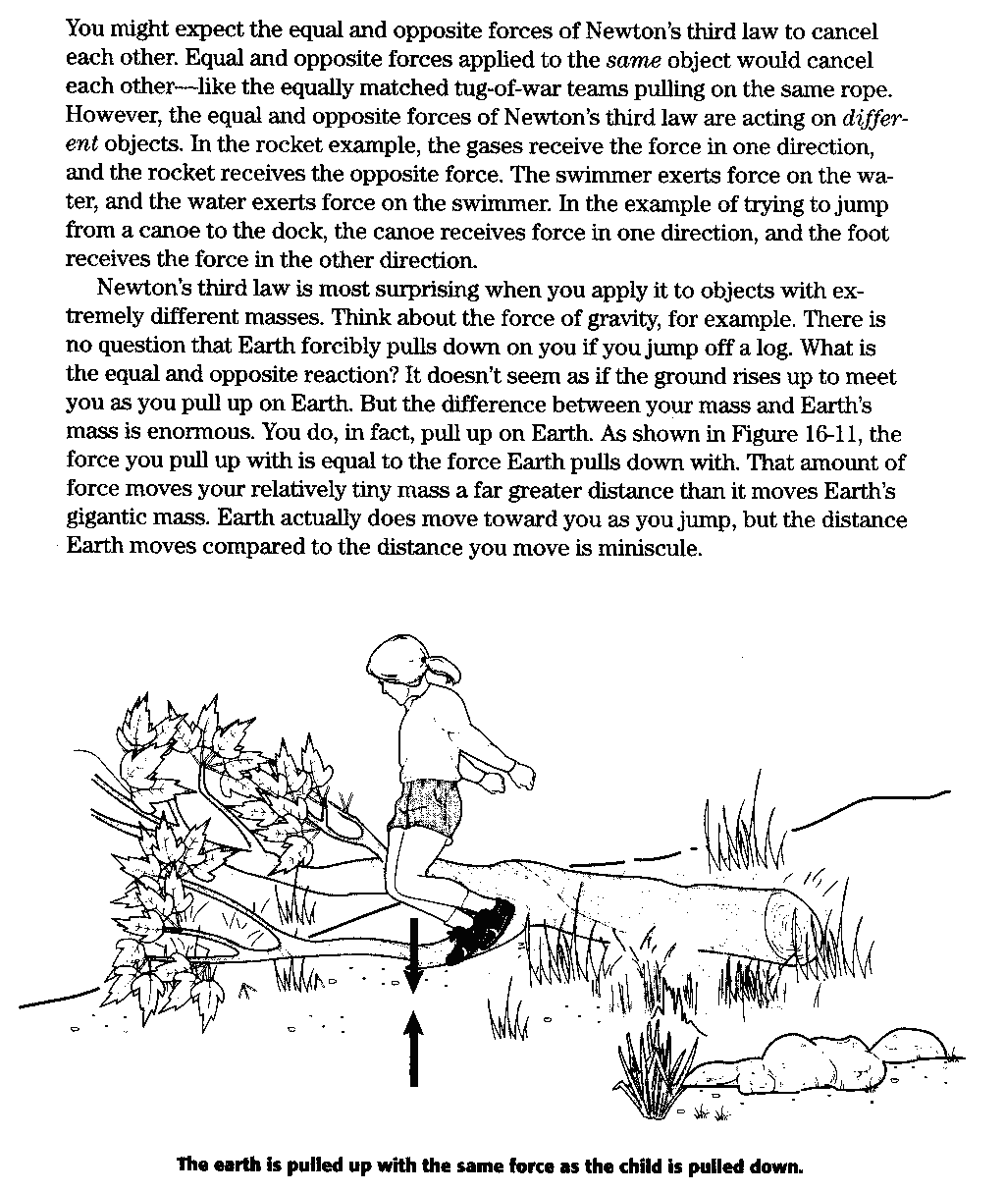
Newton’s Third Law Questions

Using the text reading answer the following questions in complete sentences.

- State Newton’s Third Law of Motion.

- Use Newton’s Third Law to explain how a rocket is propelled.

- What happens when equal and opposite forces are applied to the same object? To different objects?

- How does Newton’s Third Law apply to objects with different masses?

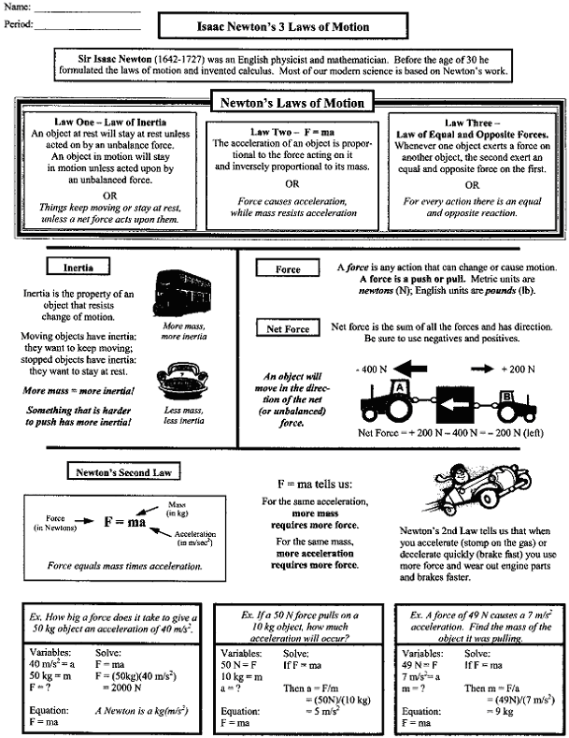
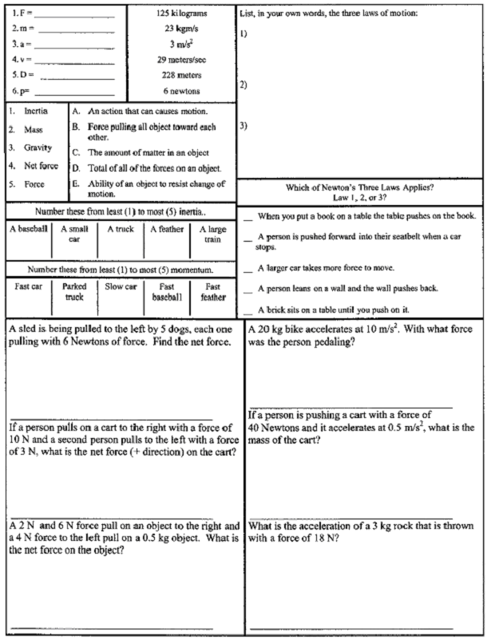

Work

Using force, you can pull a wagon down a sidewalk or push a box across the garage floor. In both cases, you do work. But work if you apply force to push a stalled car and the car doesn’t budge. Have you done any work?
In science, work occurs when a force causes an object to move in the direction of the force. The formula for calculating work is:

work = force x distance

If the distance is zero, as in the stalled car that won’t budge, no work is done. If you pull your backpack up a flight of stairs, you’ve performed work. If you pull it up two stories, you’ve done twice as much work. Or you could perform the same amount of work by pulling two backpacks up one story – twice the force for half the distance.
You are doing work when you make something move by using your force against another force that would otherwise keep it from moving. When you pulled your backpack up the staircase, that other force was gravity. When you pushed the box across the garage floor, the other force was friction. You are also doing work when you change the speed of something by applying your force against its inertia. Brakes perform work as the slow a car down.
Force, which is the product of mass (in kg) and acceleration (in m/s²), is expressed as the SI unit, the Newton (N).

1 N = 1 kg x 1 m/s²

Work, then, can be expressed in terms of newtons through distance. The product of 1 N and 1 M is 1 joule (J pronounced jewel). One joule is about the amount of work it takes to lift an apple 1 m.

Work

Read text page and answer the following questions in complete sentences.

- When does work occur?

- When is work not done?

- What is force?

- How is work expressed?

Name: Date: Period:
Calculating Work

Work has a special meaning in science. It is the product of the force applied to an object and the distance the object moves. The unit of work is the joule (J). 1 N • m = 1 J

Formulas: | Abbreviations: | Units:
Work = Force x Distance | W = F x D | Joules (J)
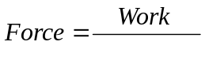  Distance | 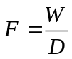 | Newtons (N)
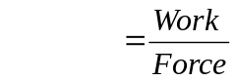  Distance | 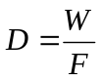 | Meters (m)

Example:
Imagine a father playing with his daughter by lifting her repeatedly into the air. How much work does he do with each lift, assuming he lifts her 2.0 m and exerts an average force of 190 N.

Formula and Work Set-Up

F = 190 N W = F x D W = 190 N • 2.0 m
D = 2.0 m W = 190 N • 2.0 m
W = ? W = 380 N • m or 380 J

Ans: W = 380 J

Solve the following problems

- A crane uses an average force of 5200 N to lift a girder 25 m. How much work does the crane do on the girder?

Formula and Work Set-Up
F =

D =

W =

Ans: ___________________

- How far was a vehicle lifted when 45 J was applied using 5 N of force?

Formula and Work Set-Up
F =

D =

W =

Ans: ___________________

- If 225 J of work was done over a distance of 25 m, how much force was used?

Formula and Work Set-Up
F =

D =

W =

Ans: ___________________

- An apple weighing 1 N falls through a distance of 1 m. How much work is done on the apple by the force of gravity?

Formula and Work Set-Up
F =

D =

W =

Ans: ___________________

- The brakes on a bicycle apply 125 N of frictional force to the wheels as the bicycle travels 14.0 m. How much work have the brakes done on the bicycle?

Formula and Work Set-Up
F =

D =

W =

Ans: ___________________

- While rowing in a race, John uses his arms to exert a force of 165 N per stroke while pulling the oar 0.800 m. How much work does he do in 30 strokes?

Formula and Work Set-Up
F =

D =

W =

Ans: ___________________

- A pitcher did 98 J of work when he threw a baseball 15 m. How much force did he put on the ball?

Formula and Work Set-Up

F =

D =

W =

Ans: ___________________

- The tight end ran for a touch down. It was calculated that he did 4500 J of work and used 90 N of force. How far did he run?

Formula and Work Set-Up
F =

D =

W =

Ans: ___________________
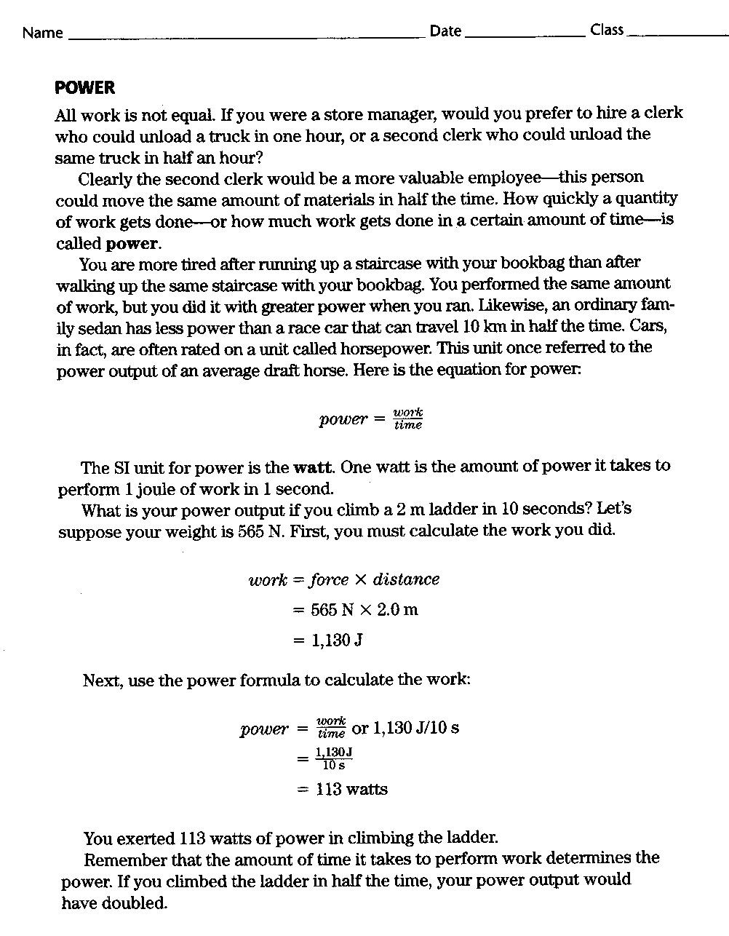
Power

Read text page and answer the following questions in complete sentences.

- How is work not equal?

- What is power?

- How are engines rated?

- What is the SI unit for power?

- What is the formula for power?

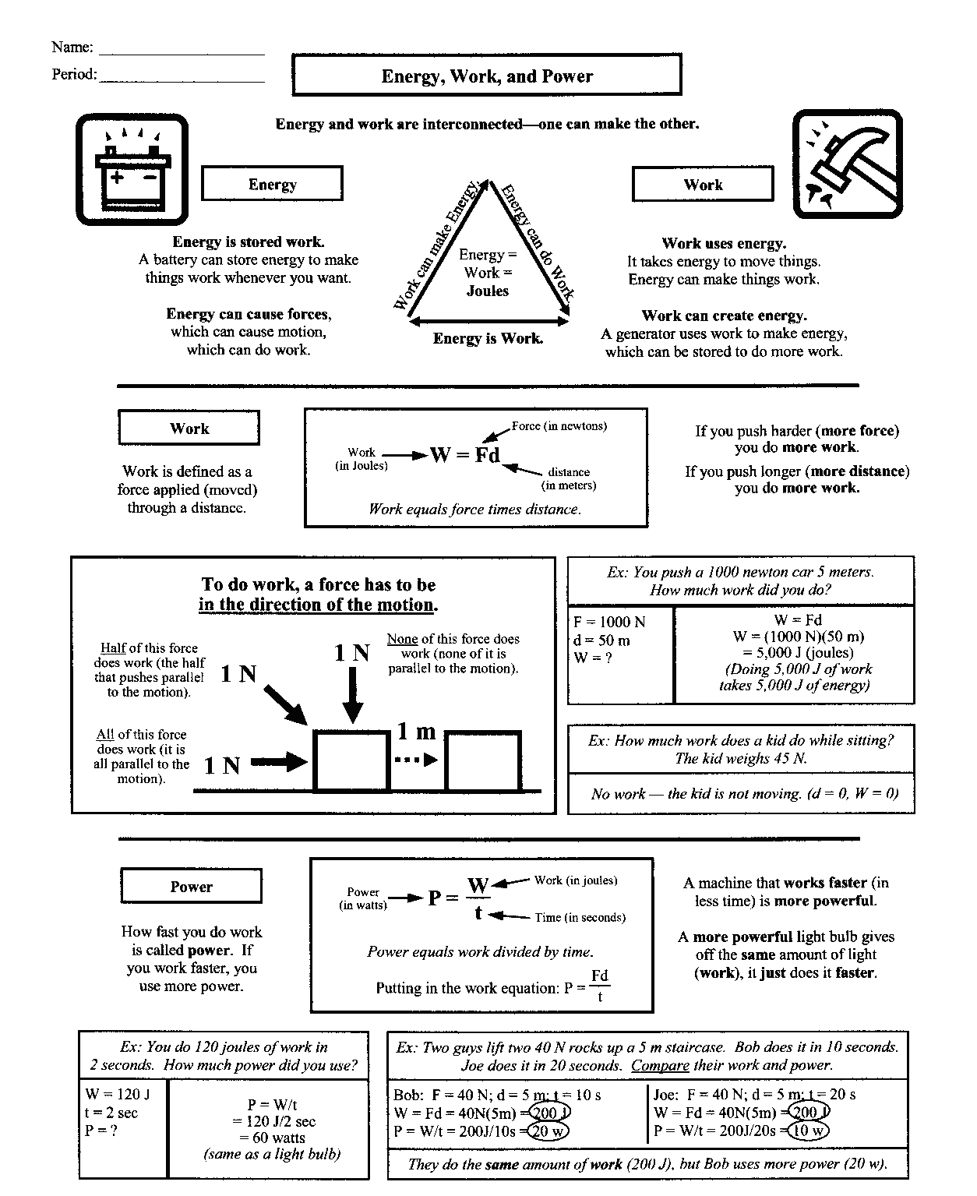
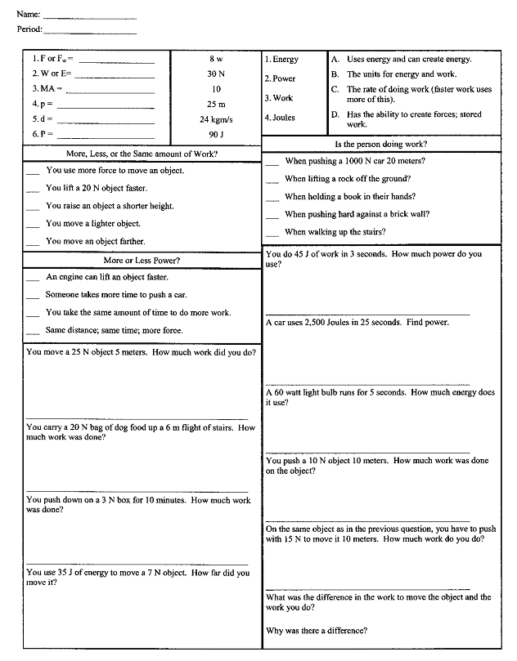

Work and Power Problems I

Work has a special meaning in science. It is the product of the force applied to an object and the distance the object moves. The unit of work is the Joule or Newton-meter. One Joule = 1 N-m or 1 kg-m²/s². Solve each problem below and show the formula, work, units.

Formulas:

Formulas: | Abbreviations: | Units:
Work = Force x Distance | W = F x D | Joules (J)
Distance |  | Newtons (N)
Distance |  | Meters (m)
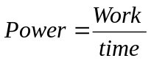 | 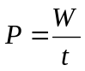 | Watts (W)
Work = Power x time | W = P x t | Joules (J)
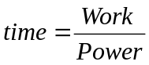 | 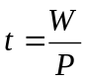 | Seconds (s)

- A book weighing 1.0 N is lifted 2 m. How much work was done?
Formula and Work Set-Up
W =

F =

D =

Ans: _____________________________

- It took 50 J to push a chair 5 m across the floor. With what force was the chair pushed?
Formula and Work Set-Up
W =

F =

D =

Ans: _____________________________

- A force of 100 N was necessary to lift a rock. A total of 150 J of work was done. How far was the rock lifted?
Formula and Work Set-Up
W =

F =

D =

Ans: _____________________________

- How much work is done using a 500 W microwave oven for 5 s?
Formula and Work Set-Up

W =

t =

P =

Ans: _____________________________

- Using a jack, a mechanic does 5350 J of work to lift a car 0.5 m in 50.0 s. What is the mechanic’s power output?
Formula and Work Set-Up

W =

t =

P =

Ans: _____________________________
- An electric mixer uses 350 W of power. If 8.75 x 10³ J of work is done by the mixer, how long has the mixer run?
Formula and Work Set-Up

W =

t =

P =

Ans: _____________________________

- While rowing in a race, John does 3960 J of work on the oars in 60 s. What is his power output in Watts?
Formula and Work Set-Up

W =

t =

P =

Ans: _____________________________

- An apple weighing 1 N falls through a distance of 3 m. How much work is done on the apple by the force of gravity?
Formula and Work Set-Up

Work =

Force =

Distance =

Ans: _____________________________

Work and Power Problems II

Solve the problems below. Show all work with correct units.

Formulas: | Abbreviations: | Units:
Work = Force x Distance | W = F x D | Joules (J)
Distance |  | Newtons (N)
Distance |  | Meters (m)
 |  | Watts (W)
Work = Power x time | W = P x t | Joules (J)
 |  | Seconds (s)

- The bakes on a bicycle apply 125 N of frictional force to the wheels as the bike travels 14.0 m. How much work have the brakes done on the bicycle?
Formula and Work Set-Up
W = ?

F = 125 N

D = 14.0 m

Ans: _____________________________

- Every second, a coal fired power plant produces enough electricity to do 9 x 10⁸ J of work. What is the plant’s power output in watts?
Formula and Work Set-Up
W =

t =

P =

Ans: _____________________________

- You are moving a set of books and in the process you exert a force of 60.0 N to push the box 12.0 m in 20 s. Calculate the work that was done and then determine the power needed.
Formula and Work Set-Up
F =

D =

t =

W =

P =

Ans: _____________________________

- In loading a truck the worker uses 300 N of force to move a heavy box 1 m off the ground in 3 s. Calculate the work that was done and then determine the power needed.
Formula and Work Set-Up
F =

D =

t =

W =

P =

Ans: _____________________________

- A set of pulleys is used to lift a piano weighing 1000 N. The piano is lifted 3 m in 60 s. How much power is used?
Formula and Work Set-Up
F =

D =

t =

W =

P =

Ans: _____________________________

