|  |  |
| --- | --- |
| # correct |  |
| Total #?’s | 170 |
| **GRADE** |  |

Name: ________________________________________________

C:\Documents and Settings\dmhenry\Local Settings\Temporary Internet Files\Content.IE5\8ZQYMVT2\MC900238385[1].wmf

Unit 1

Student Manual

Nature of Science

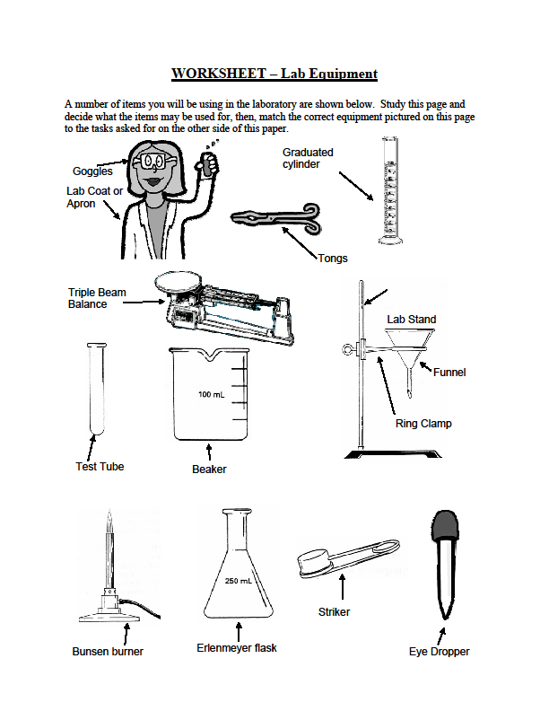

|  |  |
| --- | --- |
| **Object Name** | **Used for** |
|  | Used to pick up or hold hot objects |
|  | Protects the eyes from flying objects or chemical splashes |
|  | A wide-mouthed container used to transport, heat or store substances |
|  | A small glass container used to view chemical reactions or to heat small amounts of a substance |
|  | A device to measure the mass of an object or substance |
|  | Protects the scientist and the scientist’s clothes from hazardous or hot chemicals |
|  | Used to dispense a very small amount of a liquid |
|  | Used to light a Bunsen burner |
|  | Attaches to a lab stand and used to hold a variety of lab equipment |
|  | Used to measure volume very precisely |
|  | Used to hold a variety of lab equipment |
|  | Used to pour liquids into containers with small openings or to hold filter paper |
|  | Used to heat objects |
|  | A narrow-mouthed container used to transport, heat or store substances, often used when a stopper is required |

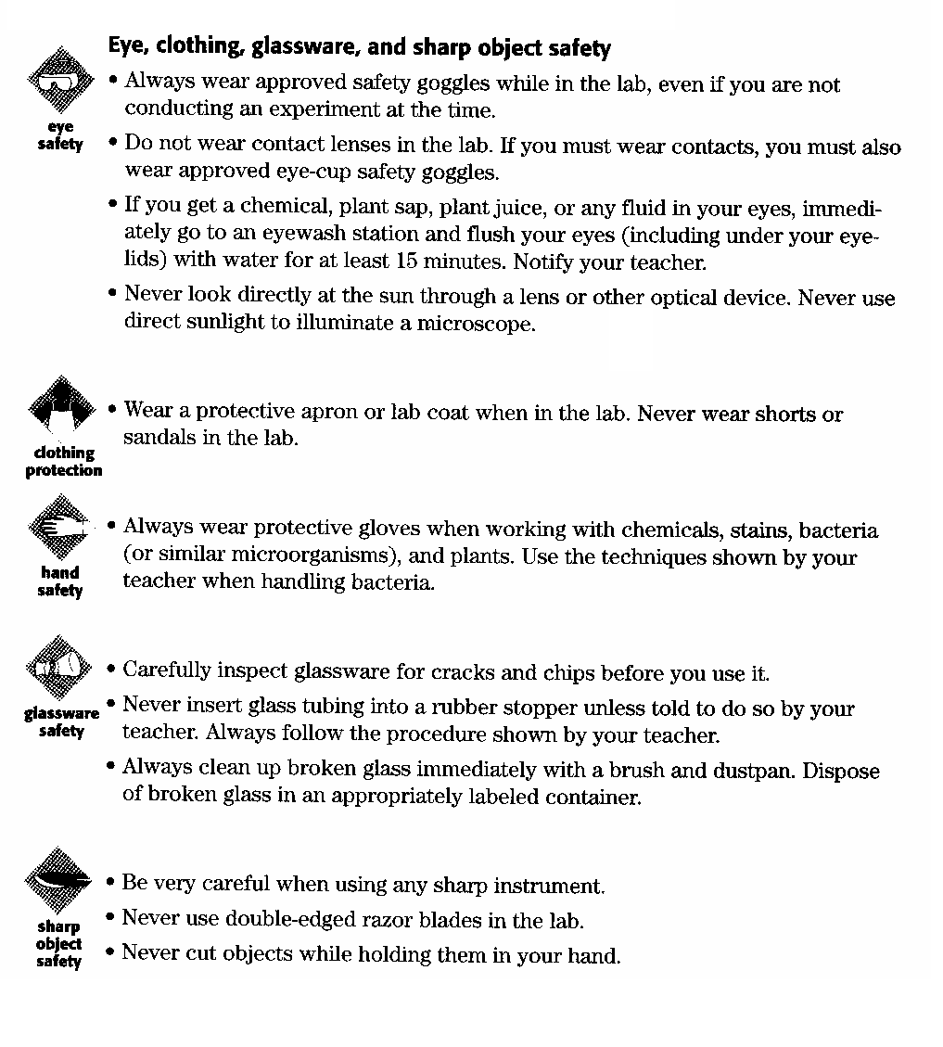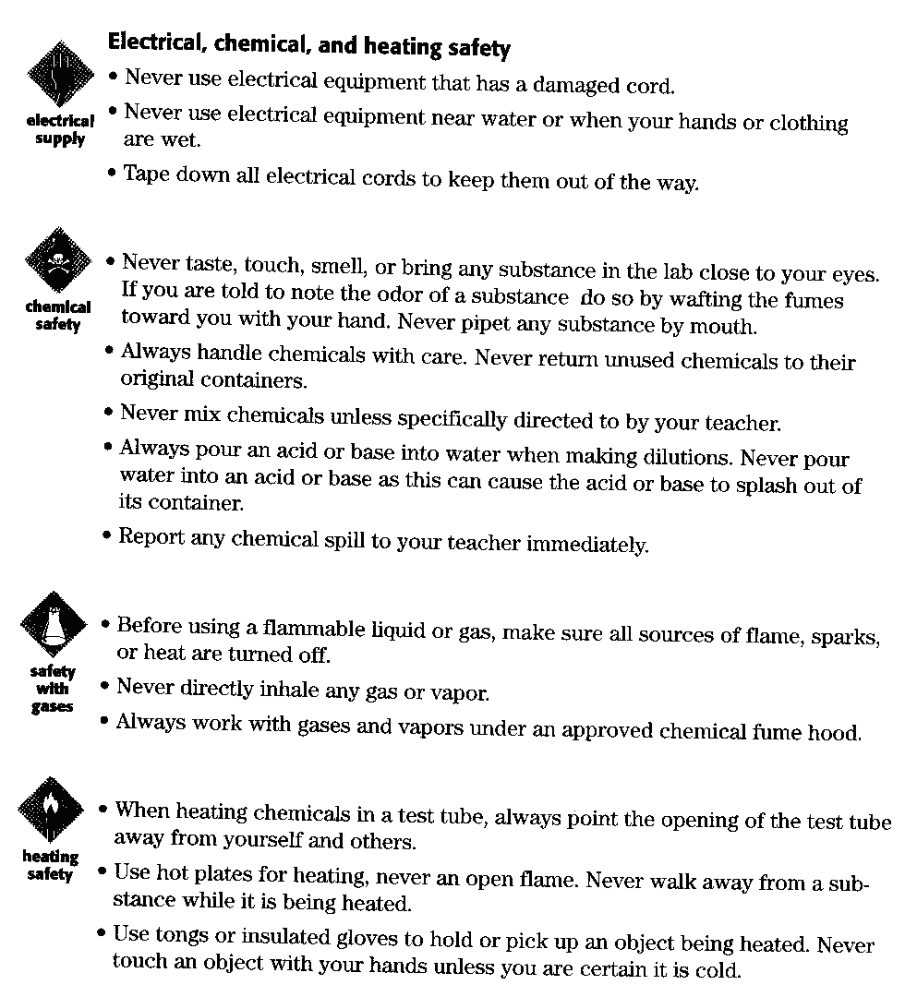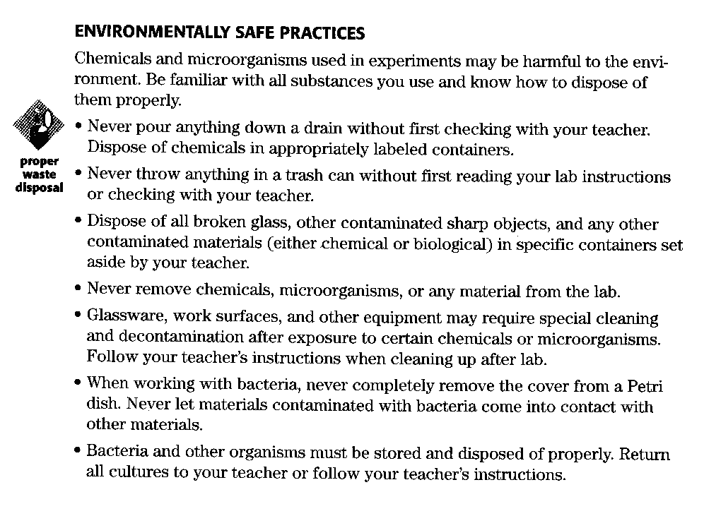

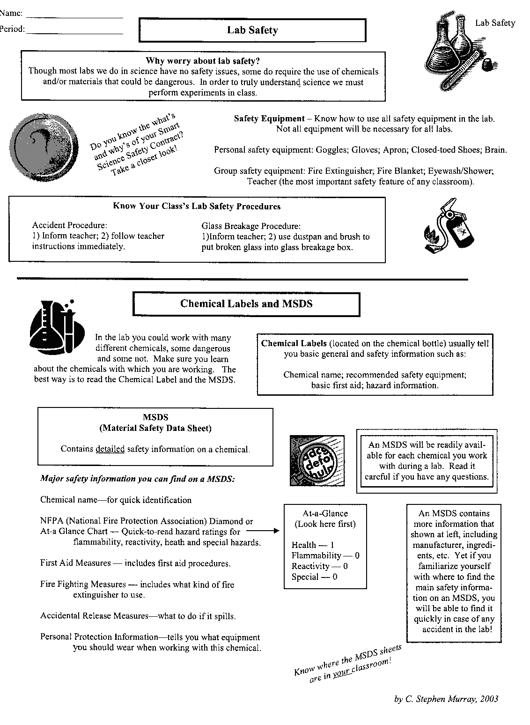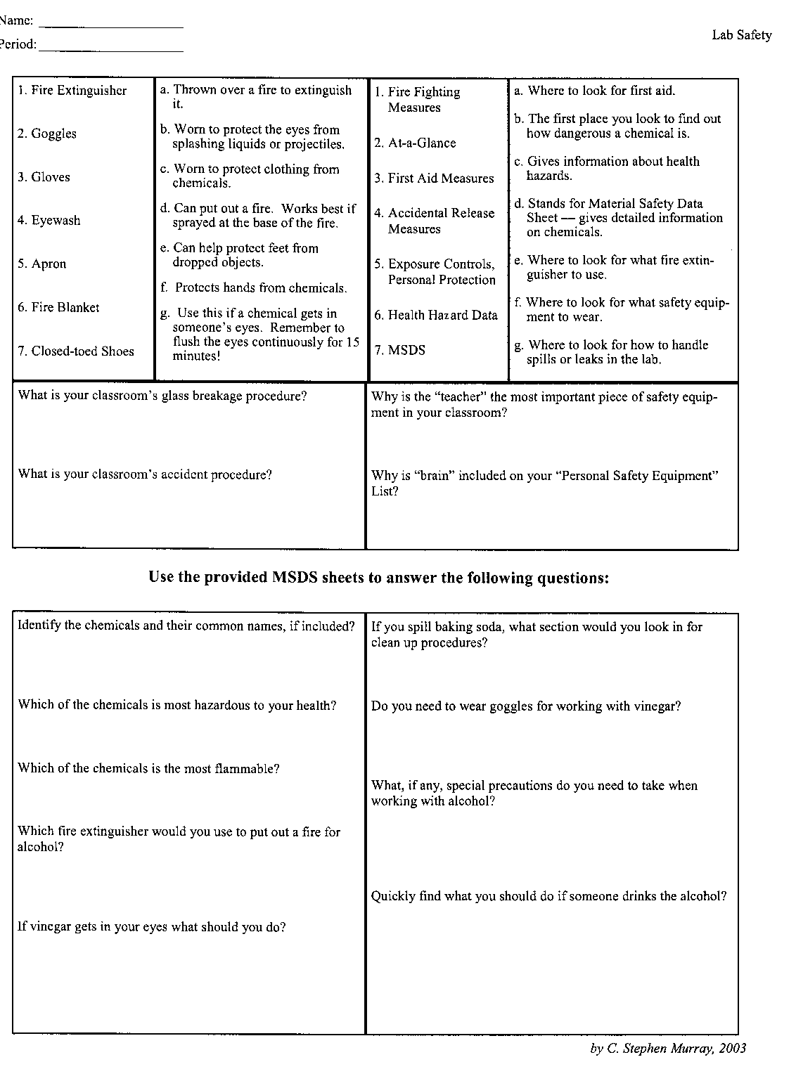

**Scenarios**

**Look at each lab scenario and list everything that is not right. Then correct it.**

**Scenario #1**

The teacher was not in the room yet. Jake began weighing chemicals, touching them with his hands. His nose itched, so he rubbed it.

**Scenario #2**

Heather and Jennifer were absent the day before when the investigation was discussed. They gathered the materials and watched their classmates to see what to do, not taking time to read the directions

**Scenario #3**

Sam was heating a test tube. He didn’t put on safety goggles since he was wearing glasses. He slanted the tube away from his work area, but toward students on the opposite side of his lab table.

**Scenario #4**

Cindy broke a test tube. Carefully she picked up pieces with one hand and placed them in her other hand. Then she dumped the glass pieces into the wastebasket.

**Scenario #5**

The cuff of Sam’s long-sleeved shirt sleeve caught fire. He ran to show his teacher.

**Scenario #6**

Mike and Colleen had a lot of a chemical left from their investigation. They dumped the chemical in the sink and left the water running in the sink as they left class.

**Scenario #7**

Diana and Mike were going to be late to their next class. After rushing to put away a few materials, they left the rest of the materials on the lab table.

**Scenario #8**

Gina didn’t pay attention when the teacher explained where safety equipment was found and how it was used. She thought to herself, “I’ll never need that.”

Identify the Controls and Variables

|  |  |
| --- | --- |
| http://www.biologycorner.com/resources/smithers2.gifSmithers thinks that a special juice will increase the productivity of workers. He creates two groups of 50 workers each and assigns each group the same task (in this case, they're supposed to staple a set of papers). Group A is given the special juice to drink while they work. Group B is not given the special juice. After an hour, Smithers counts how many stacks of papers each group has made. Group A made 1,587 stacks, Group B made 2,113 stacks. | Identify the:   1. Control Group 2. Independent Variable 3. Dependent Variable 4. What should Smithers' conclusion be? 5. How could this experiment be improved? |
| http://www.biologycorner.com/resources/homer2.gifHomer notices that his shower is covered in a strange green slime. His friend Barney tells him that coconut juice will get rid of the green slime. Homer decides to check this out by spraying half of the shower with coconut juice. He sprays the other half of the shower with water. After 3 days of "treatment" there is no change in the appearance of the green slime on either side of the shower. | 1. What was the initial observation?   Identify the:   1. Control Group 2. Independent Variable 3. Dependent Variable 4. What should Homer's conclusion be? |

Name ________________________

**Scientific Method: Bikini Bottom Experiments**

**The Bikini Bottom gang loves science class and wanted to do a little research. Read the description for each experiment and use your knowledge of the scientific method to answer the questions.**

**(1) Flower Power**

SpongeBob loves to garden and wants to grow lots of pink flowers for his pal Sandy. He bought a special Flower Power fertilizer to see if will help plants produce more flowers. He plants two plants of the same size in separate containers with the same amount of potting soil. He places one plant in a sunny window and waters it every day with fertilized water. He places the other plant on a shelf in a closet and waters it with plain water every other day.

1. What did SpongeBob do wrong in this experiment? Explain.
2. What should SpongeBob do to test the effectiveness of Flower Power fertilizer? Write an experiment.

**(2) Super Snails**

Gary is not the smartest snail in Bikini Bottom and believes he can improve his brain power by eating Super Snail Snacks. In order to test this hypothesis, he recruits SpongeBob and several snail friends to help him with the experiment. The snails ate one snack with each meal every day for three weeks. SpongeBob created a test and gave it to the snails before they started eating the snacks as well as after three weeks.

|  |  |  |
| --- | --- | --- |
| **Test Results** | | |
| Snail | Before | After |
| Gary | 64% | 80% |
| Larry | 78% | 78% |
| Barry | 82% | 84% |
| Terry | 72% | 70% |

1. Based on the data provided, do the Super Snail Snacks work? Explain your answer.

*Worksheet created by T. Trimpe 2003 http://sciencespot.net/*

**Units of Measurement**

Mathematics is the language of science, and mathematical models rely on accurate observations. But if your scientific measurements are in inches and gallons, many scientists will not understand because they do not use these units. For this reason scientist use the International System of Units, abbreviated SI, which stands for the French phrase *le Système Internationale d’Unitès.*

**SI Units are used for Consistency**

When all scientists use the same system of measurement, sharing data and results is easier. SI is based on the metric system and uses the seven SI base units.

SI Base Units

|  |  |  |
| --- | --- | --- |
| **Quantity** | **Unit** | **Abbreviation** |
| **Length** | **meter** | **m** |
| **Mass** | **kilogram** | **kg** |
| **Time** | **second** | **s** |
| **Temperature** | **Kelvin** | **K** |
| **Electric current** | **ampere** | **A** |
| **Amount of Substance** | **mole** | **mol** |
| **Luminous Intensity** | **candela** | **cd** |

Perhaps you noticed that the base units do not include area, volume, pressure, weight, force, speed, and other familiar quantities. Combinations of the base units, called derived units, are used for these measurements.

**SI prefixes are for very large and very small measurements**

Look at a meter stick. How would you express the length of a bird’s egg in meters? How about the distance you traveled on a vacation trip? The bird’s egg might be 1/100 m or 0.01 m long. Your trip could have been 800 000 m in distance. To avoid writing a lot of decimal places and zeros, SI uses prefixes to express very small or vary large numbers. These prefixes are all multiples of 10.

**Prefixes Used for Measurements**

|  |  |  |  |
| --- | --- | --- | --- |
| **Prefix** | **Symbol** | **Meaning** | **Multiple of Base unit** |
| **giga** | **G** | **billion** | **1 000 000 000** |
| **mega** | **M** | **million** | **1 000 000** |
| **kilo** | **k** | **thousand** | **1 000** |
| **hecto** | **h** | **hundred** | **100** |
| **deca** | **da** | **ten** | **10** |
| **Base Units**  **Meters, liters, grams** | **m, L, g** | **one** | **1** |
| **deci** | **d** | **tenth** | **0.1** |
| **centi** | **c** | **hundredth** | **0.01** |
| **milli** | **m** | **thousandth** | **0.001** |
| **micro** | **μ** | **millionth** | **0.000 000 1** |
| **nano** | **n** | **billionth** | **0.000 000 001** |

Table 1

Using the prefixes, you can now say that the bird’s egg is 1 cm (1 centimeter is 0.01 m) long and your trip was 800 km (800 kilometers are 800 000 m) long. Note that the base unit of mass is the kilogram which is already a multiple of gram.

It is easy to convert SI units to smaller or larger units. Remember that to make a measurement, it takes more of a small unit or less of a large unit. A person’s height could be 1.85 m, a fairly small number. In centimeters, the same height would be 185 cm, a larger number. So, if you are converting to a smaller unit, multiply the measurement to get a bigger number. To write 1.85 m as centimeters, you multiply by 100.

1.85 m x 100 cm/1m = 185 cm

If you are converting a larger unit, divide the measurement to get a smaller number. To change 185 cm to meters, divide by 100 as shown.

185 cm x 1 m/100 cm = 1.85 m

**Math Skills**

Conversions: A roll of copper wire contains 15 m of wire. What is the length of the wire in centimeters?

1. List the given and unknown values

Given: *length in meters*, l = 15 m

Unknown: *length in centiments* = ? cm

1. Determine the relationship between units

Looking at Table 1, you can find that 1 cm = 0.01 m

This also means that 1 m = 100 cm.

You will multiply because you are converting from a larger unit (meters) to a smaller unit (centimeters).

1. Write the equation for the conversion

*Length is cm* = m x 100 cm/1m

1. Insert the known values into the equation and solve

*Length in cm* = 15 m x 100 cm/1 m

*Length in cm* = 1500 cm

**Practice Conversions**

1. **Write 550 millimeters as meters**
2. **Write 3.5 seconds as milliseconds**
3. **Convert 1.6 kilograms to grams**
4. **Convert 2500 milligrams to kilograms**
5. **Convert 4.00 centimeters to micrometers**
6. **Change 2800 millimoles to moles**

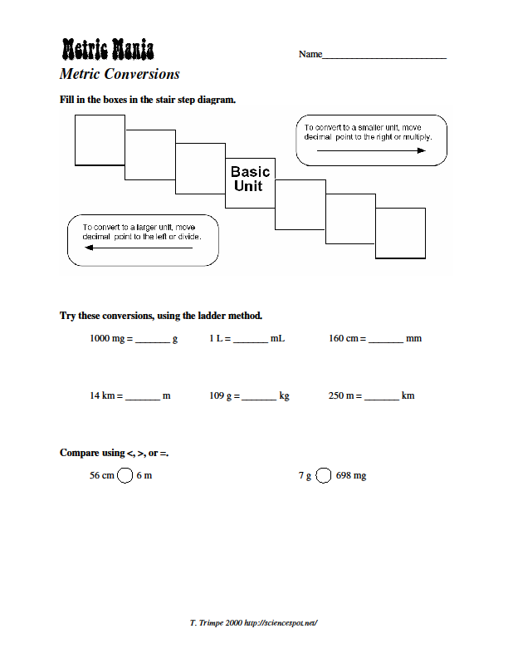

To convert to a smaller unit move decimal point to the right or multiply.

To convert to a bigger unit move decimal point to the left or divide. 

To convert to a smaller unit move decimal point to the right or multiply.

***Name ______________________***

***Metric Conversions***

**Write the correct abbreviation for each metric unit.**

1. Kilogram _____
2. Milliliter _____
3. Kilometer _____
4. Meter _____
5. Millimeter _____
6. Centimeter _____
7. Gram _____
8. Liter _____
9. Milligram _____

**Try these conversions, using the ladder method.**

10) 2000 mg = _______ g

11) 5 L = _______ mL

12) 16 cm = _______ mm

13) 104 km = _______ m

14) 198 g = _______ kg

15) 2500 m = _______ km

16) 480 cm = _____ m

17) 75 mL = _____ L

18) 65 g = _____ mg

19) 5.6 kg = _____ g

20) 50 cm = _____ m

21) 6.3 cm = _____ mm

22) 8 mm = _____ cm

23) 5.6 m = _____ cm

24) 120 mg = _____ g

**Compare using <, >, or =.**

25) 63 cm 6 m 26) 536 cm 53.6 d 27) 5 g 508 mg

Metric Conversions Practice

1. 10 dg = ________ g
2. 19 cm = ________m
3. 144 mg = ________cg
4. 2 km = _________ m
5. 1000 cm3 = _________ L
6. 10g + 2000 mg = ______ g
7. 1000 L = __________ kL
8. 25 mL = __________ cc
9. .086 km = ___________mm
10. 100 cg = ____________ g

INFERENCES

If your electricity goes out, you can infer that

1. a tree fell on the power lines
2. you will never have lights again
3. your water will be off too
4. something happened to the power

If you have to go to a new school, you can infer that

1. no one will like you
2. you will fail your first test
3. you will have to learn to get around the new school
4. your teachers will all be nice

If your best friend is not in school one day, you can infer that

1. they are out sick or on vacation
2. they are never coming back
3. they moved to a new state
4. they went to the wrong school by accident

If you see someone fall off of their bike, you can infer that

1. they lost their balance
2. they’ve never ridden a bike before
3. it’s a new bike
4. they weren’t wearing their helmet

If your teacher is out of school today, you can infer that

1. you won’t have any homework
2. the substitute teacher will be mean
3. the rules don’t apply for today
4. the teacher is either sick or out of town

If you forget to study for a test, you can infer that

1. the teacher will let you take it tomorrow
2. you might not do well
3. you will be better than if you did study
4. the teacher will send you to the principal

The pH of a solution is the measure of the acidity and basicity of a solution. The pH scale goes from 0-14. The pH below 7 is acidic. The pH of 7 is neutral. The pH above 7 is basic.

What can you infer about the following?

* The pH of a substance is measured at 17
* Apple juice has a pH of 3.6
* Baking soda has a pH higher than 7
* Water is neutral

Name _________________________________________ Date ___________________

**Nature of Science Practice**

1. With regard to safe practices in the lab, your most important general responsibility in the science lab is to:
   1. Never work alone in a lab.
   2. Keep yourself and others from being injured.
   3. Tie back any loose hair, roll up your sleeves, and put on any protective equipment your teacher requires at the beginning of the lab.
   4. Read the lab activity completely before coming to the lab.
2. Which of the following is the first and most important step in protecting your eyes while in the laboratory?
   1. Never use direct sunlight to illuminate a microscope.
   2. If you get a chemical or any fluid in your eyes, immediately go to an eyewash station and flush your eyes and eyelids for 15 minutes.
   3. Always were approved safety goggles while in the lab, even if you are not conducting an experiment at the time.
   4. Do not wear contact
3. When you clean up after a laboratory exercise
   1. Dispose of all used solutions by carefully diluting them with water in the sink.
   2. Be sure to dispose of all cracked or chipped glass containers in the trash.
   3. Return all unused chemicals to their properly labeled containers.
   4. Dispose of broken glass in a special container labeled for this purpose.
4. Regarding heating materials in the laboratory, which of the following statements is NOT true?
   1. When heating chemicals in a test tube, point the opening of the test tube away from yourself and others.
   2. Work with chemicals that produce gases and vapors only in a well-ventilated room.
   3. Use hot plates, not open flames, for heating materials.
   4. Use tongs or insulated glove when handling an object being heated.
5. In an experiment, the factor that the experiment manipulates and controls is
   1. The dependent variable
   2. The control group
   3. The instrumentation
   4. The independent variable
6. Which of the following is NOT testable?
   1. Fish are sad in a rocky environment but are happy in a sand environment
   2. Fish become more active when they are exposed to light.
   3. Fish remain healthier in water temperatures below 20ºC
   4. Fish cannot reproduce if the pH of the water is below 7
7. A scientist is trying to determine the best nutrient solution in which to grow a certain type of bacteria. He tried to grow five bacteria samples in 100 mL solutions. Each with a different nutrient present. He checked each solution after the one week to measure the amount of bacteria that grew. In this experiment, what is the dependent variable?
   1. The nutrient present in a solution
   2. The type of bacteria growing in each solution
   3. The number of bacteria that grew in each solution
   4. The number of bacteria grown per day in each solution

|  |  |  |  |
| --- | --- | --- | --- |
| **Types of Rocks** | **Igneous** | **Metamorphic** | **Sedimentary** |
| Characteristics | Can be either fine- or course-grained | Tendency to split along a smooth, flat surface | Composed of visible layers, usually horizontal |
| Examples | Granite, obsidian | Slate, Marble | Sandstone, Limestone |

1. Above is part of a field guide a student is using to identify rocks in the field. She found a rock that appears to be made of layers. When she struck one end with a rock hammer; the rock split in two, revealing a flat surface. Based on the student’s findings, which of the following inferences can be made?
   1. The rock is a igneous rock
   2. The rock may have been slate or marble
   3. The rock is a sedimentary rock
   4. The rock cannot be identified from the information provided
2. Which of the following statements best describes the term theory as used by scientists?
   1. A mathematical law that is true most of the time.
   2. A hypothesis that has not yet been tested
   3. A set of related hypothesis that will never change
   4. A set of related hypothesis that have been repeatedly tested and confirmed

|  |  |  |  |
| --- | --- | --- | --- |
| **Light Bulb Brand** | **Price per light bulb** | **Average life (hours)** | **Watts** |
| Glow Bright | $1.00 | 1,000 | 100 |
| Electric | $5.00 | 10,000 | 95 |
| Economy Power | $1.15 | 1,000 | 75 |
| Basic Bulbs | $0.75 | 900 | 75 |

1. After reading the paper one evening, a student made the table above from information in advertisements she had seen. Which of the following conclusion can you draw based on the information in the table?
   1. Glow bright light bulbs last twice as long as a basic bulbs light bulbs
   2. Light bulbs of 100 watts are the most efficient
   3. Electric light bulbs provide the most hours of use for the money.
   4. Basic Bulbs are better than Economy Power light bulbs

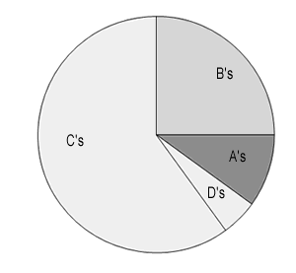Interpreting Graphs

1. Ms. M’s class grades were graphed as a pie graph. Based on this graph:

a) The largest percentage of students received what grade? ________  
b) The largest percentage of students received what grade? ________

c) Estimate what percentage of the class received a B. ___________

d) Based on the graph, do you think Ms. M’s class is hard?   
 Why or why not? _____________________________________________

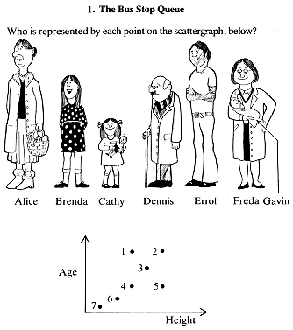2. The scatter plot shows a bus stop where those waiting at the bus are plotted by their height and by their age. Identify which dot goes with which passenger.

1) _____________________

2) _____________________

3) _____________________

4) _____________________

5) _____________________

6) _____________________  
7) _____________________

3. The bar graph compares the number of students enrolled in classes.

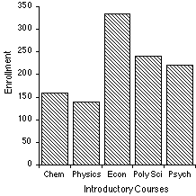a) What class has the highest enrollment?

______________________________

b) How many students are enrolled in Chemistry (chem.) _____

c) How many are enrolled in Physics? _______

4. This line graph compares the growth of plants that were kept in the sun for different amounts of time.

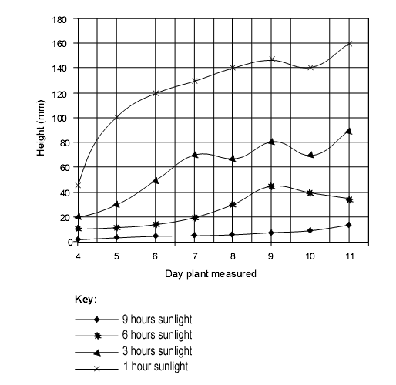

a) On Day 7, the plants kept in the sun for 3 hours were how tall? _________

b) On Day 7, the plants kept in the sun for 6 hours were how tall? _________

c) On Day 10, the plants kept in the sun for 9 hours were how tall? ________

d) On Day 10, the plants kept in the sun for 6 hours were how tall? ________

e) Based on the graph, the plant grows best in what amount of sunlight? __________

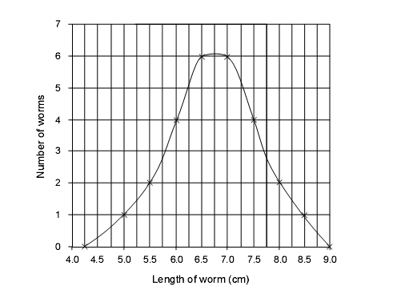

5. The line graph shows the number of worms collected and their lengths.

a) What length of worm is most common? _____________

b) What was the longest worm found?

_____________

c) How many worms were 6 cm long?

____________

d) How many worms were 7.25 cm long?

____________

e) The peak of the curve represents the

[ longest worms / average worms ]

Interpreting Graphs & English Usage

peak

rise

soar

fluctuate

decline

drop

climb

increase

The verbs in the box can be used to describe changes commonly seen on graphs. Examine the words (Look them up if you don’t know what they mean)

1. Circle the verbs that mean to go up.

2. Underline the verbs that mean to go down.

3. Put a star next to the verb that means to go up and down.

4. Use an arrow to indicate the word that means to reach its highest level.

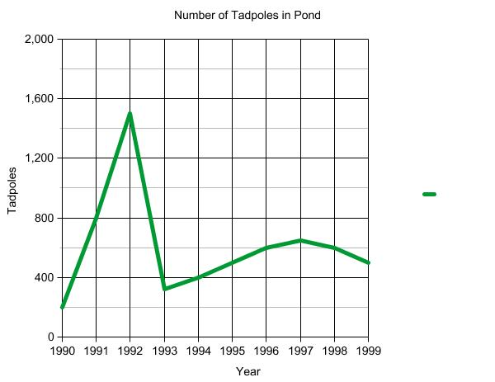

Use the words in the box to help you complete some of the sentences.

1. In the year 1990, tadpole populations began to _____________ rapidly.

2. Tadpole populations reached a _______________ in 1992.

3. Between 1992 and 1993, populations of tadpoles ___________________

4. Tadpole populations ____________after 1993.

5. Between 1995 and 1999, populations _______________________

6. How many tadpoles were in the pond at its highest point? _____________

7. How many tadpoles were present in the pond in 1998? ___________

8. Between 1998 and 1999, tadpole populations ____________ somewhat.

Graphing Practice

1. A class survey revealed that out of 30 students, 13 listed their favorite lunch item as pizza, 9 chose cheeseburgers, 6 picked lasagna, and 2 chose tacos.

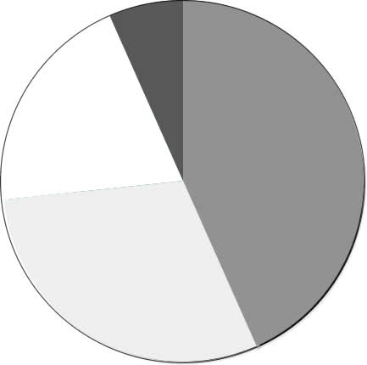

Label the pie graph.

2. Jamie bought a new video game and decided to keep track of his scores.

Try 1 – 150 pts

Try 2 – 190 pts

Try 3 – 500 pts

Try 4 – 900 pts

Try 5 – 1100 pts

Try 6 – 1500 pts

Create a graph of Jamie’s progress.

Put the “trys” on the X axis

3. Jamie’s friend, Josie tries out the same game.

Try 1 – 100 pts

Try 2 – 500 pts

Try 3 – 900 pts

Try 4 – 1100 pts

Try 5 – 1400 pts

Try 6 -- 1500 pts

Use the same graph and draw another line to represent Josie’s scores – Label each line as Jamie or Josie.

4. Based on your graph, who is the better player? Justify your answer.